Contents

[Tracks & Github Answer 4](#_Toc162181130)

[01/01/23 【**Introduction to Python】**- NumPy 5](#_Toc162181131)

[01/11/23 2D NumPy 6](#_Toc162181132)

[Subsettings 6](#_Toc162181133)

[Numpy Basic Statistics 6](#_Toc162181134)

[Generate Data 7](#_Toc162181135)

[03/20/23 【**Intermediate Python】-** Basic plots with Matplotlib 7](#_Toc162181136)

[Line plots 7](#_Toc162181137)

[Scatter plots 8](#_Toc162181138)

[Histogram 8](#_Toc162181139)

[Axis Labels, Titles 9](#_Toc162181140)

[Ticks 10](#_Toc162181141)

[Sizes 10](#_Toc162181142)

[Colors 11](#_Toc162181143)

[Additional customizations 11](#_Toc162181144)

[03/24/23 Dictionaries 12](#_Toc162181145)

[03/25/23 Pandas 14](#_Toc162181146)

[CSV - comma separated values 14](#_Toc162181147)

[Index and Select Data – square brackets, loc, iloc 15](#_Toc162181148)

[loc, iloc 20](#_Toc162181149)

[04/10/23 Logic, Control Flow and Filtering 20](#_Toc162181150)

[Comparison Operators 20](#_Toc162181151)

[Equality 21](#_Toc162181152)

[Greater and Less than 21](#_Toc162181153)

[Compare arrays 21](#_Toc162181154)

[Boolean Operators - and, or, not 21](#_Toc162181155)

[Boolean operators with Numpy 23](#_Toc162181156)

[Conditional Statement - if, elif, else 23](#_Toc162181157)

[Filtering Pandas DataFrames – Numpy 25](#_Toc162181158)

[Filtering DataFrame based on Bolean arrays 26](#_Toc162181159)

[05/29/23 Loops 27](#_Toc162181160)

[While loop 27](#_Toc162181161)

[For loop 28](#_Toc162181162)

[Enumerate 28](#_Toc162181163)

[Loop over string 29](#_Toc162181164)

[Loop over list of lists 30](#_Toc162181165)

[Loop over dictionary - items() method 30](#_Toc162181166)

[Loop over NumPy array – np.nditer() for 2D array 32](#_Toc162181167)

[Pandas – iterrows method 33](#_Toc162181168)

[Pandas – apply() function 34](#_Toc162181169)

[06/03/23 Case Study: Hacker Statistics 36](#_Toc162181170)

[Np.random.rand() & Np.random.seed() 36](#_Toc162181171)

[Np.randint() 38](#_Toc162181172)

[Random walk 38](#_Toc162181173)

[Distribution of random walk – matplotlib.pyplot 41](#_Toc162181174)

[plt.clf() - clear the figure 43](#_Toc162181175)

[06/04/23 【**Python Data Science Toolbox (Part 1)】** 44](#_Toc162181176)

[User-defined functions 44](#_Toc162181177)

[Single-parameter functions 46](#_Toc162181178)

[Functions that return single values 47](#_Toc162181179)

[Tuples 47](#_Toc162181180)

[Functions with multiple parameters 48](#_Toc162181181)

[Function的结构总结 50](#_Toc162181182)

[整合的例子 50](#_Toc162181183)

[06/12/23 Default arguments, variable-length arguments and scope 51](#_Toc162181184)

[Global vs Local Scope 51](#_Toc162181185)

[Buiilins() 52](#_Toc162181186)

[Nonlocals 53](#_Toc162181187)

[Scopes Searches 53](#_Toc162181188)

[Flexible arguments: \*args, \*\*kwargs 54](#_Toc162181189)

[12/07/23 Lambda functions and error-handling 54](#_Toc162181190)

[Map() and lambda functions 55](#_Toc162181191)

[Filter() and lambda functions 55](#_Toc162181192)

[Reduce() and lambda functions 55](#_Toc162181193)

[Error handling: Try-Except, Raise 56](#_Toc162181194)

[Cases 57](#_Toc162181195)

[12/14/23 **【Python Data Science Toolbox (Part II)】** 57](#_Toc162181196)

[Iterators vs Iterables 57](#_Toc162181197)

[Enumerator() vs Zip() 59](#_Toc162181198)

[Using Zip() 61](#_Toc162181199)

[Using \* and zip to 'unzip' 61](#_Toc162181200)

[Using iterators to load large files into memory 62](#_Toc162181201)

[01/29/24 List comprehensions and generators 63](#_Toc162181202)

[List comprehensions 63](#_Toc162181203)

[Nested List comprehensions 64](#_Toc162181204)

[Conditionals in comprehensions 65](#_Toc162181205)

[Dict comprehensions 65](#_Toc162181206)

[Generator 66](#_Toc162181207)

[List comprehensions for time-stamped data 67](#_Toc162181208)

[03/10/24 Bringing it all together! 69](#_Toc162181209)

[03/11/24 **【Investigating Netflix Movies】**Project 71](#_Toc162181210)

[03/13/24 【**Data Manipulation with pandas】-** Transforming DataFrames 74](#_Toc162181211)

[03/14/24 Aggregating DataFrames 76](#_Toc162181212)

[.agg() method 76](#_Toc162181213)

[Cumulative statistics一些公式 77](#_Toc162181214)

[Counting – categorical data 77](#_Toc162181215)

[.groupby() 77](#_Toc162181216)

[Pivot Table 78](#_Toc162181217)

[03/14/24 Slicing and Indexing DataFrames 79](#_Toc162181218)

[.set\_index(), .reset\_index(), .reset\_index(drop=True)) 79](#_Toc162181219)

[.loc[] 79](#_Toc162181220)

[.sort\_index() 80](#_Toc162181221)

[使用.loc[]来slice index values 81](#_Toc162181222)

[.iloc[] 82](#_Toc162181223)

[the .loc[] + slicing combination is often helpful 83](#_Toc162181224)

[03/15/24 Creating and Visualizing DataFrames 83](#_Toc162181225)

[matplotlib.pyplot 83](#_Toc162181226)

[Missing Values 85](#_Toc162181227)

[List of dictionaries 87](#_Toc162181228)

[Dictionary of lists 87](#_Toc162181229)

[csv - comma-separated values 87](#_Toc162181230)

[03/17/24 **【Exploring NYC Public School Test Result Scores】**Project 88](#_Toc162181231)

[03/19/24【**Joining Data with pandas**】Data Merging Basics 89](#_Toc162181232)

[Merge() 89](#_Toc162181233)

[One to many relationships 89](#_Toc162181234)

[03/21/24 Merging Tables With Different Join Types 91](#_Toc162181235)

[Inner Join & Left join 91](#_Toc162181236)

[Right join 93](#_Toc162181237)

[Outer join 94](#_Toc162181238)

[Self join – 可以是inner, outer, right, left 94](#_Toc162181239)

[Merge in indices 95](#_Toc162181240)

[03/24/24 Advanced Merging and Concatenating 96](#_Toc162181241)

[Filtering Join 96](#_Toc162181242)

[Semi Join 96](#_Toc162181243)

[Anti Join 97](#_Toc162181244)

[Concatenation >> grow vertically 98](#_Toc162181245)

[verifying integrity >>. merge(validate=”???”) 和.concat(verify\_integrity=True/False) 99](#_Toc162181246)

[03/24/24 Merging Ordered and Time-Series Data 99](#_Toc162181247)

[Merge\_ordered() 99](#_Toc162181248)

[Merge\_asof() 100](#_Toc162181249)

[//24 【**Introduction to Statistics in Python**】 101](#_Toc162181250)

[Xxxxxx 101](#_Toc162181251)

[//24 【Introduction to Data Visualization with Matplotlib】 101](#_Toc162181252)

[Xxxxxx 101](#_Toc162181253)

[//24 【xxxxxx】 101](#_Toc162181254)

[Xxxxxx 101](#_Toc162181255)

# Tracks & Github Answer

这个文件主要是用于 Python 相关的

* Data Scientist with Python
* Python Fundamentals
* Data Scientist with Python
* Python Programming
* Machine Learning Fundamentals with Python

<https://github.com/aladinbrahem/My-python-data-science-track/tree/3b73922ff42adc679056b9f0ff3e19cad341ba88>

<https://github.com/Murad-pitafi/Investing-Netflix-movies-and-Guest-Stars-in-the-office/blob/main/Netflix%20Movies%20and%20Guest%20Stars.ipynb>

<https://github.com/nabinno/dojo/blob/ca92fae02fafa6c4935d8175b7efb60938d7ae6c/datacamp/data_manipulation_with_pandas.md?plain=1#L55>

<https://github.com/Ashleshk/DataScience-DataCamp-Exercises/blob/63014e891a69328aafe44f08ddb1d8ffc5236cc2/Data%20Scientist%20Python/3.%20Joining%20Data%20with%20Pandas/merging.md?plain=1#L99>

# 01/01/23 【**Introduction to Python】**- NumPy

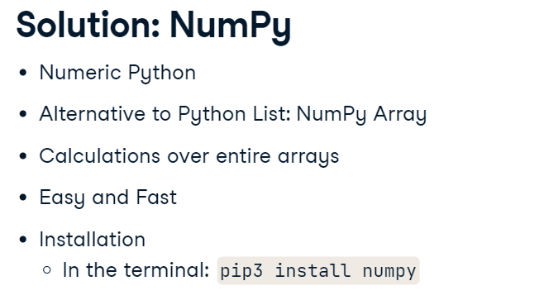 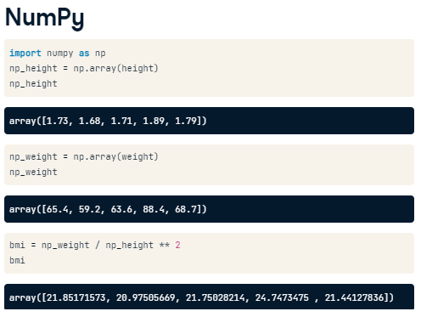

6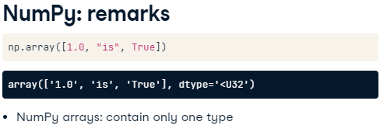 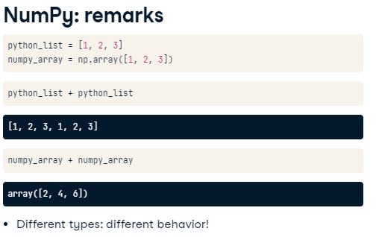

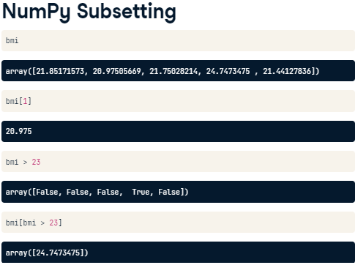 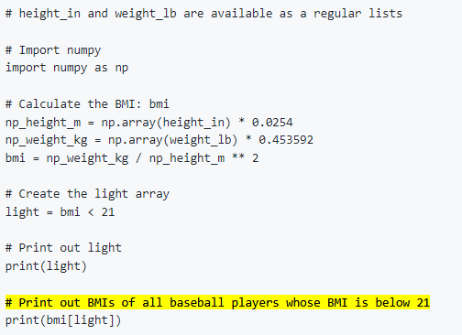

* First of all, numpy arrays cannot contain elements with different types. If you try to build such a list, some of the elements' types are changed to end up with a homogeneous list. This is known as **TYPE COERCION**.
* Second, the typical arithmetic operators, such as +, -, \* and / have a different meaning for regular Python lists and numpy arrays.

# 01/11/23 2D NumPy

* An array can only contain a single type - If you change one float to be string, all the array elements will be coerced to strings, to end up with a homogeneous array.
* shape is a so-called attribute of the np2d array, that can give you more information about what the data structure looks like.
* Print(np\_2d.shape)

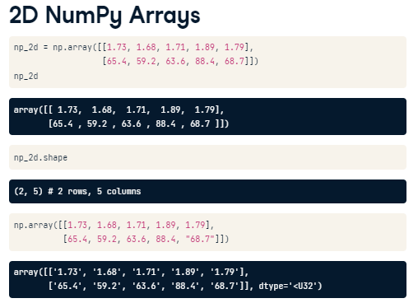

* 注意计算机传统是0~n是指从0到n-1的n个数字。0:1就是从0开始1—0个数字就剩下0自己了

## Subsettings

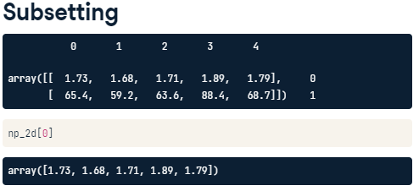 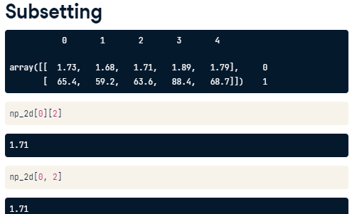

## Numpy Basic Statistics

* NumPy also features more basic functions, such as sum and sort, which also exist in the basic Python distribution. However, the big difference here is speed. Because NumPy enforces a single data type in an array, it can drastically speed up the calculations.
* Np.mean
* Np.median
* Np.corrcoef >> to check if 2 arrays are correlated

np.corrcoef(np\_city[:,0], np\_city[:,1])

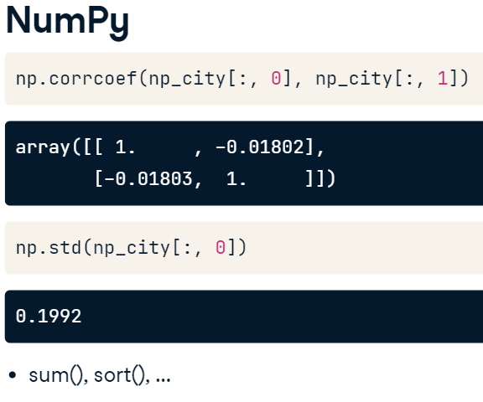

Np.std

## Generate Data

* We simulated it with NumPy functions! I sampled two random distributions 5000 times to create the height and weight arrays, and then used column\_stack to paste them together as two columns.

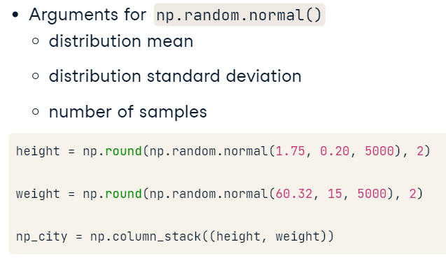

# 03/20/23 【**Intermediate Python】-** Basic plots with Matplotlib

1. Just remember this: the plot function tells Python what to plot and how to plot it. show actually displays the plot.

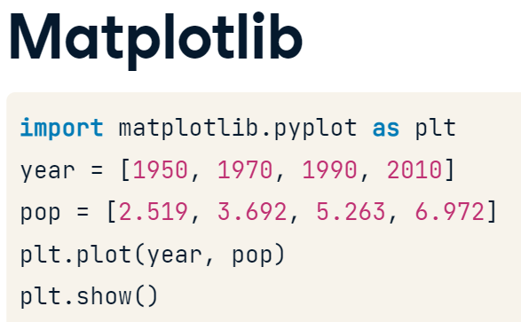

## Line plots

1. Before you can start, you should import matplotlib.pyplot as plt. pyplot is a sub-package of matplotlib, hence the dot.

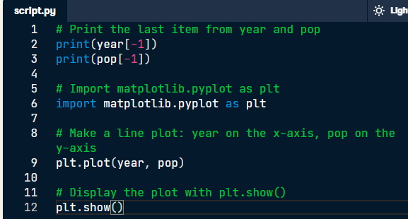

## Scatter plots

1. The matplotlib.pyplot package is available as plt.

import matplotlib.pyplot as plt

plt.scatter(x,y)

plt.show()

1. Build a scatter plot, where pop is mapped on the horizontal axis, and life\_exp is mapped on the vertical axis.

# Import package

import matplotlib.pyplot as plt

# Build Scatter plot

plt.scatter(pop,life\_exp)

# Show plot

plt.show()

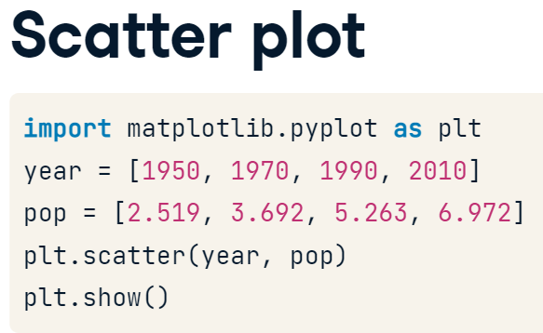

## Histogram

1. Matplotlib

* Plt.host(要画图的对象，bins的数量)

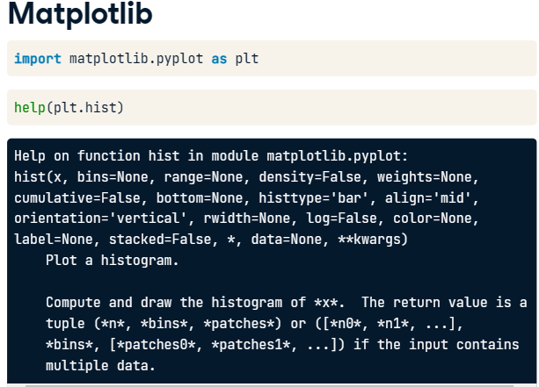

1. If no specify the number of bins; Python will set the number of bins to 10 by default for you.
2. plt.show() displays a plot; plt.clf() cleans it up again so you can start afresh.

## Axis Labels, Titles

1. sample

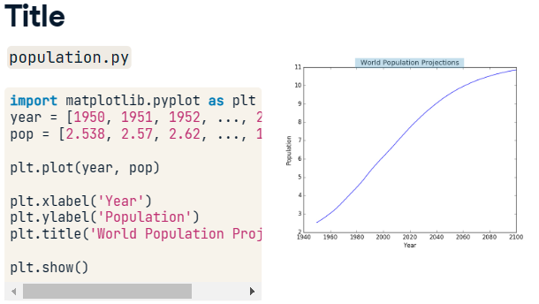

1. 如何先自定义标签名后在放入到plt公式里面

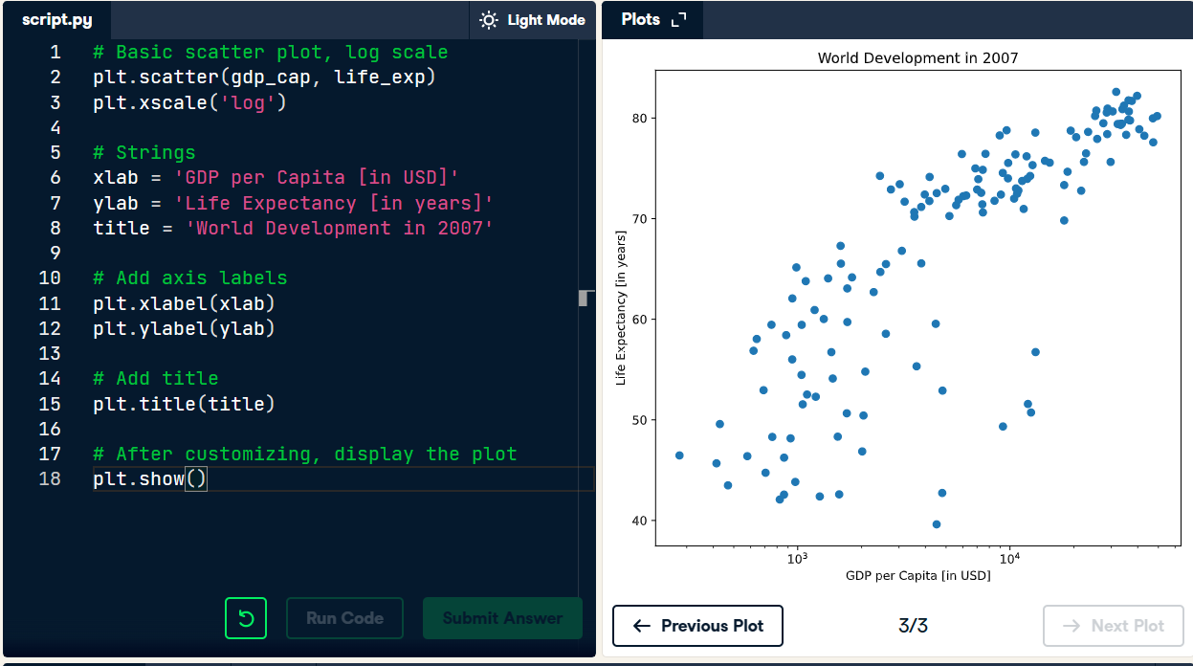

## Ticks

1. In this example, the ticks corresponding to the numbers 0, 1 and 2 will be replaced by one, two and three, respectively.

plt.yticks([0,1,2], ["one","two","three"])

1. Sample code

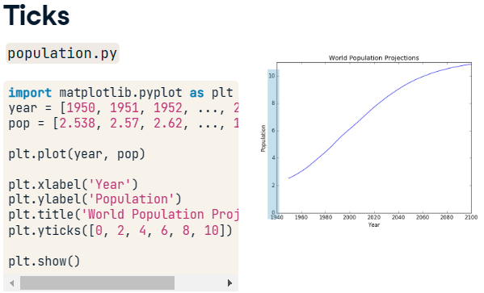 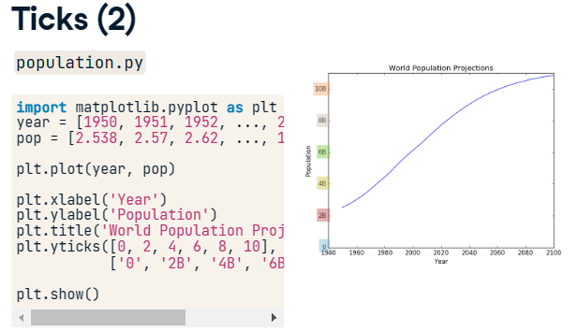

1. 先定义tick\_val和tick\_lab然后再代入plt.xticks

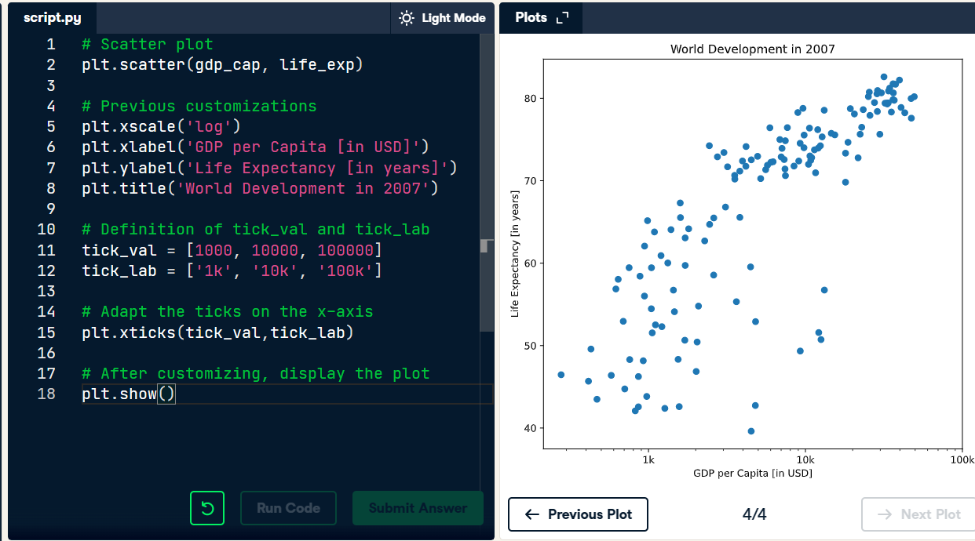

## Sizes

1. You can see that this list is added to the scatter method, as the argument s, for size.
2. 图形的大小代表用人口数量的多少

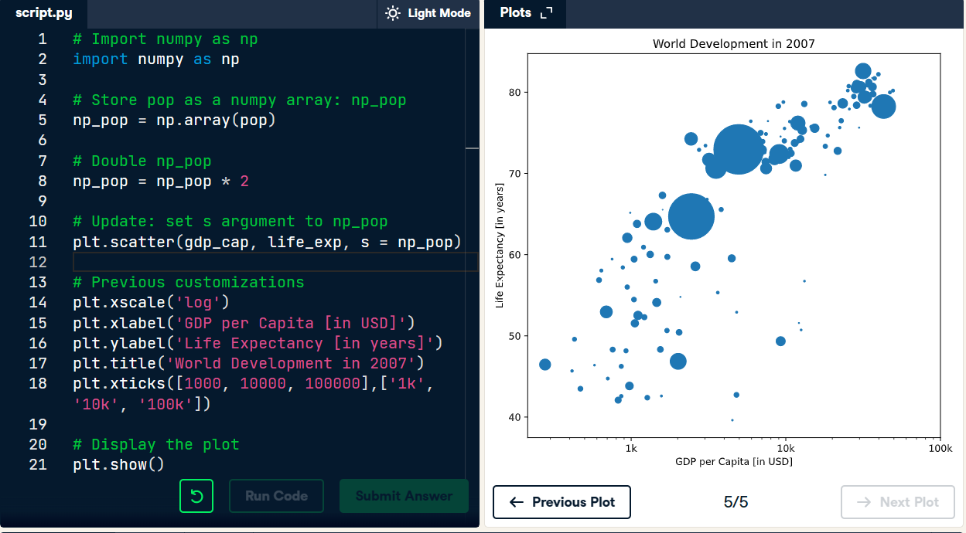

## Colors

1. To create a list ‘col’ with a color for each corresponding country, depending on the continent the country is part of.

How did we make the list col you ask? The Gapminder data contains a list continent with the continent each country belongs to. A dictionary is constructed that maps continents onto colors:

dict = {

'Asia':'red',

'Europe':'green',

'Africa':'blue',

'Americas':'yellow',

'Oceania':'black'

}

1. 带有alpha和c变量的

alpha : float, default: None. The alpha blending value, between 0 (transparent) and 1 (opaque).  
c : array-like or list of colors or color, optional. The marker colors.

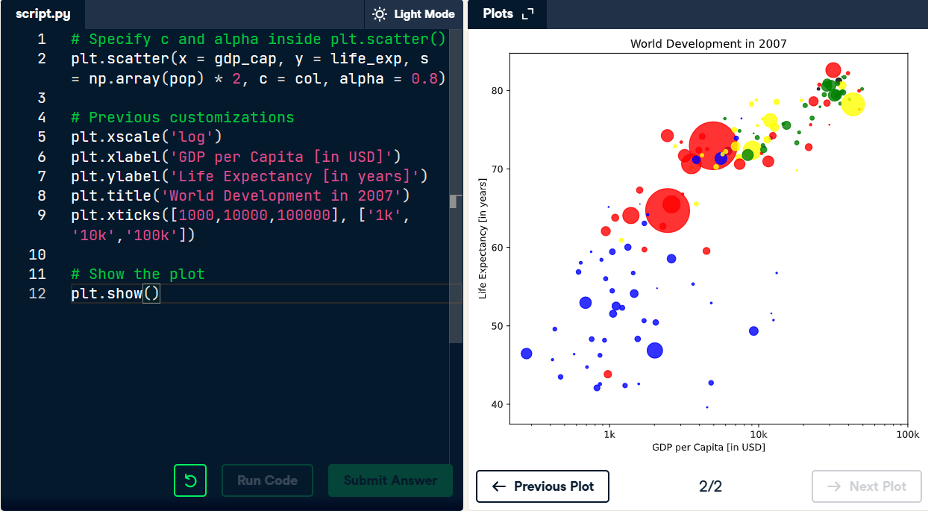

## Additional customizations

1. 比如特别标注出来中国和印度

# Additional customizations

plt.text(1550, 71, 'India')

plt.text(5700, 80, 'China')

1. Add plt.grid(True) after the plt.text() calls so that gridlines are drawn on the plot.

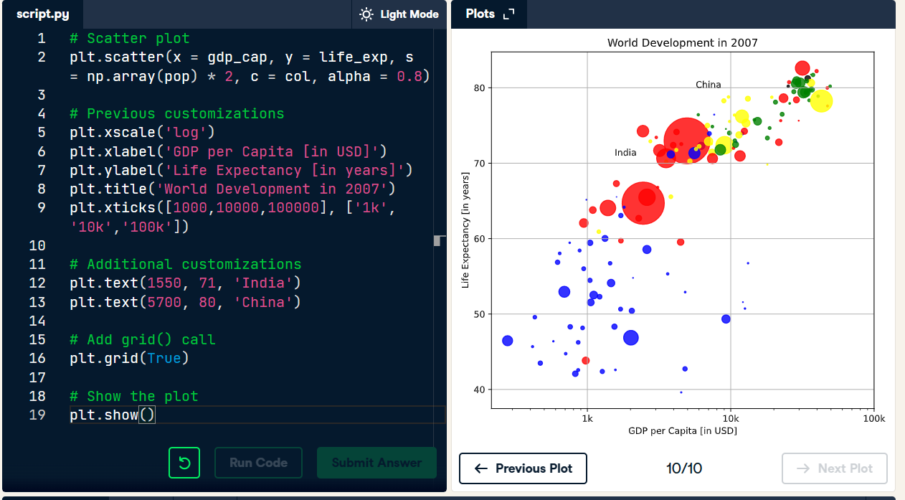

# 03/24/23 Dictionaries

1. List 方法不是很方便直接

Remember about the method index()… we can use this index to subset the pop list, to get the population corresponding to Albania… So we built two lists, and used the index to connect corresponding elements in both lists. It worked, but it's a pretty terrible approach: it's not convenient and not intuitive. Wouldn't it be easier if we had a way to connect each country directly to its population, without using an index? This is where the dictionary comes into play.

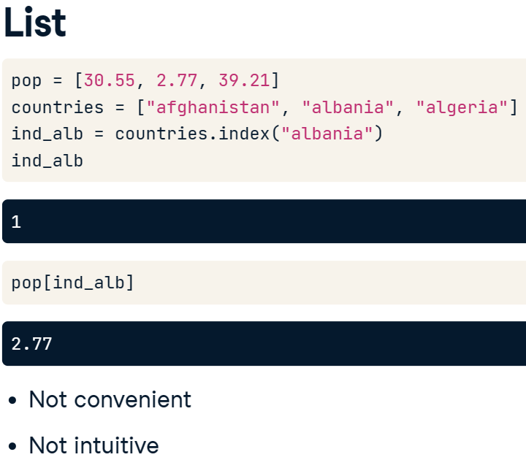 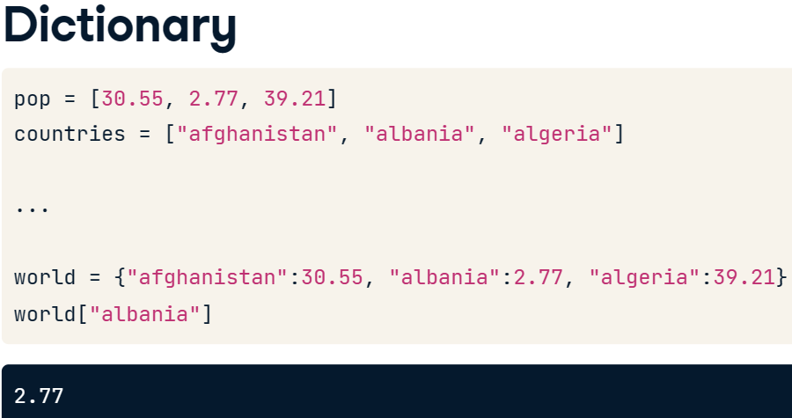

1. To create the dictionary, you need curly brackets {}. Next, inside the curly brackets, you have a bunch of what are called key:value pairs.

* In our case, the keys are the country names, and the values are the corresponding populations.

1. simply type world, and then the string Albania inside square brackets []. In other words, you pass the key in square brackets, and you get the corresponding value. The key opens the door to the value: pretty poetic, isn't it? This approach is not only intuitive, it's also very efficient, because Python can make the lookup of these keys very fast, even for huge dictionaries.
2. Xxxxxx.keys()和xxxxxx.values()调出字典里面的数据

# Definition of dictionary

europe = {'spain':'madrid', 'france':'paris', 'germany':'berlin', 'norway':'oslo' }

# Print out the keys in europe

print(europe.keys())

# Print out value that belongs to key 'norway'

print(europe['norway'])

1. List vs Dictionary

* The LIST is a sequence of values that are indexed by a range of numbers. The DICTIONARY, on the other hand, is indexed by unique keys, that can be any immutable type.
* If you have a collection of values where the order matters, and you want to easily select entire subsets of data, you'll want to go with a LIST. If, on the other hand, you need some sort of look up table, where looking for data should be fast and where you can specify unique keys, a DICTIONARY is the preferred option.

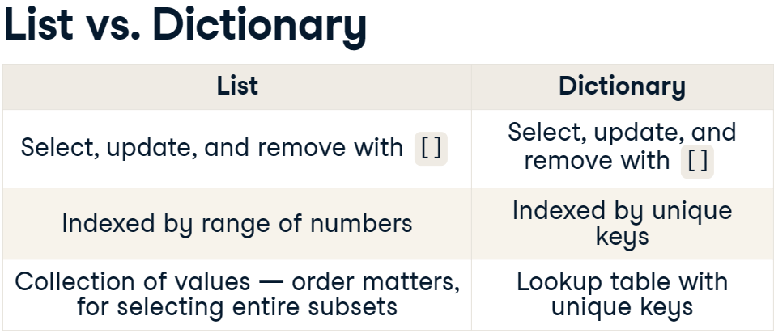

1. 从字典里面移除用del()

# Update capital of germany

europe['germany'] = 'berlin'

# Remove australia

del(europe['australia'])

1. Lists could contain anything, even other lists.

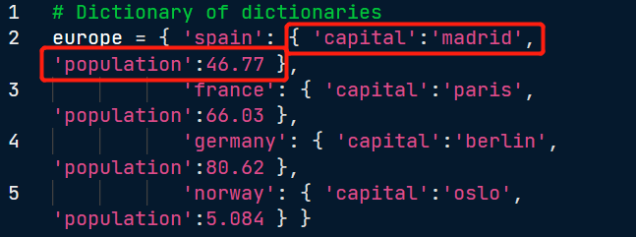

1. 注意定义的时候数字不用’’括号

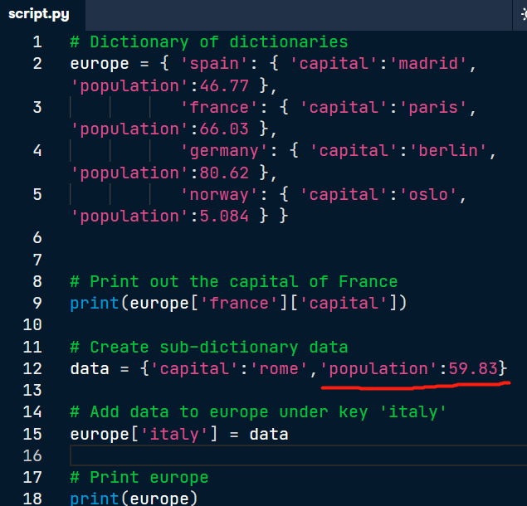

# 03/25/23 Pandas

1. Pandas is a high level data manipulation tool developed by Wes McKinney, built on the NumPy package. Compared to NumPy, it's more high level, making it very interesting for data scientists all over the world. In pandas, we store the tabular data in an object called a DataFrame.

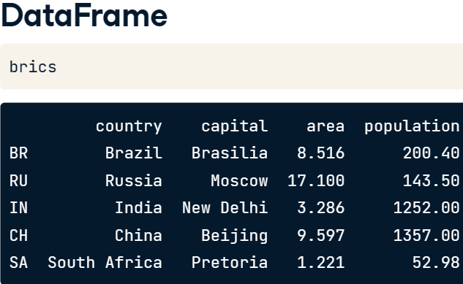

1. Using the distinctive curly brackets, we create key value pairs. The keys are the column labels, and the values are the corresponding columns, in list form. After importing the pandas package as pd, you can create a DataFrame from the dictionary using pd (dot) DataFrame.

* The DataFrame is one of Pandas' most important data structures. It's basically a way to store tabular data where you can label the rows and the columns.

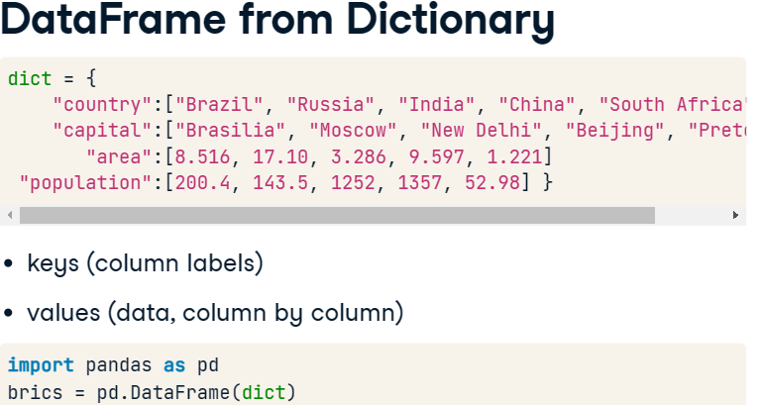

* Pandas assigned some automatic row labels, 0 up to 4.

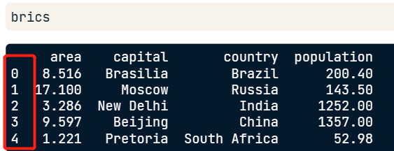

## CSV - comma separated values

1. 直接从csv导入文件

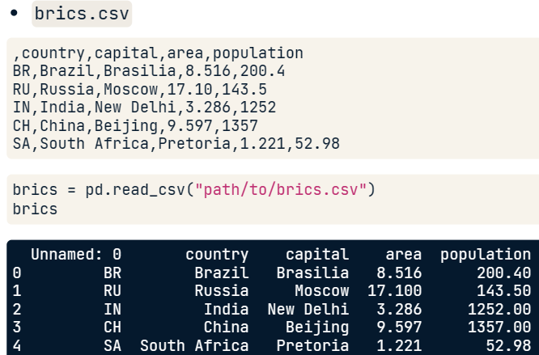

* there's still something wrong. The row labels are seen as a column in their own right.
* To solve this, we'll have to tell the read\_csv function that the first column contains the row indexes. You do this by setting the index\_col argument

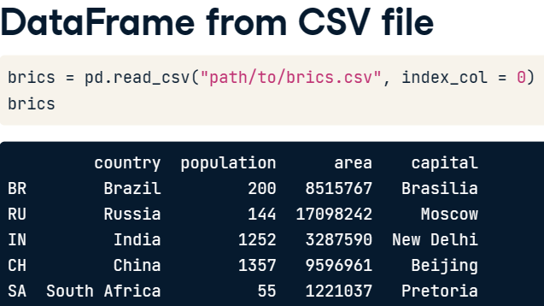 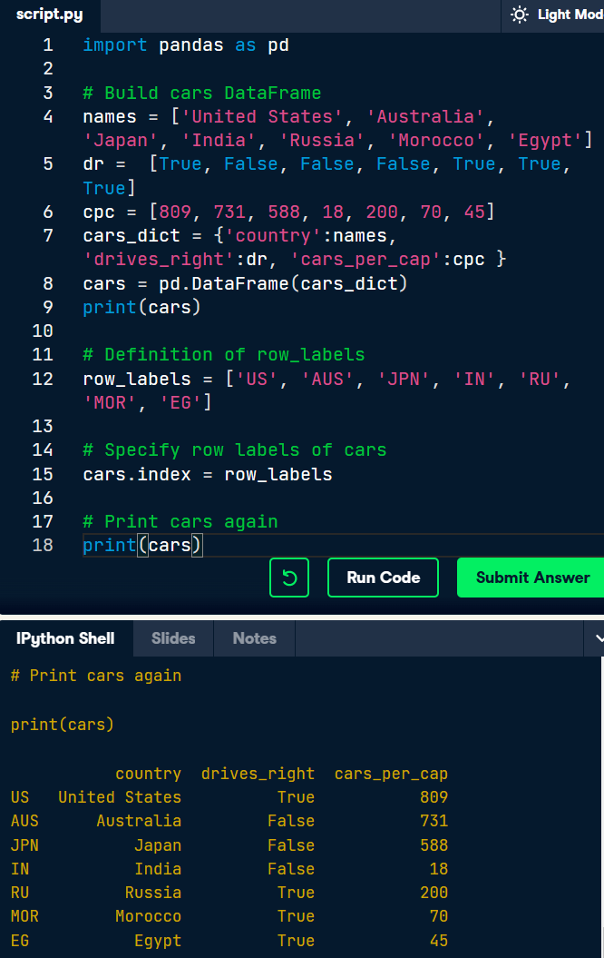

## Index and Select Data – square brackets, loc, iloc

1. There are numerous ways in which you can index and select data from DataFrames, so we'll take this step by step. First, I'm going to talk about how to use square brackets; next, I'm going to tell you about advanced data access methods, loc and iloc, that make Pandas extra powerful.
2. 如果只有一个[]则会返回这样的结果，多了一列

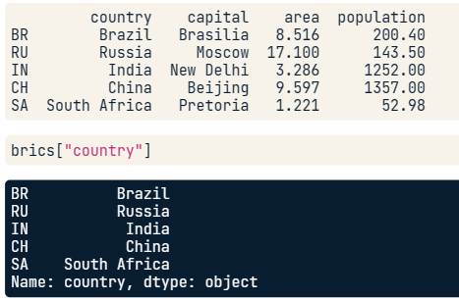 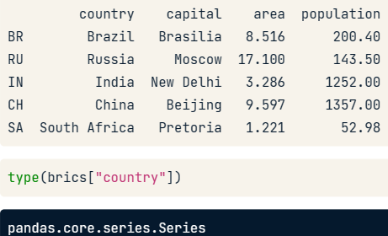

1. 用两个[[]]

* If you want to select the country column but keep the data in a DataFrame, you'll need double square brackets, like this. If you check out the type of this fellow, it's a good old DataFrame, this time with only one column though.

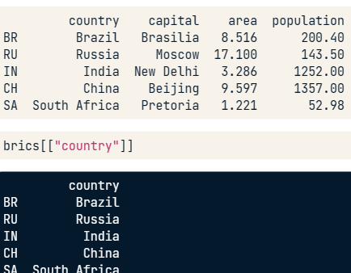 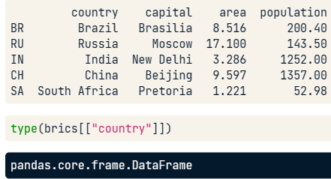

1. 得到两列

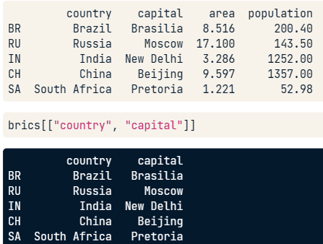

1. 如何得到指定的行row >> The way to do it is by specifying a slice.

* To get the second, third and fourth rows of brics, we use the slice 1 colon 4.
* Remember that the end of the slice is exclusive and that the index starts at zero.

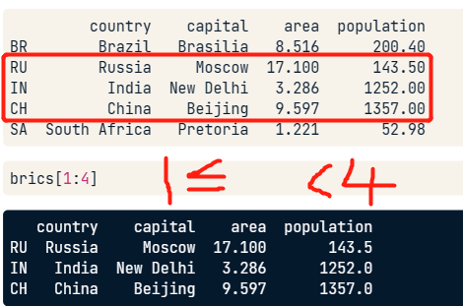

1. These square brackets work, but it only offers limited functionality. Ideally, we'd want something similar to 2D NumPy arrays. There, you also used square brackets, the index or slice before the comma referred to the rows, the index or slice after the comma referred to the columns. If we want to do a similar thing with Pandas, we have to extend our toolbox with the loc and iloc functions.

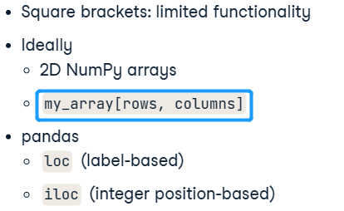

* loc is a technique to select parts of your data based on labels
* iloc is integer position based.

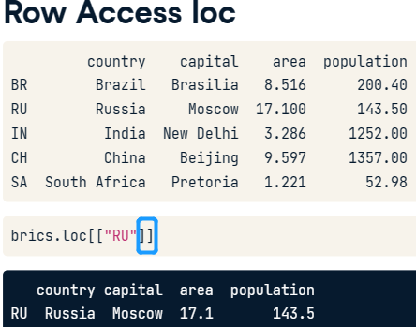 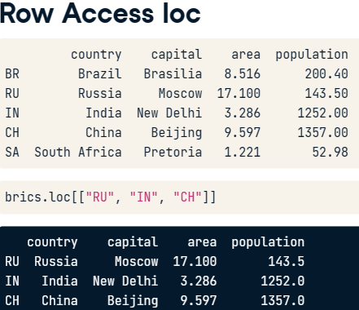

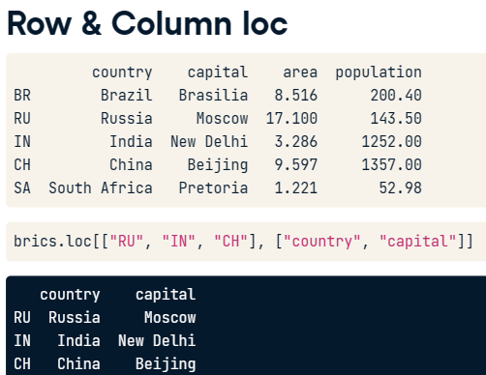 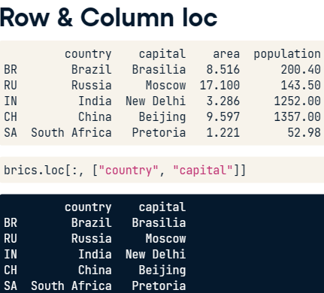

1. The loc function is more versatile: you can select rows, columns, but also rows and columns at the same time. When you use loc, subsetting becomes remarkable similar to how you subsetted 2D NumPy arrays. The only difference is that you use row labels with loc, not the positions of the elements. If you want to subset Pandas DataFrames based on their position, or index, you'll need the iloc function.

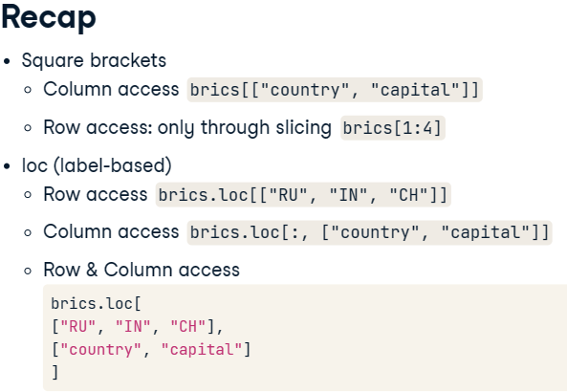

1. Iloc >> loc and iloc are pretty similar, the only difference is how you refer to columns and rows.

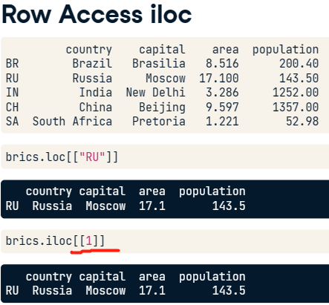

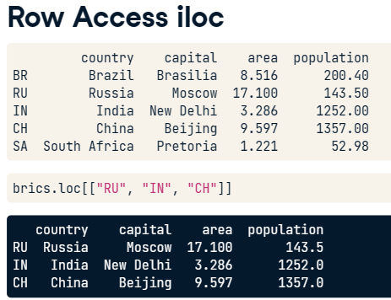 === 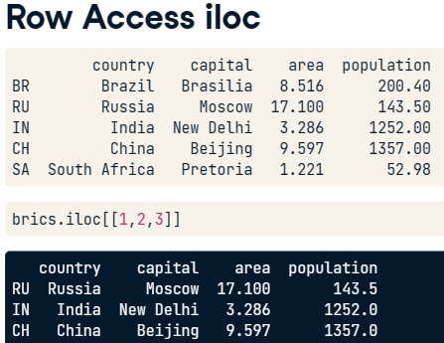

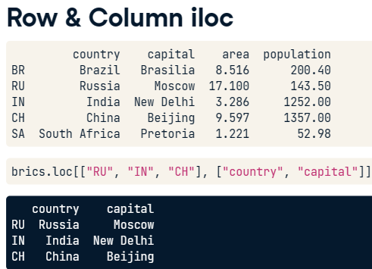 === 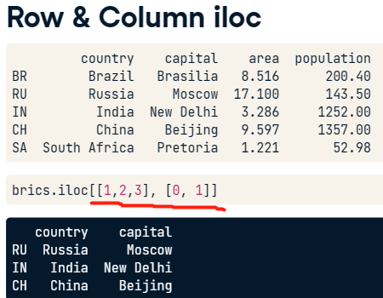

1. 注意区分print出来的是series还是dataframe，关键在于一个还是两个[]

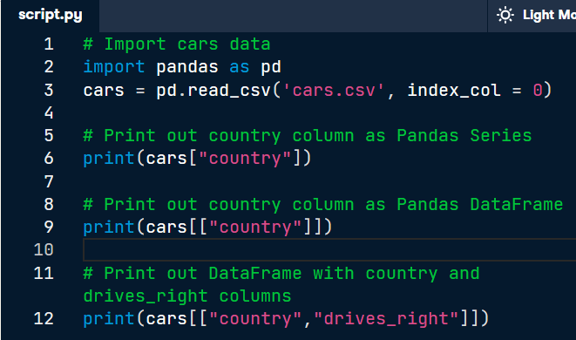

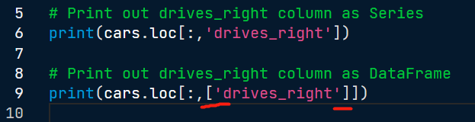

1. 例子

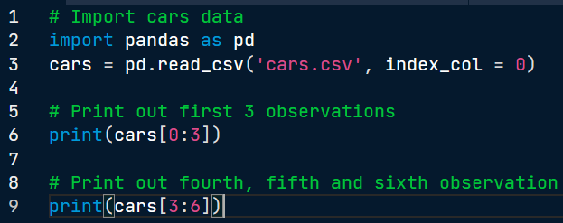

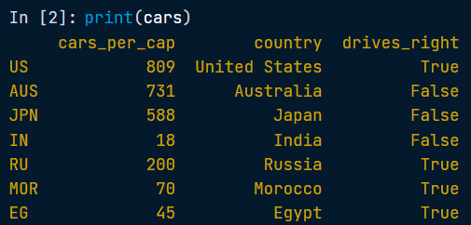

# Print out first 3 observations

print(cars[0:3])

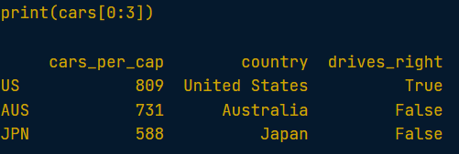

# Print out fourth, fifth and sixth observation

print(cars[3:6])

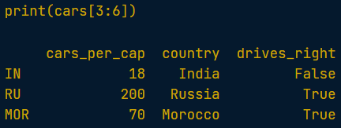

## loc, iloc

1. With loc and iloc you can do practically any data selection operation on DataFrames you can think of.
2. loc is label-based, which means that you have to specify rows and columns based on their row and column labels. Loc是基于行列名字的
3. iloc is integer index based, so you have to specify rows and columns by their integer index like you did in the previous exercise. Iloc是基于行列数的

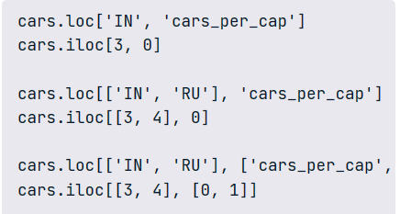

1. It's also possible to select only columns with loc and iloc. In both cases, you simply put a slice going from beginning to end in front of the comma:

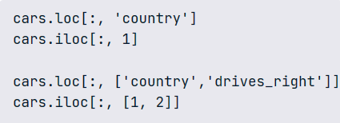

# 04/10/23 Logic, Control Flow and Filtering

## Comparison Operators

1. Typically, Python can't tell how two objects with different types relate. Different numeric types, such as floats and integers, are exceptions as this example shows: no error this time. In general, always make sure that you make comparisons between objects of the same type.

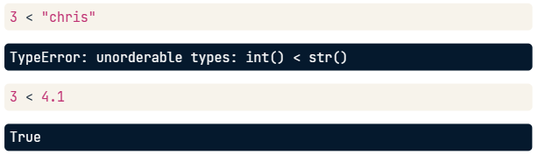

1. NumPy figures out that you want to compare every element in bmi with 23, and returns corresponding booleans. Behind the scenes, NumPy builds a numpy array of the same size filled with the number 23, and then performs an element-wise comparison. This is concise yet very efficient code, something data scientists love!

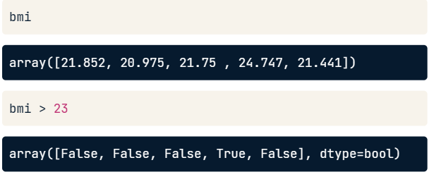

1. Operators

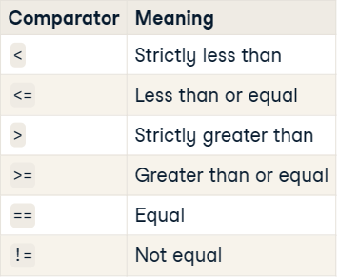

## Equality

## Greater and Less than

## Compare arrays

## Boolean Operators - and, or, not

1. A boolean is either 1 or 0, True or False.
2. AND: It takes two booleans and returns True only if both the booleans themselves are True.

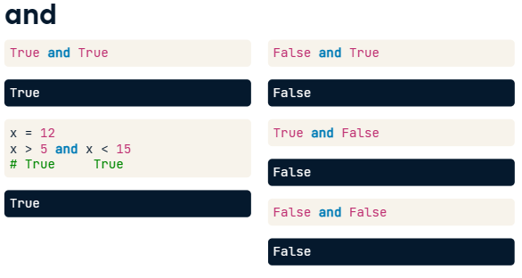

1. OR: only at least one of the booleans it uses should be True.

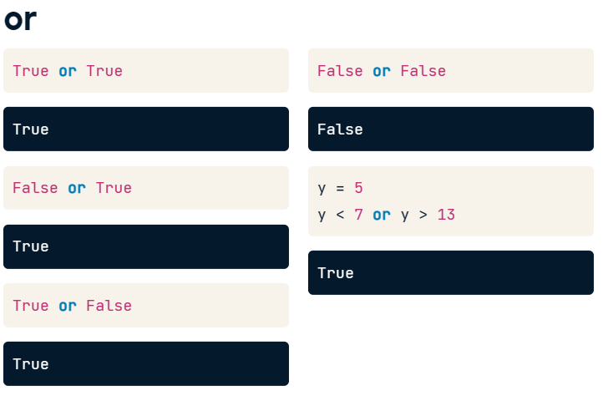

1. Arrays - functions logical\_and, logical\_or and logical\_not, the "array equivalents" of and or and not.

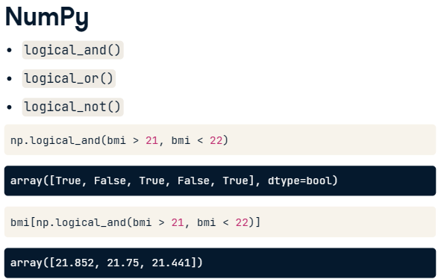

## Boolean operators with Numpy

* Before, the operational operators like < and >= worked with NumPy arrays out of the box.
* Unfortunately, this is not true for the boolean operators and, or, and not.
* To use these operators with NumPy, you will need np.logical\_and(), np.logical\_or() and np.logical\_not().

## Conditional Statement - if, elif, else

* It reads as follows: if condition, execute expression.
* colon at the end
* indent the Python code with 4 spaces (or a tab) to tell Python what to do in the case the condition succeeds
* To exit the if statement, simply continue with some Python code without indentation, and Python will know that it's not part of the if statement.
* possible to have more lines inside the if statement

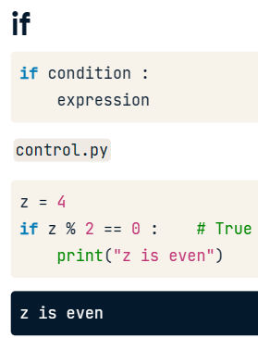 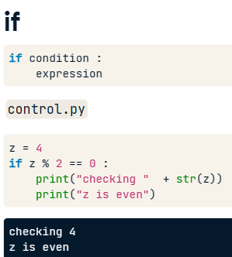

* for the else statement, you don't need to specify a condition.
* The corresponding expression gets run if the condition of the if statement it belongs to does not hold.

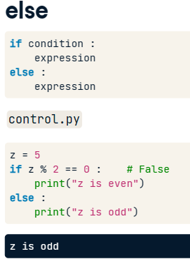

* even more customized behavior is necessary
* As soon as Python bumps into a condition that is true, it executes the corresponding code and then leaves the control structure after that >> This means the second condition, corresponding to the elif, is never reached so there's no corresponding printout.

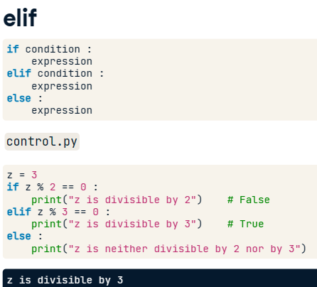 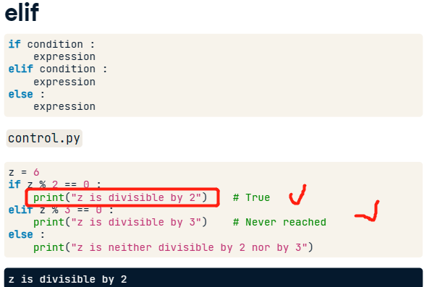

## Filtering Pandas DataFrames – Numpy

* we used this logical\_and function from the NumPy package to do an element wise boolean operation on NumPy arrays to create a Boolean Series
* Pandas is built on NumPy, you can also use that function here.

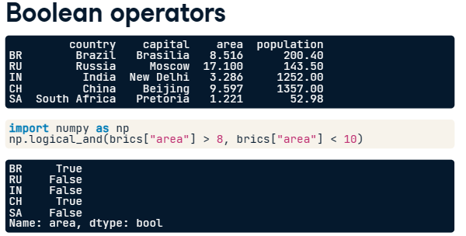

* Place the code inside square brackets to subset brics

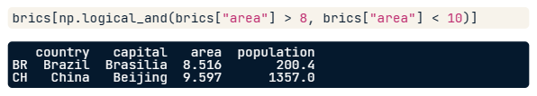

* 另外一个例子

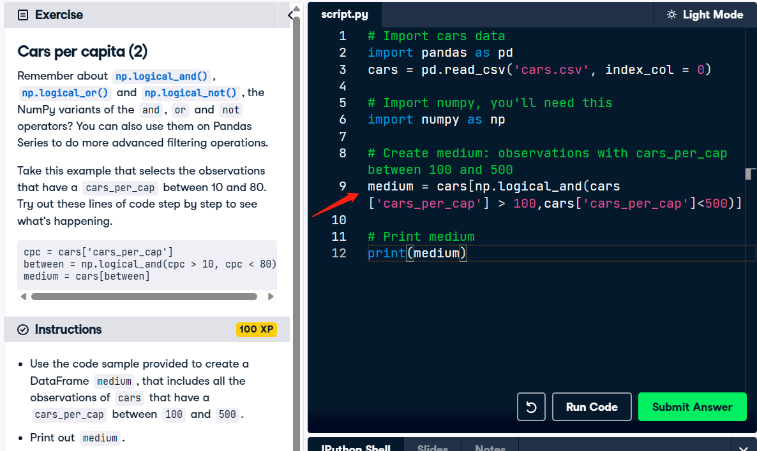

## Filtering DataFrame based on Bolean arrays

* actually unnecessarily created a new variable dr.

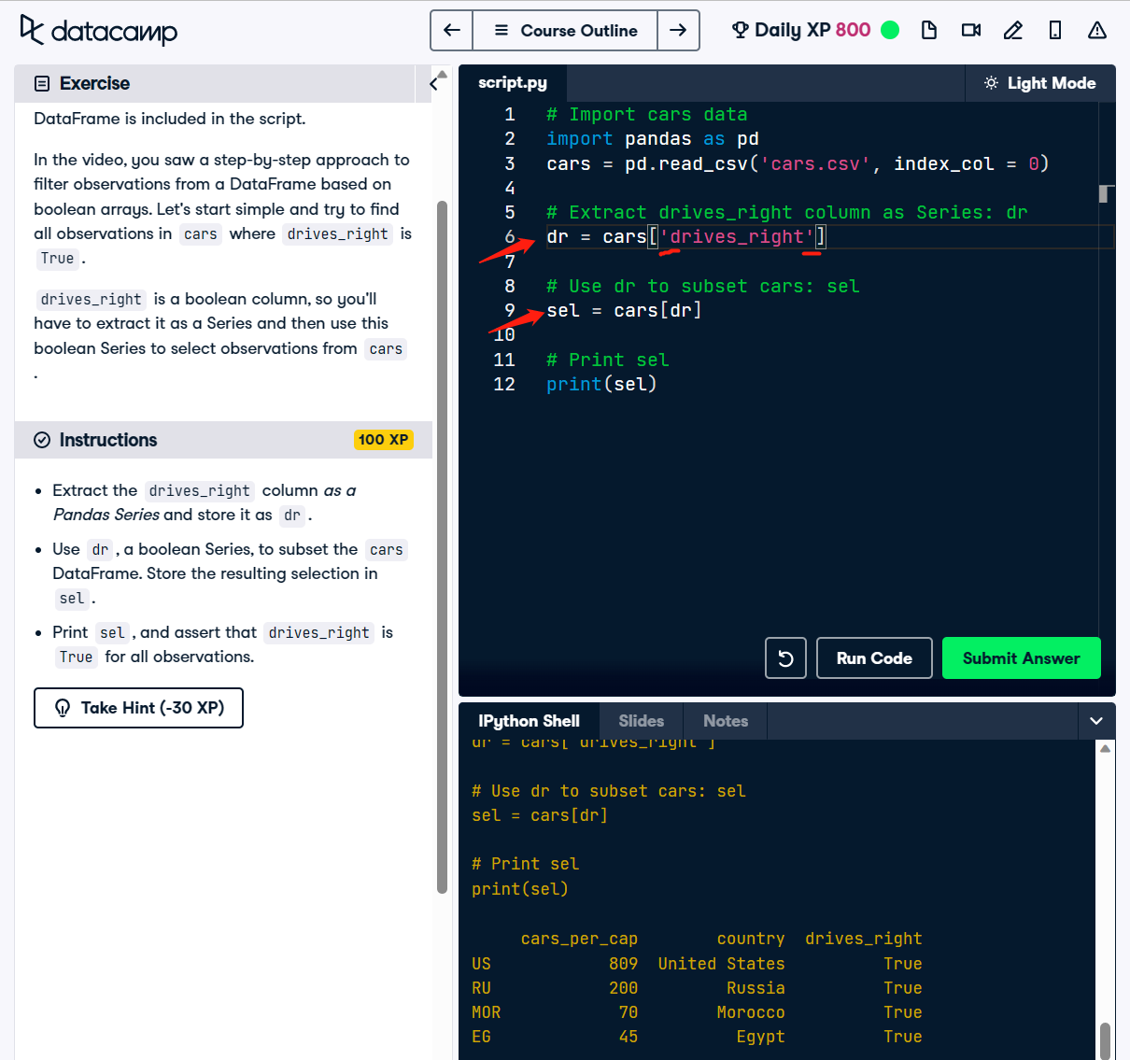

* can achieve the same result without this intermediate variable. Put the code that computes dr straight into the square brackets that select observations from cars.

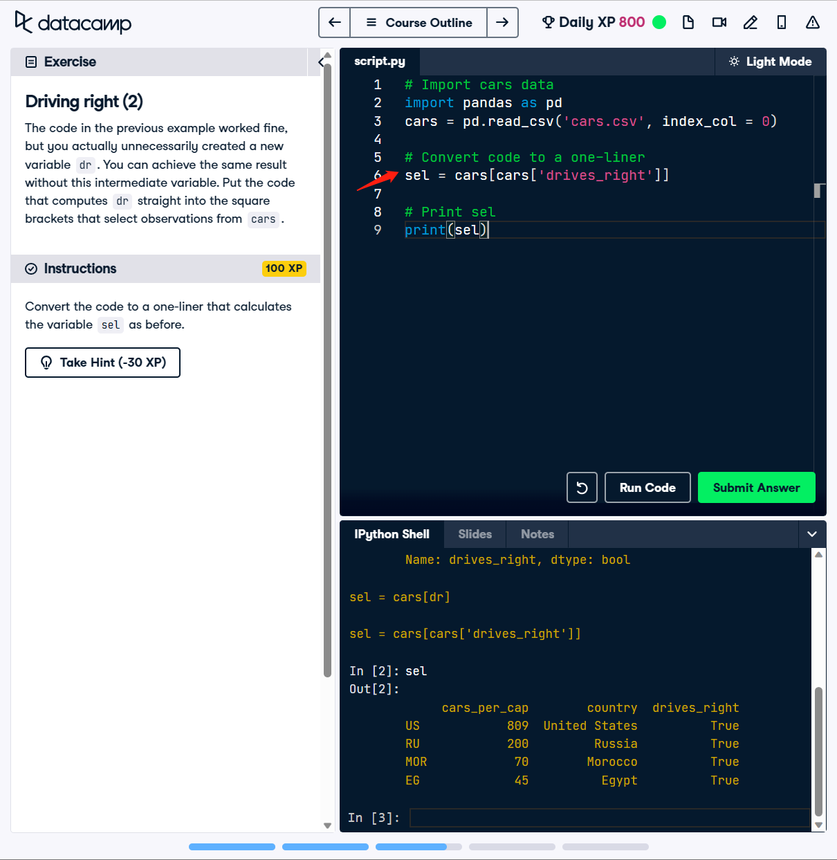

* 这个是有比较的

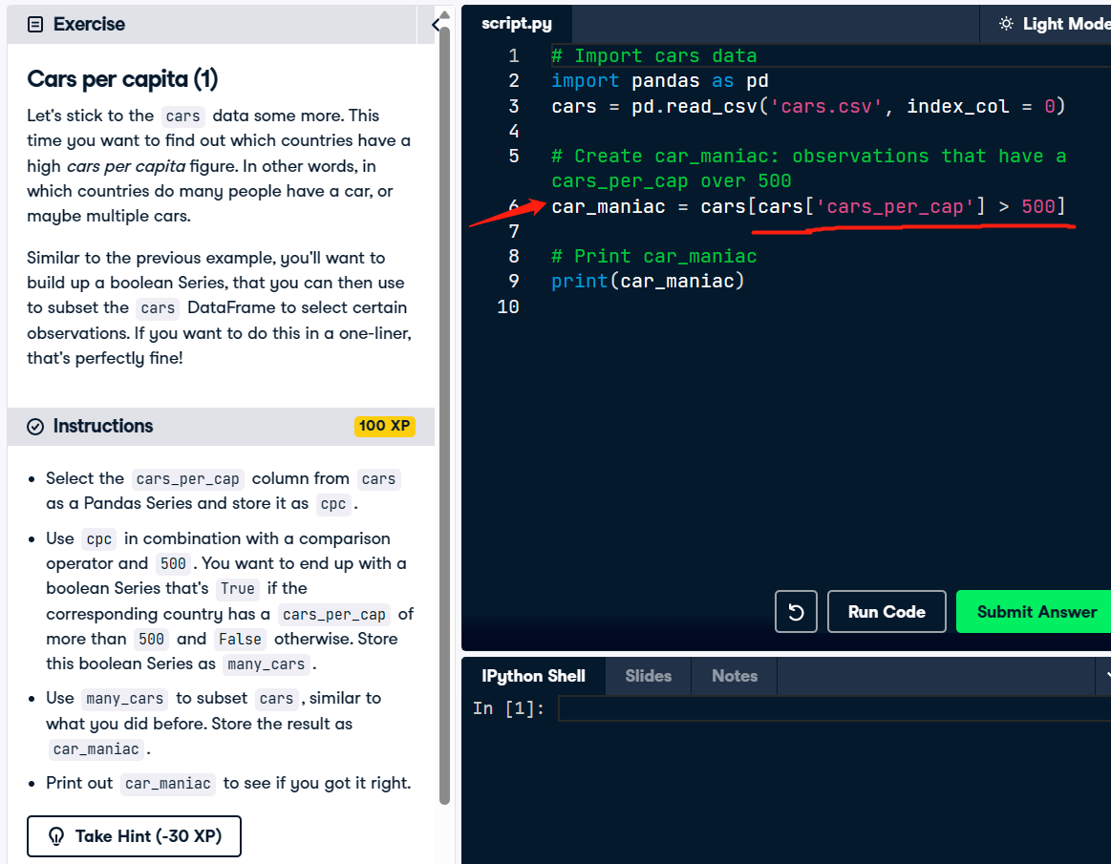

# 05/29/23 Loops

## While loop

* The while loop is somewhat similar to an if statement (The while loop is like a repeated if statement): it executes the code inside if the condition is True. However, as opposed to the if statement, the while loop will continue to execute this code over and over again as long as the condition is true.
* When you can reformulate the problem as 'repeating an action until a particular condition is met', a while loop is often the way to go.

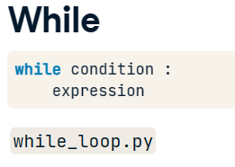

* Suppose that we comment out these updates of the error value, and run the script again. The error isn't updated, so the condition is always True and the while loop will go on forever. On DataCamp, this will cause your session to be disconnected. If you're making this mistake on your own system, you will have to interrupt the python program by pressing the control and C keys.

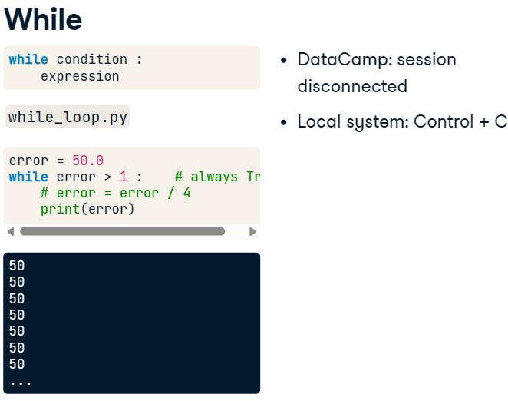

* Note that if your while loop takes too long to run, you might have made a mistake.
* In particular, remember to indent the contents of the loop using four spaces or auto-indentation!

## For loop

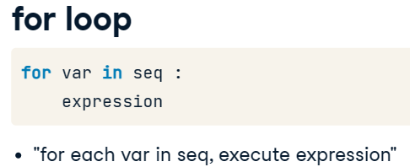 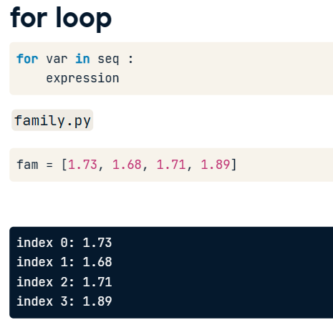

## Enumerate

* Now, on each iteration, index will contain the index, and height will contain the float. This means that we can now also update the statement inside the for loop with a more complicated print() call.
* Notice that I had to convert the floats to strings with str() so that you can add everything together.

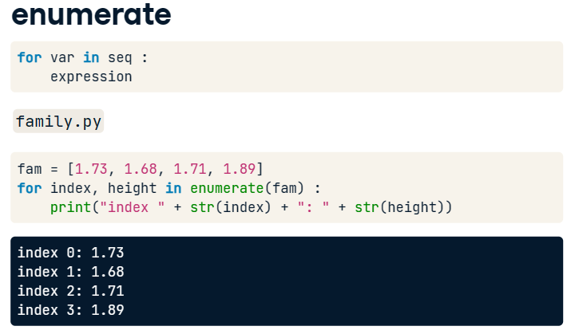

## Loop over string

* The for loop doesn't only work with lists.
* You can also create a for loop that iterates over every character a string, "family" for example, and stores it in c, one after the other. Inside the loop, the string c is capitalized and printed out.

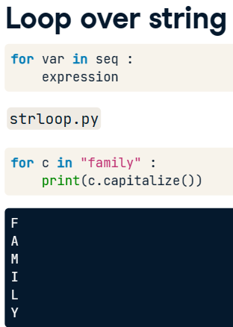

## Loop over list of lists

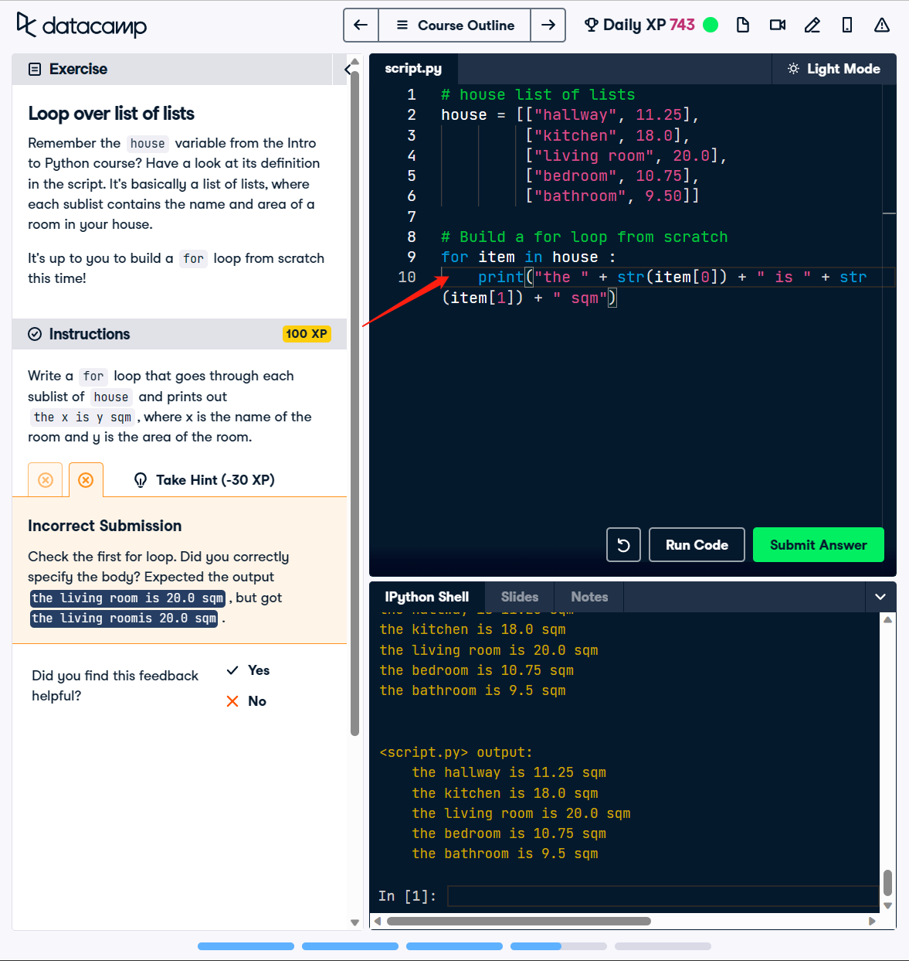

## Loop over dictionary - items() method

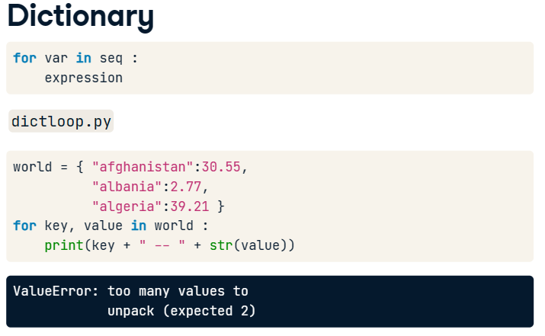

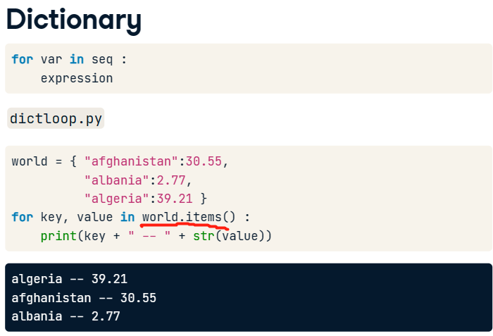

* dictionaries are inherently unordered: the order in which they're iterated over is not fixed, at least in Python 3.5. 所以可以看到结果和world字典里面的顺序不太一样

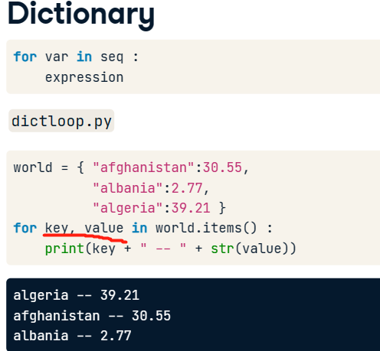

* The names key and value are totally arbitrary by the way, I can also call these k and v, like here. The order does matter though. The first variable gets the key, the second one the value.
* In Python 3, you need the items() method to loop over a dictionary:

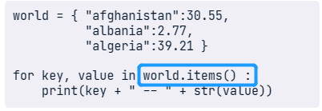

## Loop over NumPy array – np.nditer() for 2D array

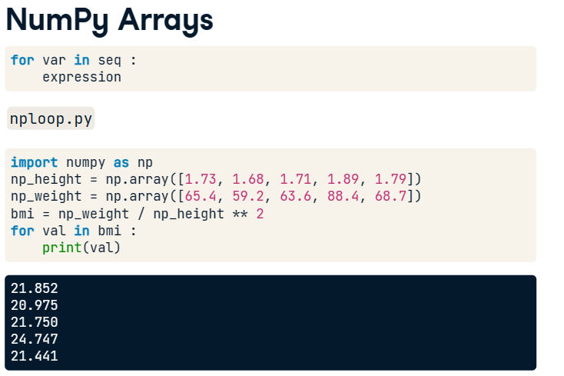

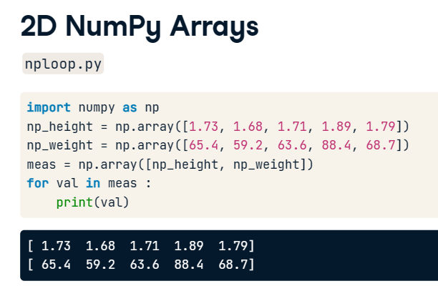 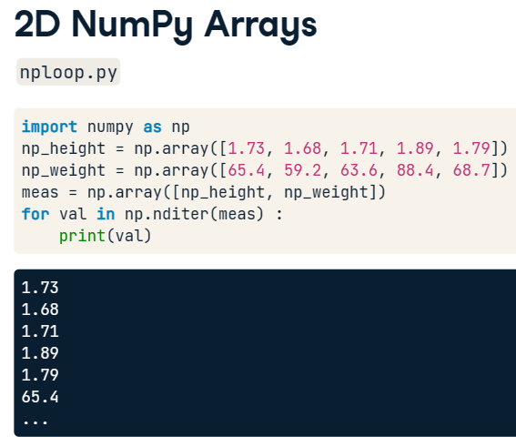

* If you're dealing with a 2D NumPy array, it's more complicated. A 2D array is built up of multiple 1D arrays. To explicitly iterate over all separate elements of a multi-dimensional array, you'll need this syntax:

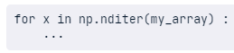

* To get every element of an array, you can use a NumPy function called nditer(). The input is the array you want to iterate over, meas in our case.
* To recap:
  + if you want to iterate over key-value pairs in a dictionary, use the items() method on the dictionary to define the sequence in the for loop.
  + If you want to iterate over all elements in a NumPy array, you should use the nditer() function to specify the sequence.
  + Pay attention here: dictionaries require a method, NumPy arrays use a function.

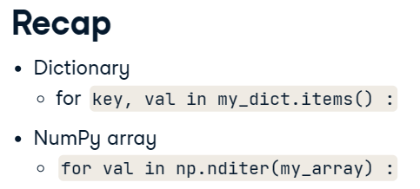

## Pandas – iterrows method

* 这个只返回了列的名字

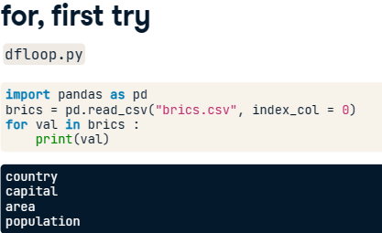

* In Pandas, you have to mention explicitly that you want to iterate over the rows.
* You do this by calling the iterrows method on the brics country, thus specifying another "sequence": The iterrows method looks at the DataFrame, and on each iteration generates two pieces of data: the label of the row and then the actual data in the row as a Pandas Series.
* we store the row label as lab, and the row data as row.
* In the first iteration, lab is BR, and row is this entire Pandas Series. Because this row variable on each iteration is a Series, you can easily select additional information from it using the subsetting techniques you learned about earlier.

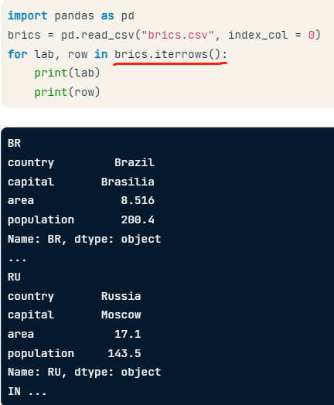

* Suppose you only want to print out the capital on each iteration: let's change the print statement as follows, printing the label and the capital together.

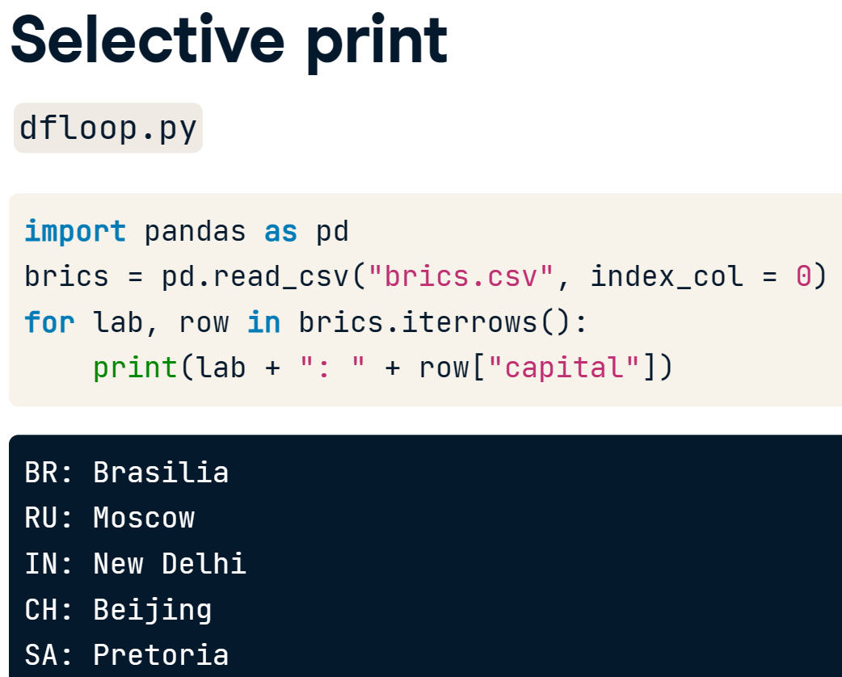

* Iterating over a Pandas DataFrame is typically done with the iterrows() method. Used in a for loop, every observation is iterated over and on every iteration the row label and actual row contents are available
* The row data that's generated by iterrows() on every run is a Pandas Series. This format is not very convenient to print out.
* 另一个例子：注意需要结合数字的话要用到str()功能！！！

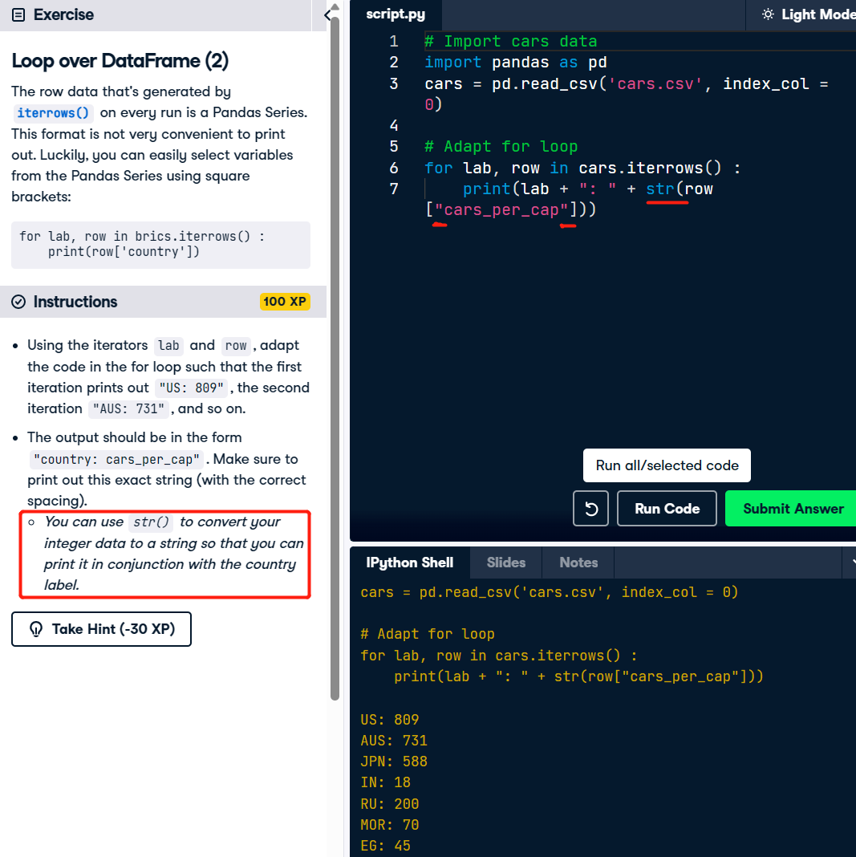

## Pandas – apply() function

* 不是很有效的添加一个额外列的方法for loop + .loc()

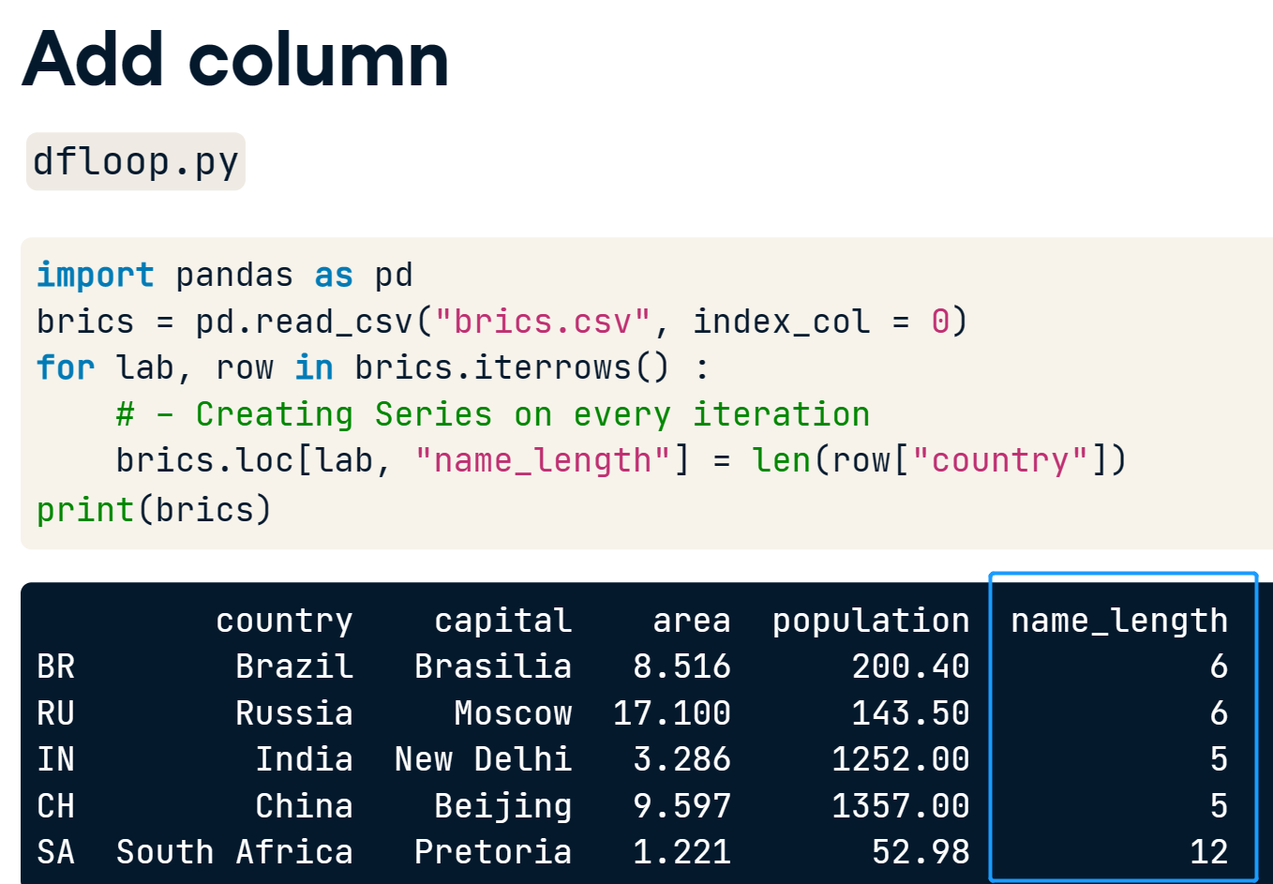

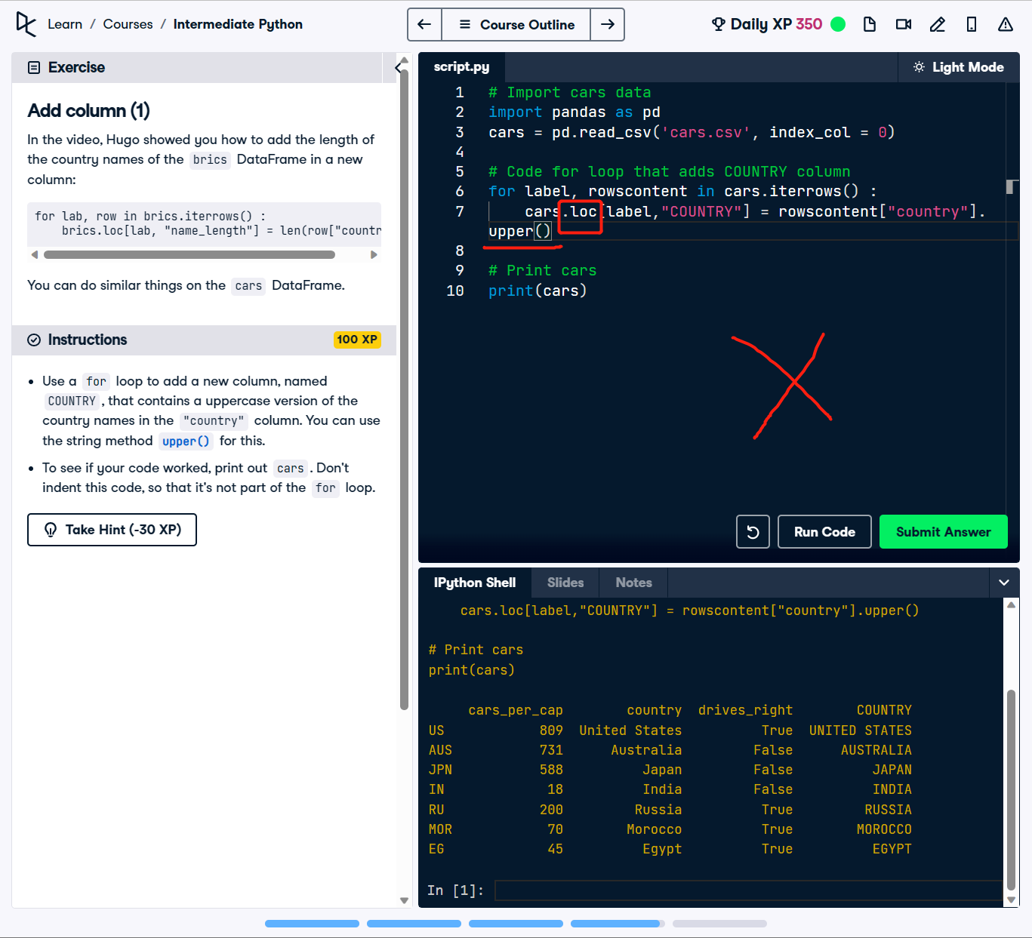

* A way better approach if you want to calculate an entire DataFrame column by applying a function on a particular column in an element-wise fashion, is apply().
* In this case, you don't even need a for loop.
* Basically, you're selecting the country column from the brics DataFrame, and then, on this column, you apply the len function. Apply calls the len function with each country name as input and produces a new array, that you can easily store as a new column, "name\_length".

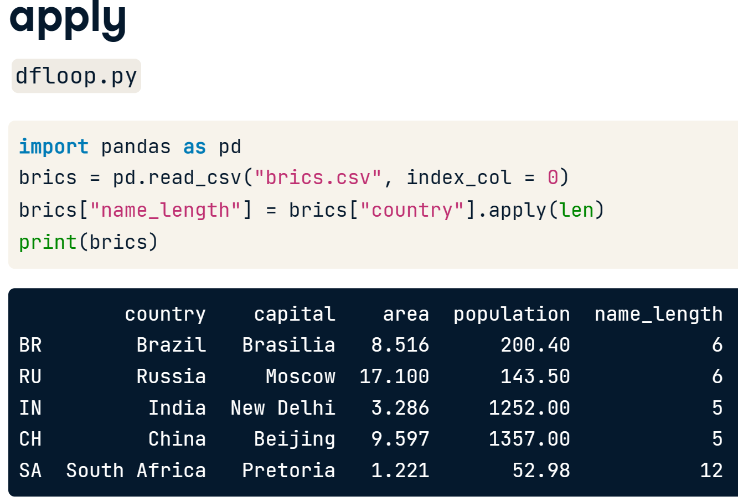

* 另外一个例子。这里注意的是利用大写功能upper()在apply()功能里面的时候用str.upper >> 原因是**[upper()](https://docs.python.org/3/library/stdtypes.html" \l "str.upper" \t "_blank)** is a **method**

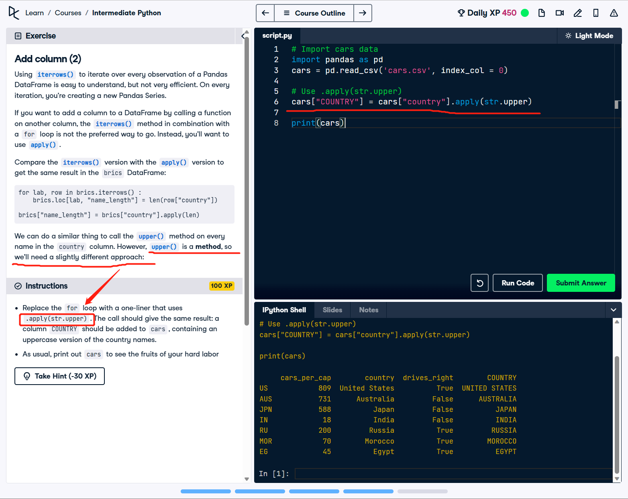

# 06/03/23 Case Study: Hacker Statistics

## Np.random.rand() & Np.random.seed()

* Inside numpy, there is the random package. Inside that package we find the "rand" function.
* we get a random number between zero and one.
* How was this random number created? Well, computers typically generate so-called pseudo-random numbers伪随机数. Those are random numbers that are generated using a mathematical formula, starting from a random seed. This seed was chosen by Python when we called the rand function, but you can also set this manually.
* Suppose we set it to 123, just a number I chose, like this, and then call the rand function twice. We get two random numbers.

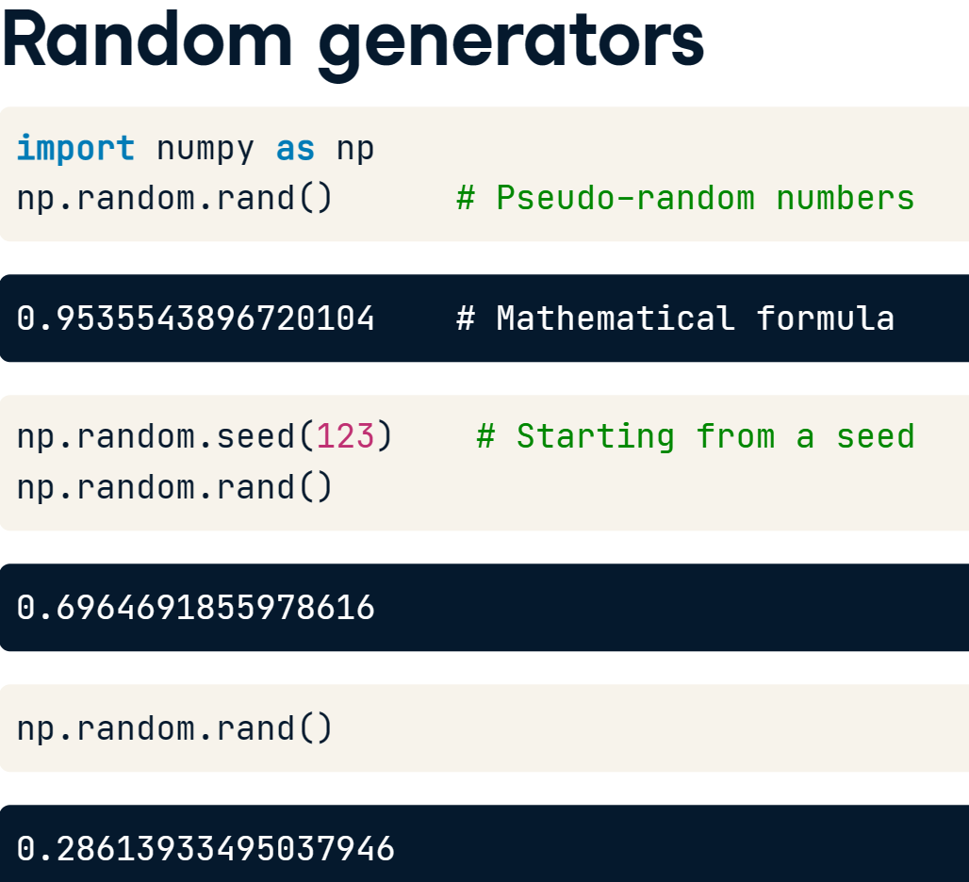

* if I set the seed back to 123, and call rand twice more, we get the exact same random numbers.
* This is funky: you're generating random numbers, but for the same seed, you're generating the same random numbers.
* That's why it's called pseudo-random; it's random but consistent between runs; this is very useful, because this ensures "reproducibility".
* seed(): sets the random seed, so that your results are reproducible between simulations. As an argument, it takes an integer of your choosing. If you call the function, no output will be generated.
* rand(): if you don't specify any arguments, it generates a random float between zero and one.

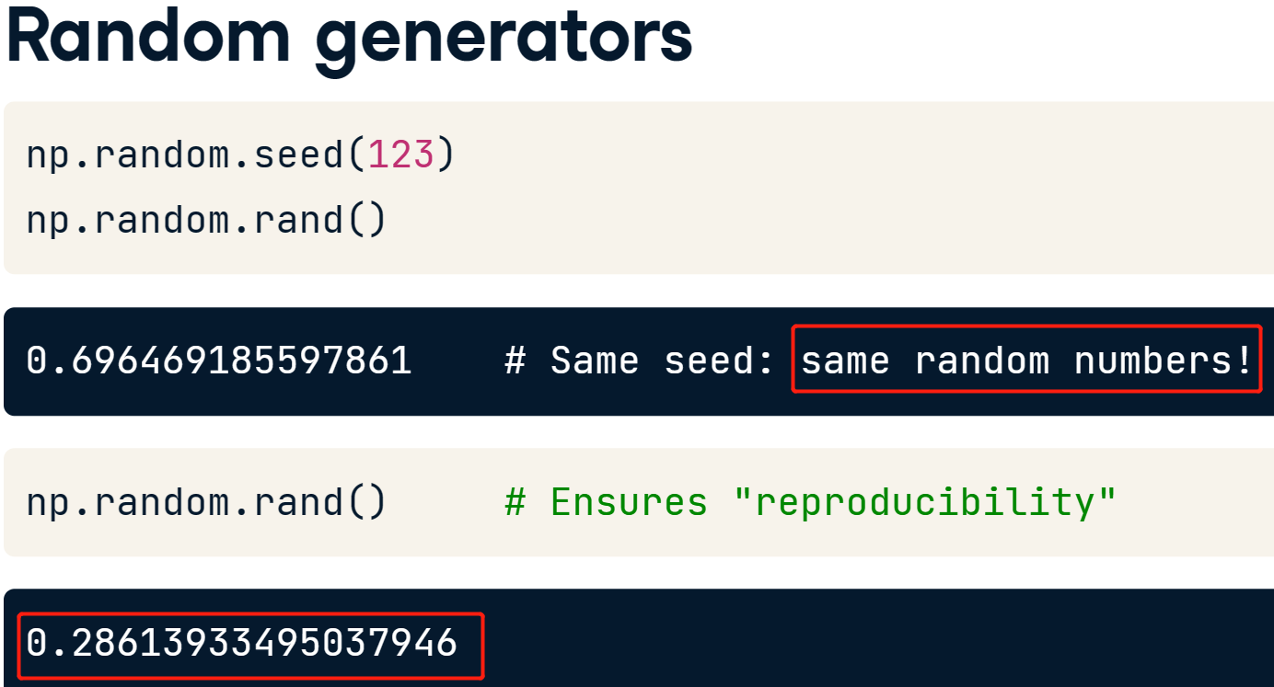

## Np.randint()

* 扔骰子的例子。2在右边括号不会被包含

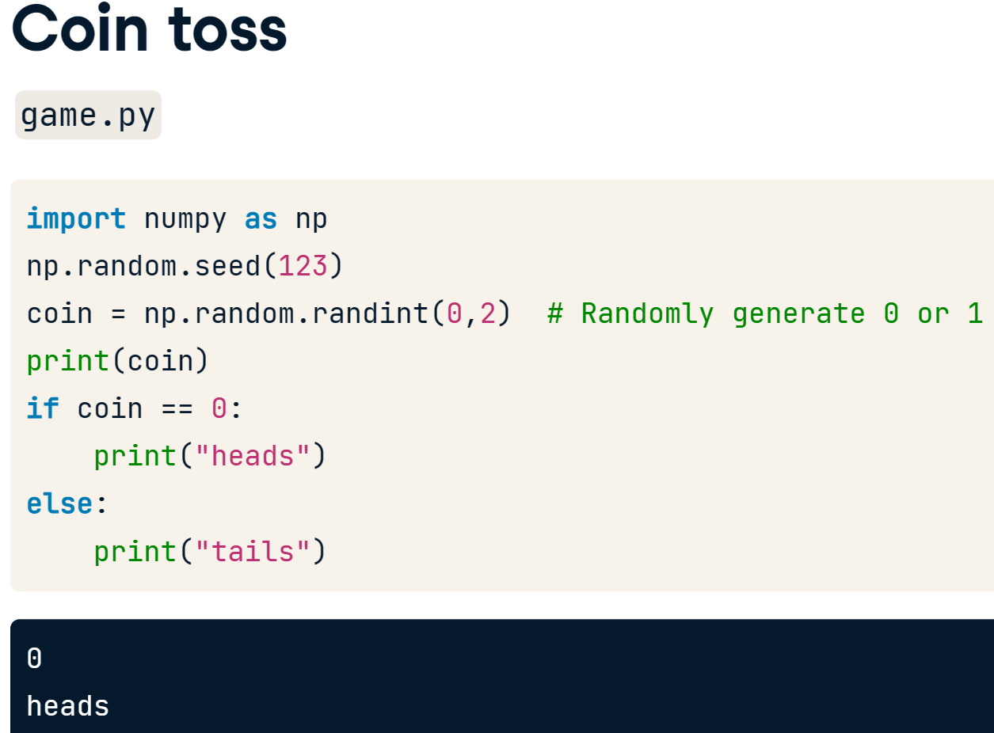

* you can just as well use randint(), also a function of the random package, to generate integers randomly.

## Random walk

* we initialize an empty list "outcomes".
* we build a for loop that should run 10 times. We can do this with the range() function, that generates a list of numbers that you can use to iterate over.
* Inside this for loop, we generate a random integer coin that's either zero or one. Zero corresponds to heads, 1 to tails. If coin is zero, we append the string heads to the list. Else, we append the string tails. In both cases, we do this with the append method, which you learned about in the intro course. Finally, we print the outcomes list we've built up in these 10 iterations. If we run this script, eventually a list with 10 strings will be printed out.
* This list is random, but it's not a random walk, because the items in the list are not based on the previous ones. It's just a bunch of random steps.

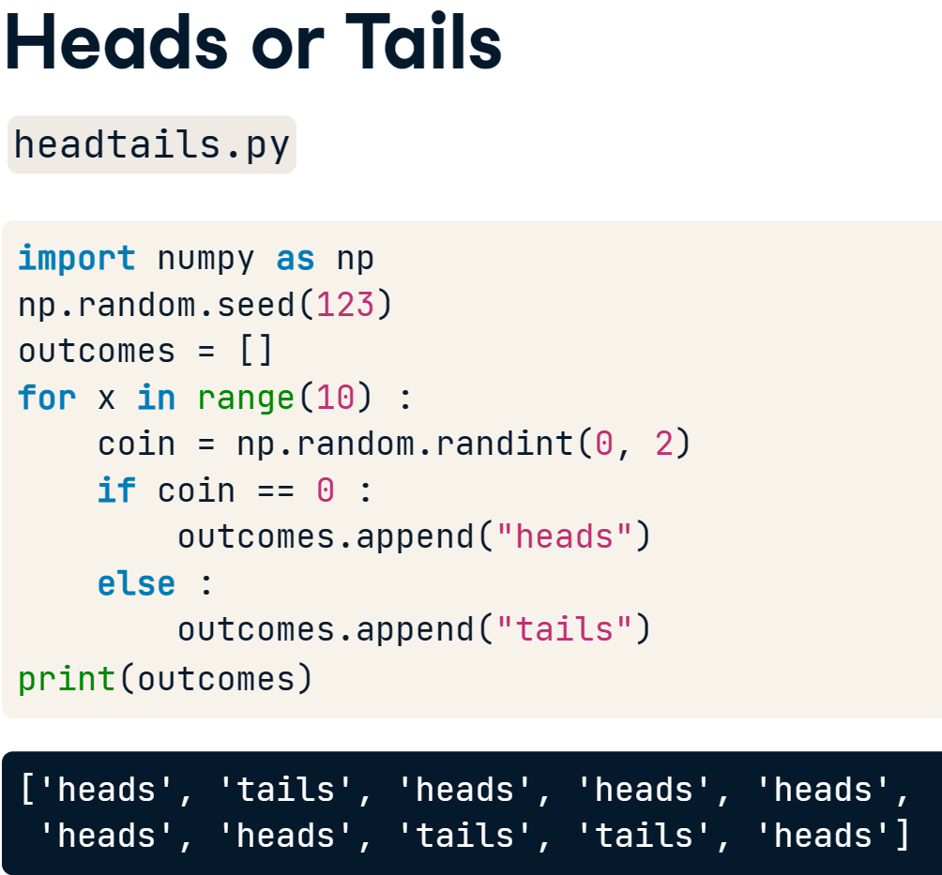

* Random walk
* start by creating a list, tails, that already contains the number 0, because at the start, you haven't thrown any tails. Then you again start a for loop that runs 10 times, using the range function. In there, you again generate a random number.
* Instead of the if-else structure, you can simplify things. If coin is 0, so heads, the number of tails you've thrown shouldn't change. If a 1 is generated, the number of tails should be incremented with 1. This means that you can simply add coin to the previous number of tails, and add this count to the list with append. Finally, you again print the list tails. After running this script, a list with 11 elements will be printed out.
* The final element in this list tells you how often tails was thrown.

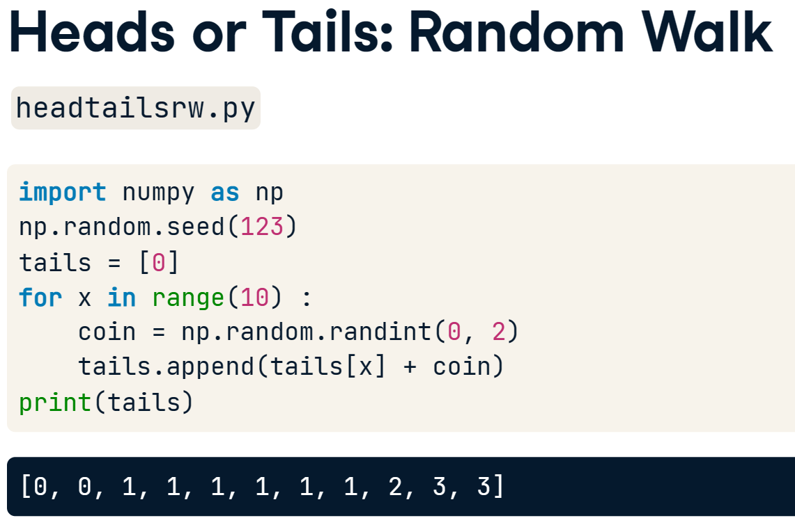

* 另一个例子。得到最后一个element用index = -1
* 用.append()去修改

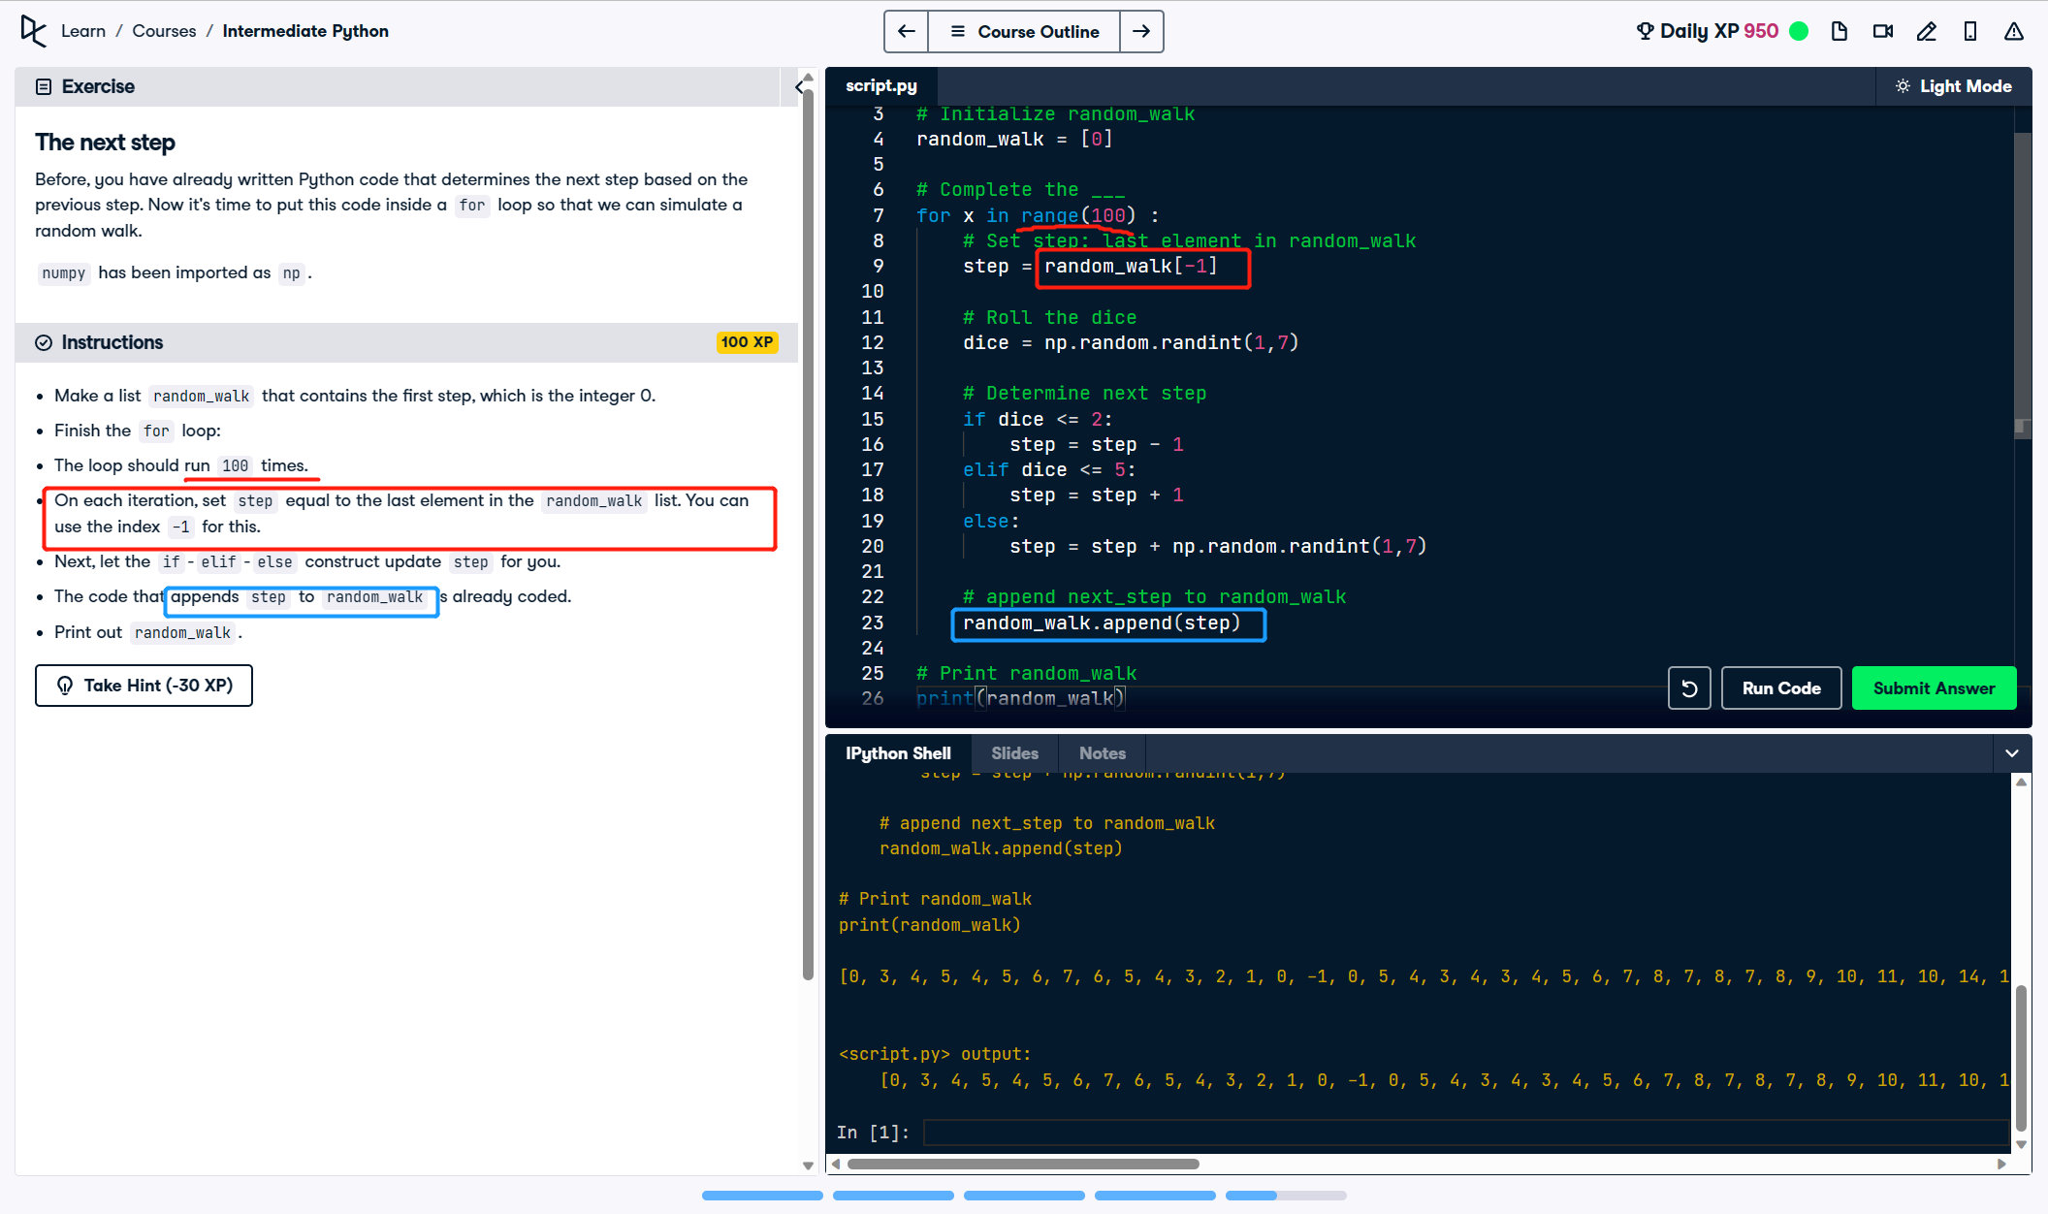

* 用max()确保不会小于0
* 用matplotlib画线状图
* plt.plot(x, y) >> The first list you pass is mapped onto the x axis and the second list is mapped onto the y axis.
* If you pass only one argument, Python will know what to do and will use the index of the list to map onto the x axis, and the values in the list onto the y axis.

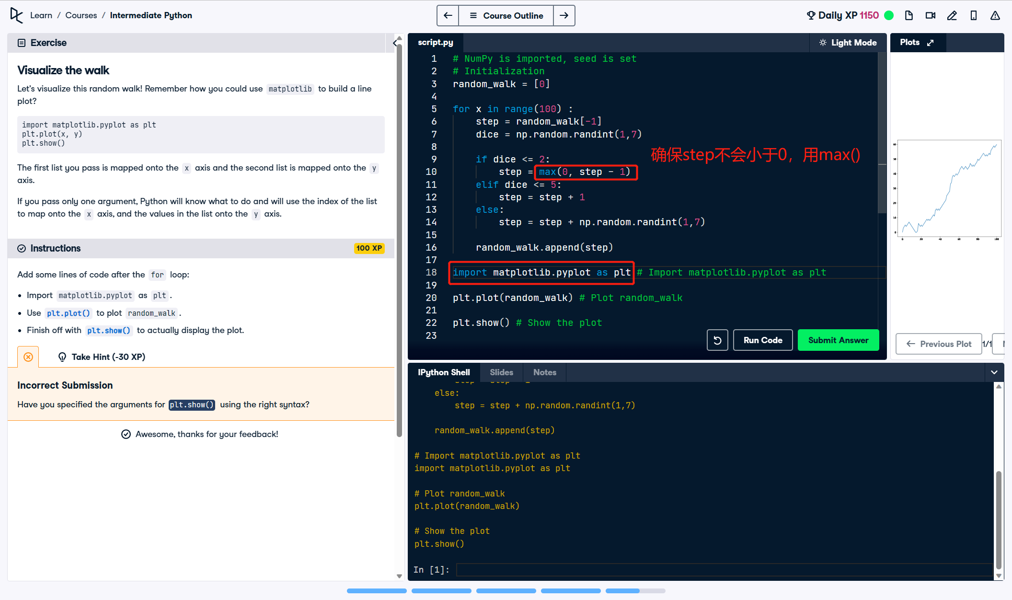

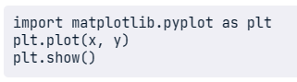

## Distribution of random walk – matplotlib.pyplot

* To find the distribution of this walk, we start by setting a random seed, and then create an empty list named final\_tails.
* Inside this for loop, we put the code from before, that gradually builds up the tails list. After simulating this single game, we append the last number, so the number of tails after tossing 10 times, to the final\_tails list.
* Notice that the indentation here specifies that this last line is part of the top-level for loop. If you put a last line in here to print final\_tails, outside of the for loops, and run the script, you see that final\_tails contains numbers between 0 and 10. Each number is the number of tails that were thrown in a game of 10 tosses.
* All these values actually represent a distribution, that we can visualize. Hmm, visualizing a distribution, that calls for a histogram!

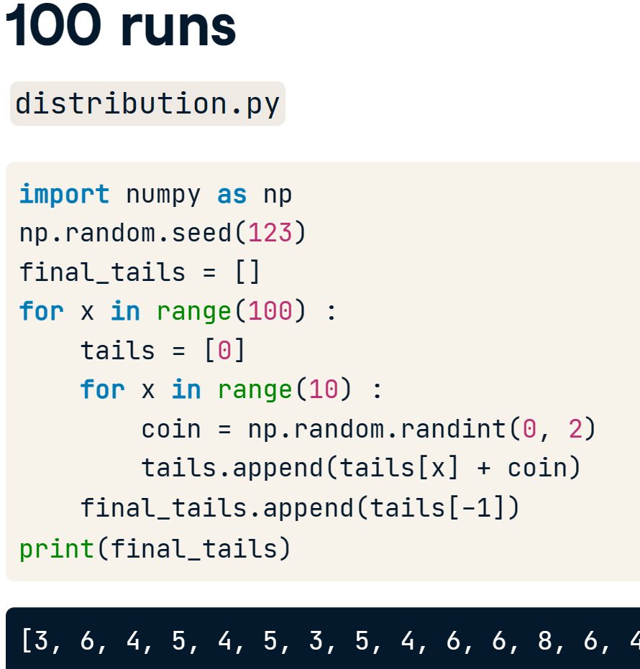

* Plt.hist()

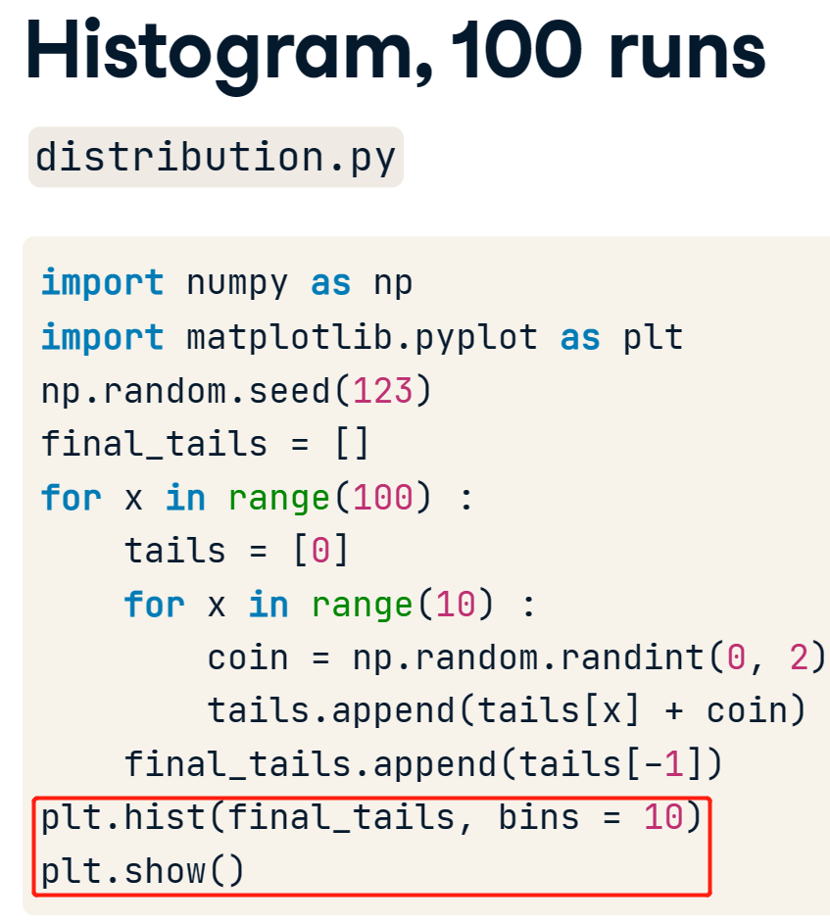 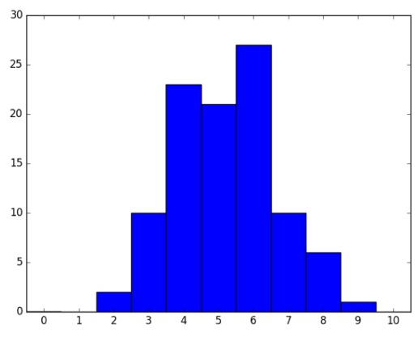

* 1000 runs = 10 \* 100

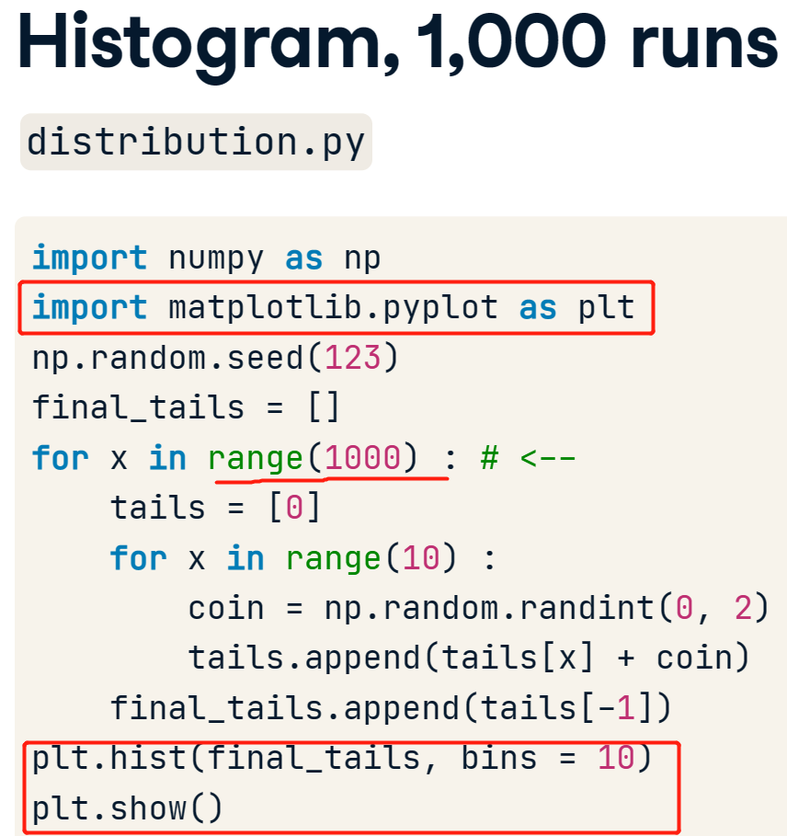

## plt.clf() - clear the figure

* clear the plot so it doesn't get cluttered if you run this many times
* 把0.05%可能直接掉下0的可能性考虑进来

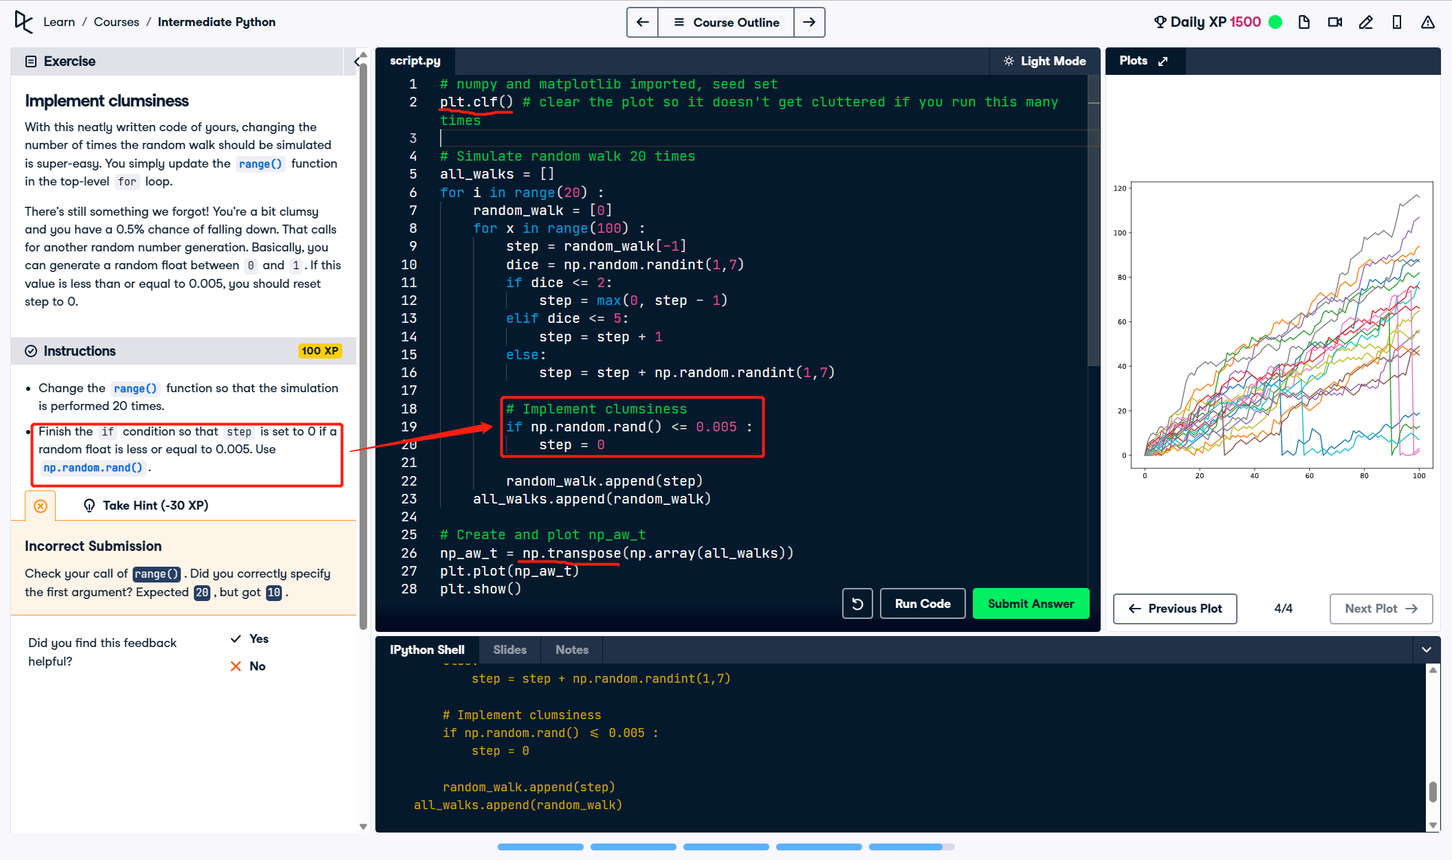

* last row写法是[-1,:]

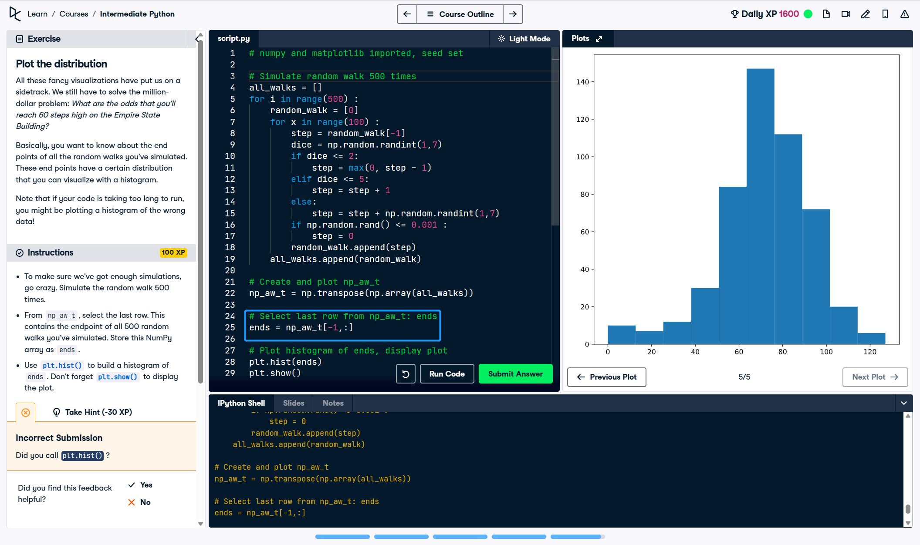

# 06/04/23 【**Python Data Science Toolbox (Part 1)】**

## User-defined functions

* To define the function, We begin with the keyword def, followed by the function name square; this is then followed by a set of parentheses and a colon. This piece of code is called a function header.
* To complete the function definition, let's write the function body by squaring a value, say 4, and printing the output. Right now, our square function does not have any parameters within the parentheses. We will add them later.
* Now, whenever this function is called, the code in the function body is run. In this case, new\_value is assigned the value of 4 \*\* 2 and then printed out. You can call the function as you do with pre-built functions: square. This should yield the value, 16.

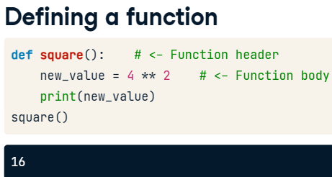

* What if you wanted to square any other number besides 4, though?
* To add that functionality, you add a parameter to the function definition in between the parentheses. Here you see that we've added a parameter value and in the new function body, the variable new\_value takes the square of value, which is then printed out. We can now square any number that we pass to the function square as an argument.
* A quick word on parameters and arguments: when you define a function, you write parameters in the function header. When you call a function, you pass arguments into the function.
* “value”是定义的parameters
* New\_value是我们的variable

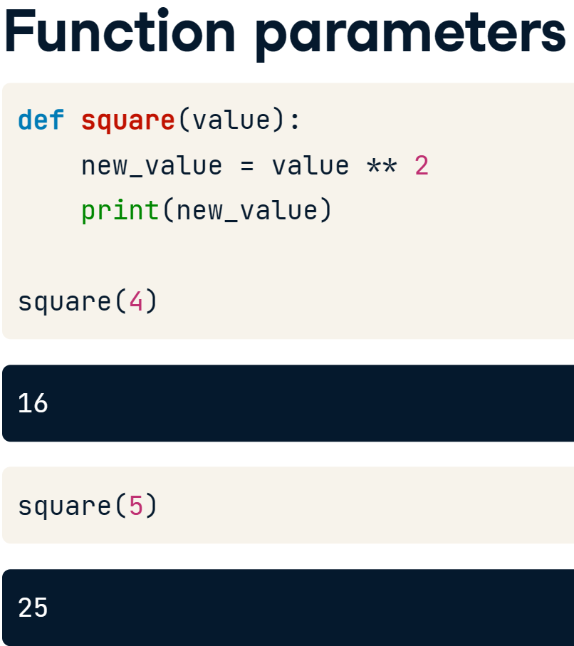

* 把计算出来的值用在其他的变量上的时候就需要return

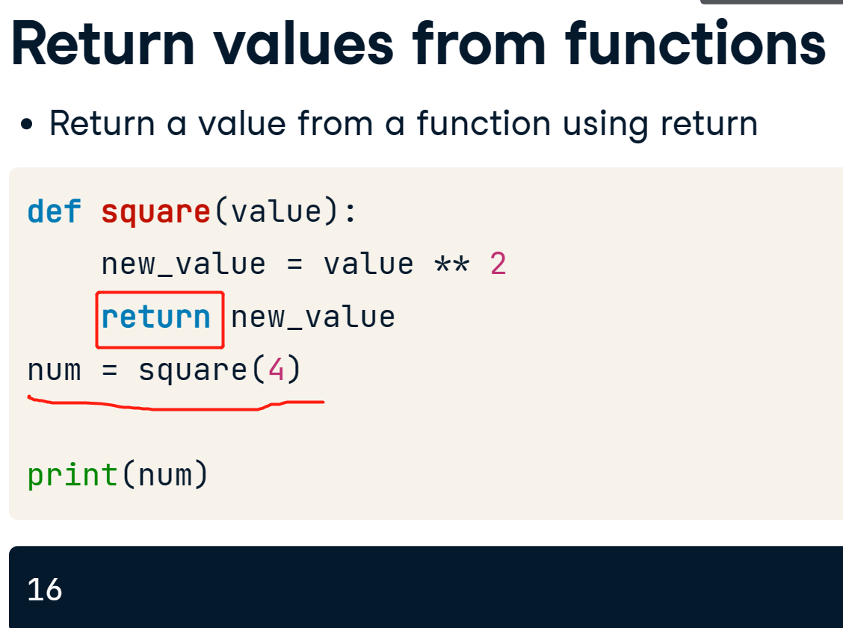

* Docstrings - describe what your function does, such as the computations it performs or its return values.
* Function docstrings are placed in the immediate line after the function header and are placed in between triple quotation marks.

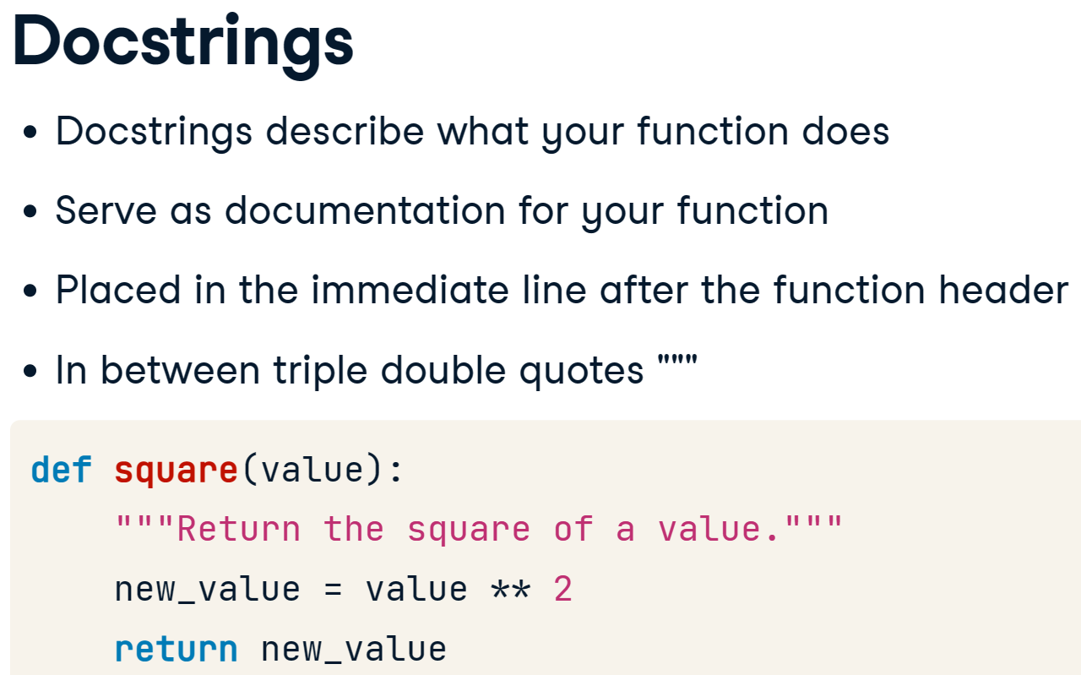

* It is important to remember that assigning a variable y2 to a function that prints a value but does not return a value will result in that variable y2 being of type NoneType.

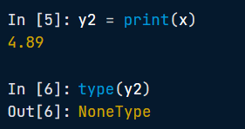

## Single-parameter functions

* 注意str(word)
* 注意最后print的是shout('congratulations’)有单引号的
* Word是parameter

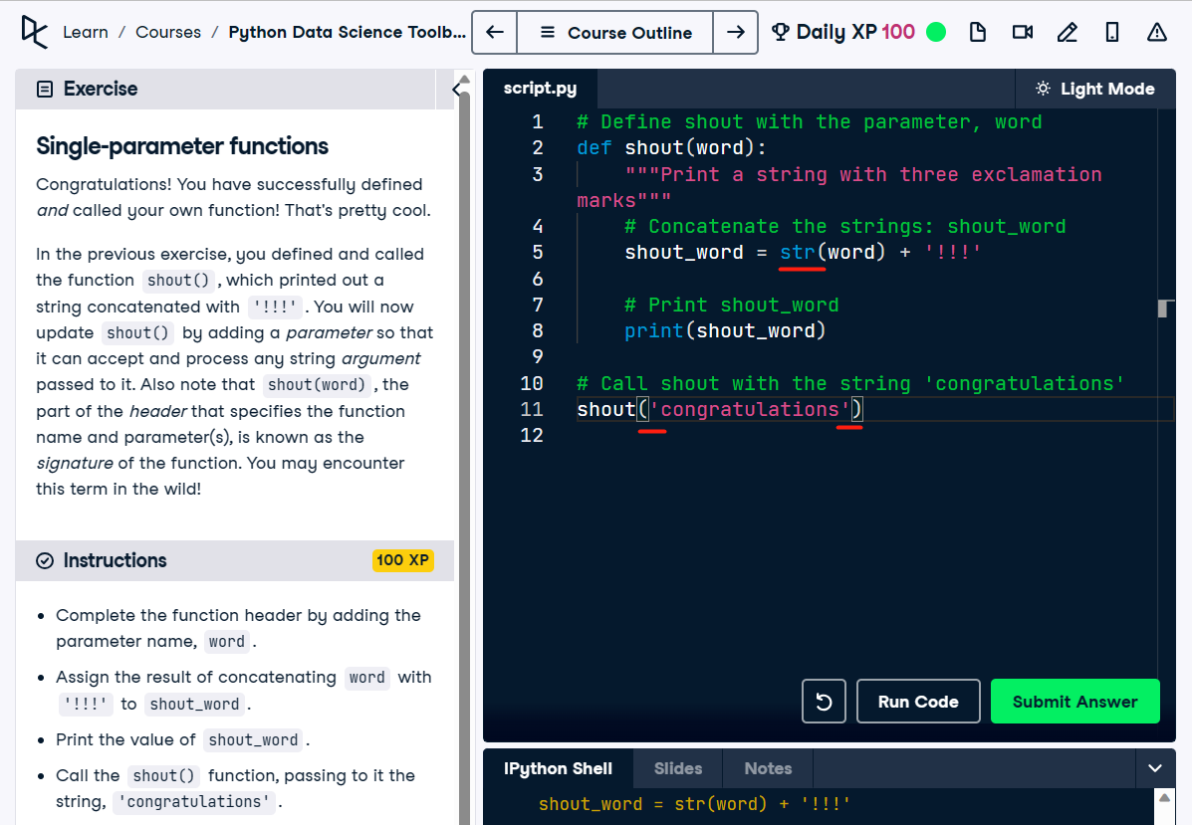

## Functions that return single values

* 注意 return的东西

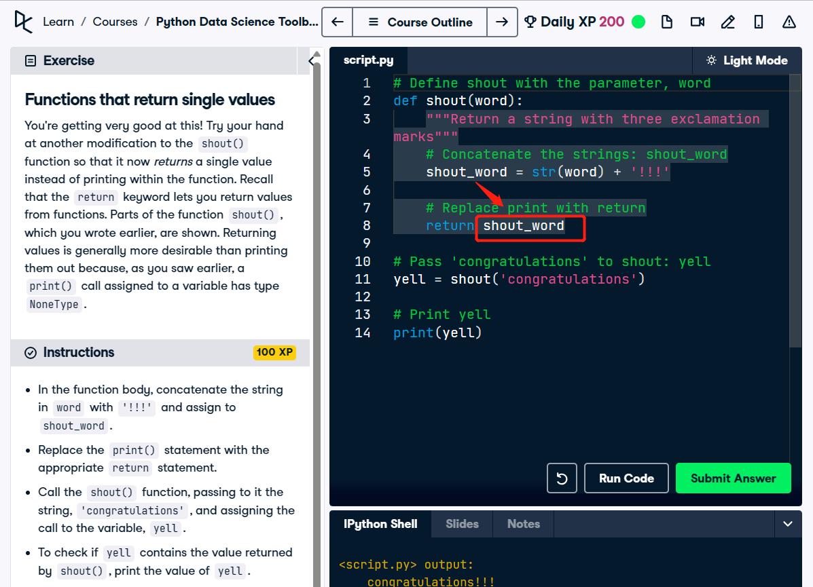

## Tuples

* You can also make your function return multiple values.
* A tuple is like a list, in that it can contain multiple values.
* There are some differences, however. Firstly, unlike a list, a tuple is immutable, that is, you cannot modify the values in a tuple once it has been constructed.
* Secondly, while lists are defined using square brackets, tuples are constructed using a set of parentheses.

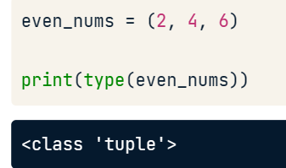

* Here we construct a tuple containing 3 elements. You can also unpack a tuple into several variables in one line. Doing so means that you assign to the variables a, b, and c the tuple values, in the order that they appear in the tuple.

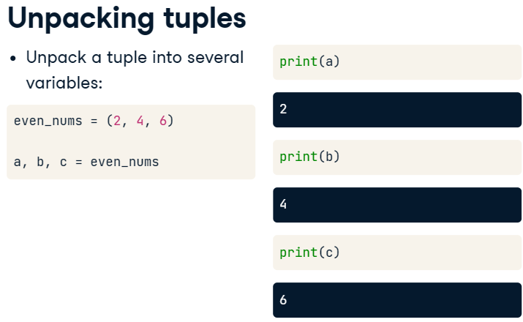

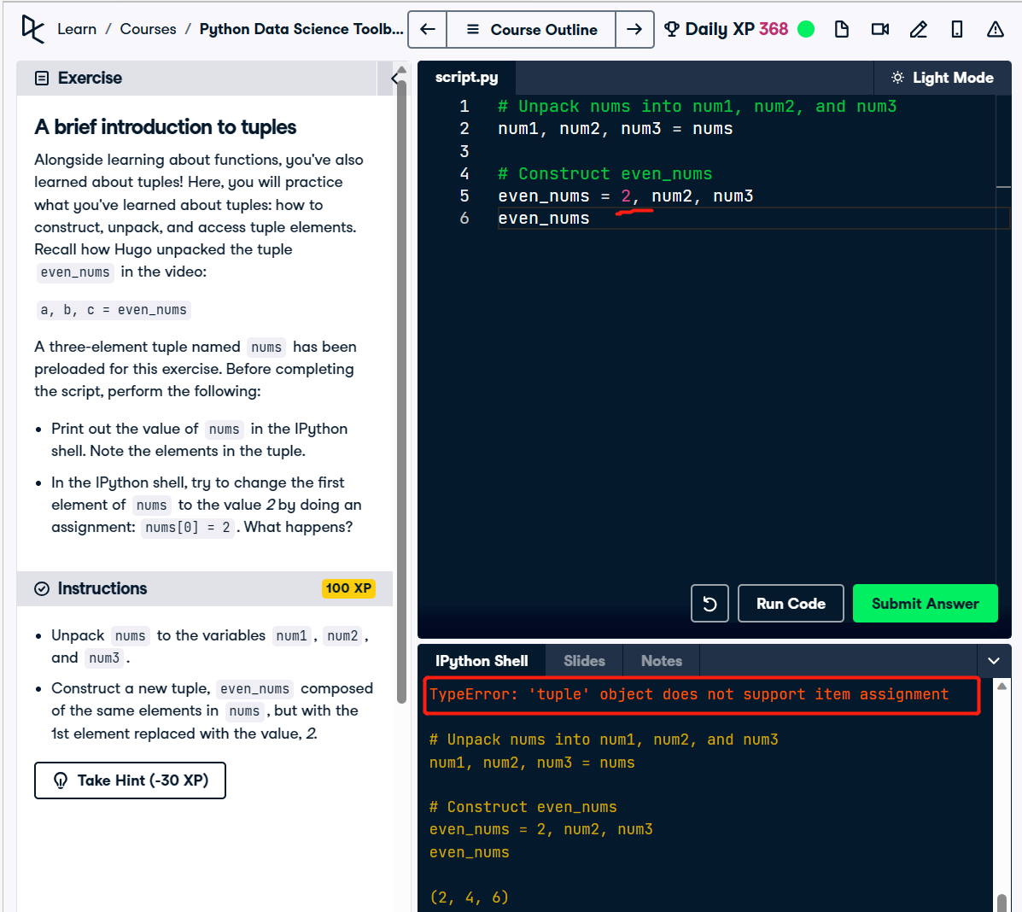

## Functions with multiple parameters

* 一个例子

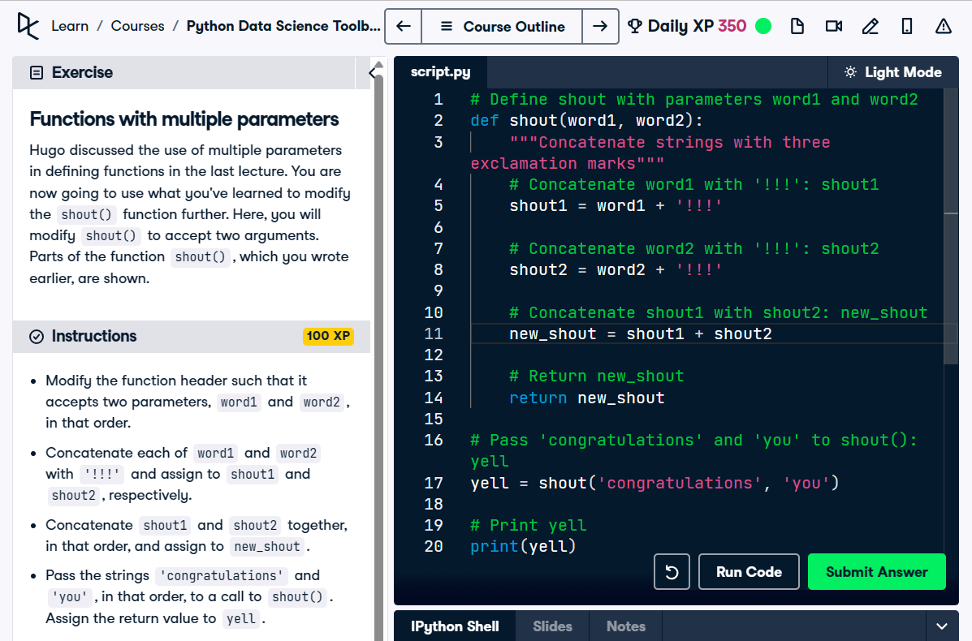

* 注意这个例子里面本身shout\_all() 就带有了两个变量所以返回的时候对应的会有yell1和yell2

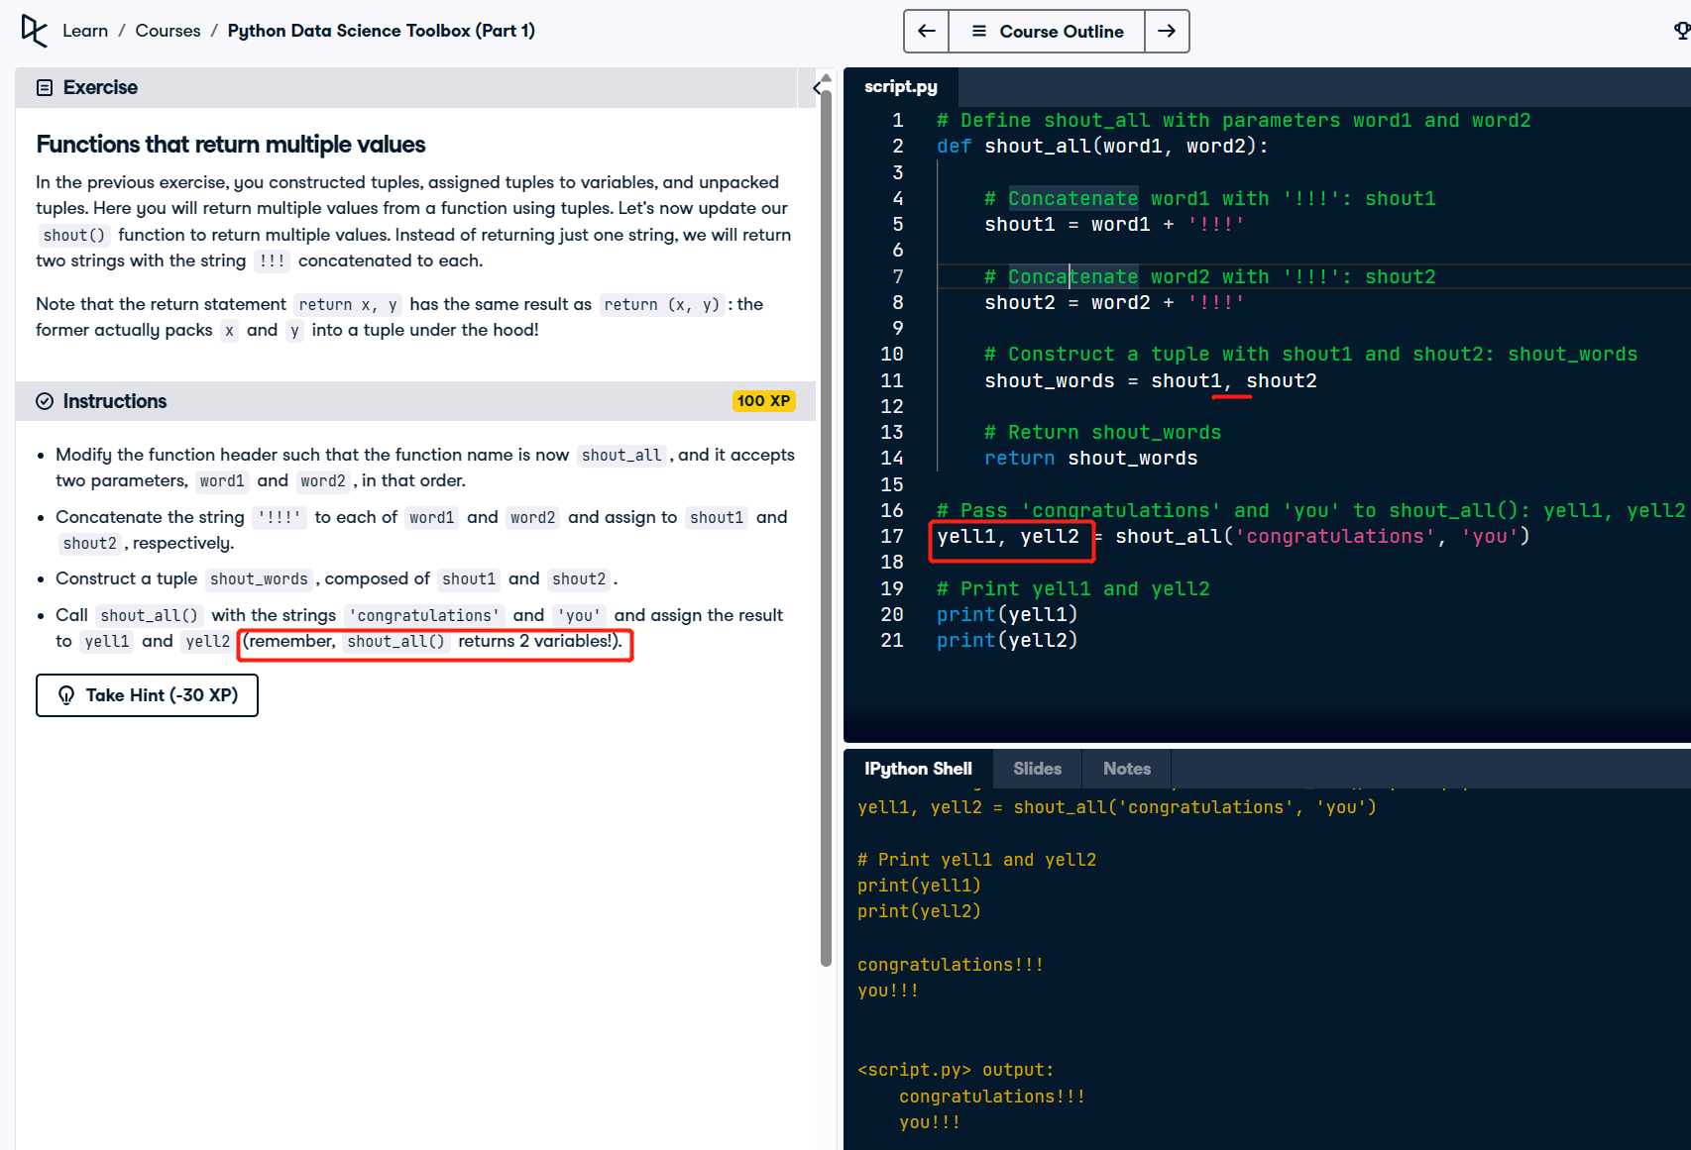

## Function的结构总结

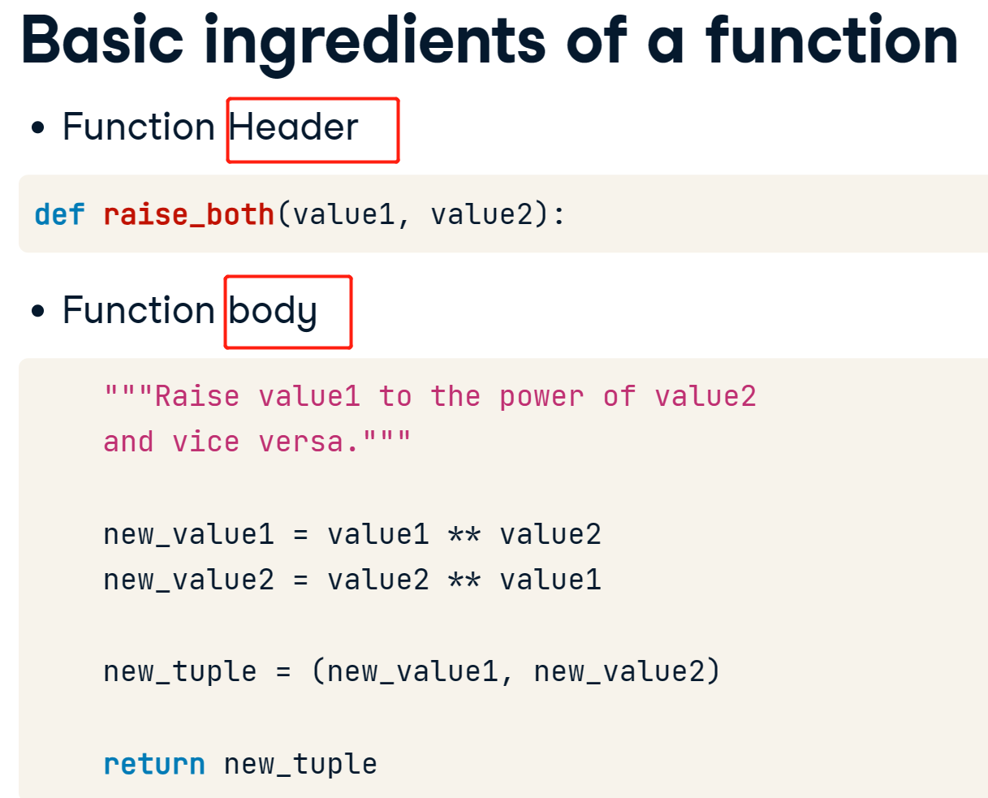

## 整合的例子

* 注意导入excel的时候用pd.read\_csv！！！不要忘记pd.
* 这里有个空的字典看看写法
* += 1说明原来的数据上再加1后赋值给那个变量

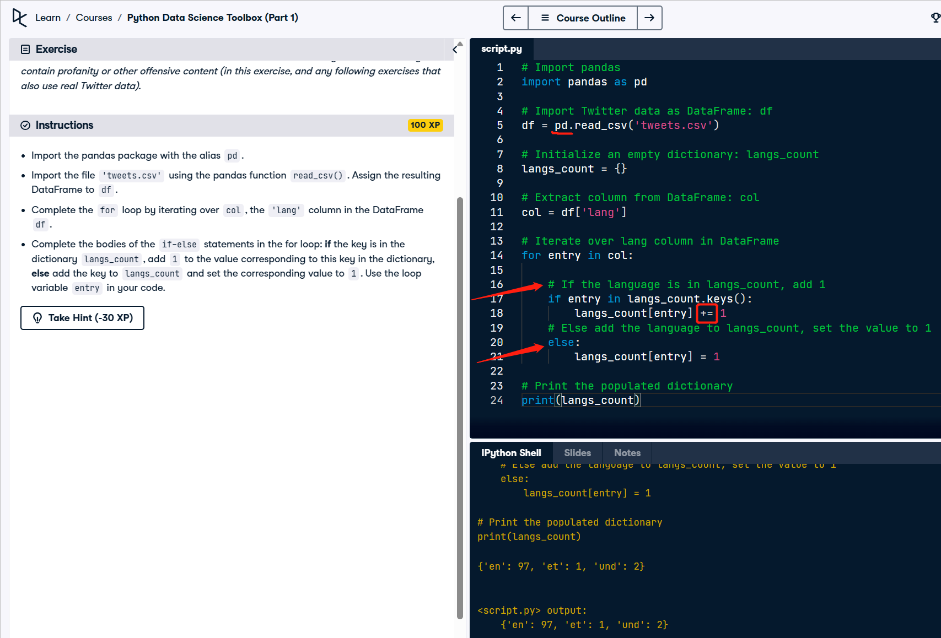

* 一个例子

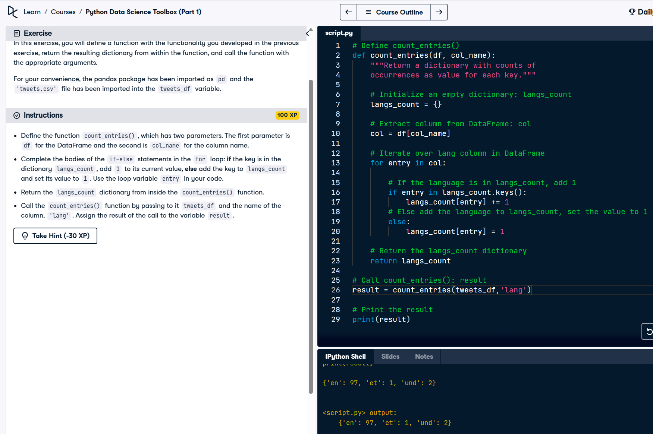

# 06/12/23 Default arguments, variable-length arguments and scope

* However, one thing you should know is that not all objects that you define are always accessible everywhere in a program. Enter the idea of scope, which tells you which part of a program an object or a name may be accessed.
* Names refer to the variables or, more generally, objects such as functions that are defined in your program, for example, a variable x has a name, as does the function sum.
* There are 3 types of scope that you should know.
* The first one is the idea of the global scope. A name that is in the global scope means that it is defined in the main body of a script or a Python program.
* The second one, is the local scope. A name that is in a local scope means that it is defined within a function. Once the execution of a function is done, any name inside the local scope ceases to exist, which means you cannot access those names anymore outside of the function definition.
* The third is something called the built-in scope: this consists of names in the pre-defined built-ins module Python provides, such as print and sum. You'll play around with the built-ins module in the interactive exercises.

## Global vs Local Scope

* If we then try to access the variable name new\_val after function execution, the name is not accessible.
* This is because it was defined only within the local scope of the function. The name new\_val was not defined globally.

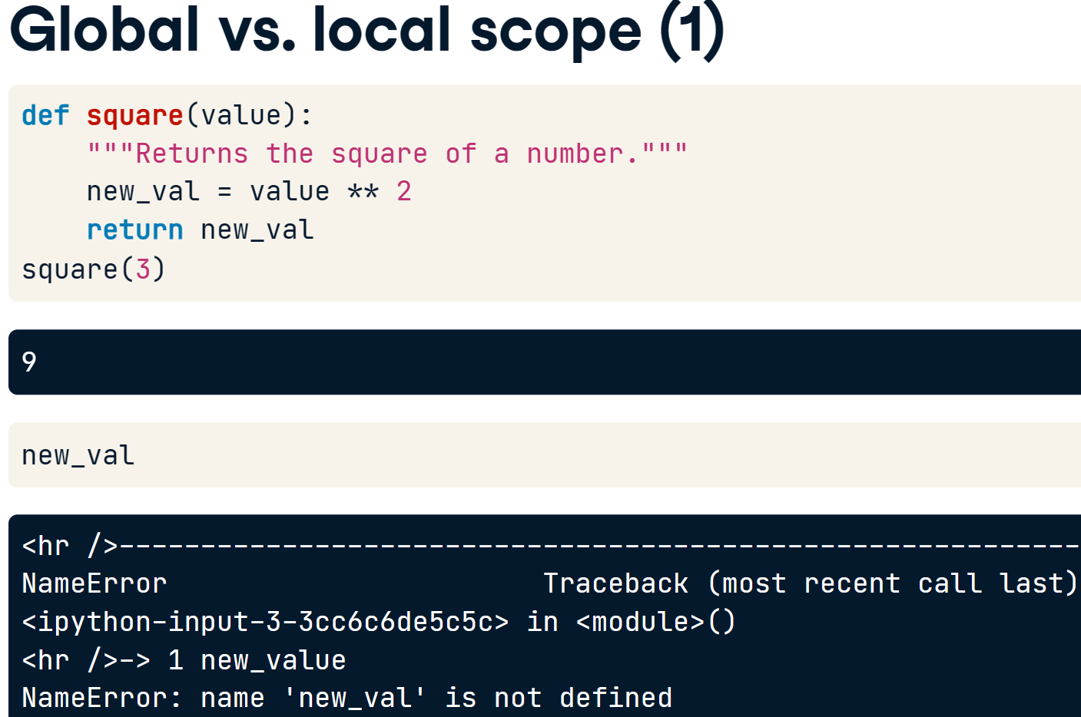

* Global
* Any time we call the name in the local scope of the function, it will look first in the local scope.
* That's why calling square(3) results in 9 and not 10.
* If Python cannot find the name in the local scope, it will then and only then look in the global scope.

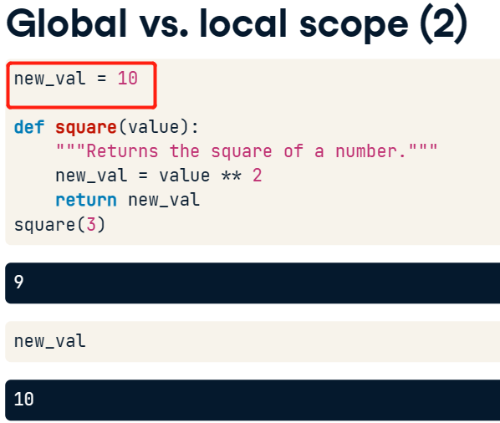

## Buiilins()

* Python's built-in scope, which is really just a built-in module called builtins. However, to query builtins, you'll need to import builtins 'because the name builtins is not itself built in…
* execute dir(builtins) to print a list of all the names in the module builtins.

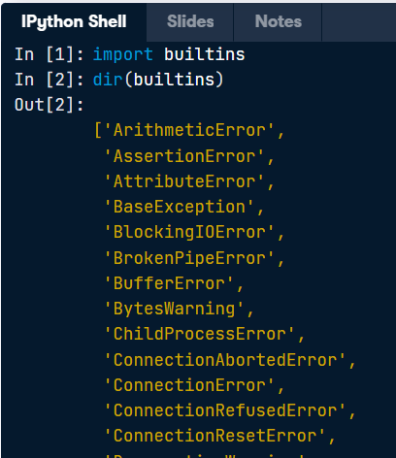

## Nonlocals

* The nonlocal keyword is used to work with variables inside nested functions, where the variable should not belong to the inner function.

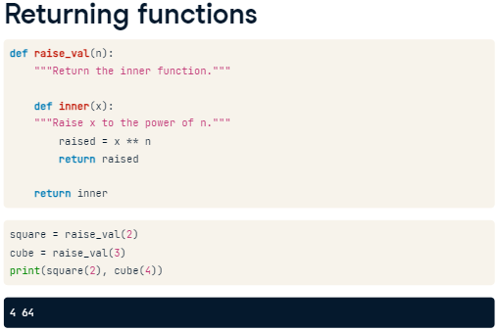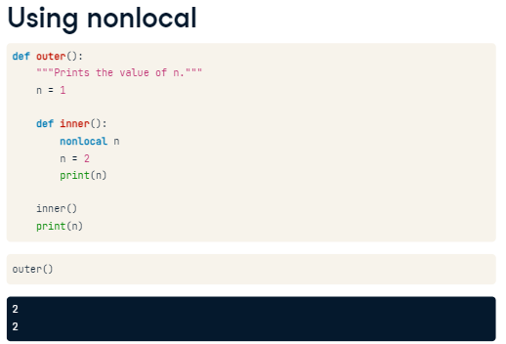

* you can use the keyword nonlocal to create and changes names in an enclosing scope. In this example, we alter the value of n in the inner function; because we used the keyword nonlocal, it also alter the value of n in the enclosing scope. This is why calling the function outer prints the value of n as determined within the function inner.
* 不能在函数的外部函数里面声明nonlocal
* nonlocal 可以用于内部函数访问外部函数的局部变量，但是无法访问全局变量。
* 如果要在嵌套函数中访问全局变量，需要使用 global 关键字。

## Scopes Searches

* To summarize: name references search at most four scopes, the local scope, then those of enclosing functions, if there are any; then global, then built-in. This is known as the LEGB rule, where L is for local, E for enclosing, G for global and B for built-ins!
* Also, remember that assigning names will only create or change local names, unless they are declared in global or nonlocal statements using the keyword global or the keyword nonlocal, respectively.

## Flexible arguments: \*args, \*\*kwargs

* 我们并不是一定要写成\*args 和 \*\*kwargs，关键是前面的\* 和 \*\*,换句话说，我们也可以\*var 和 \*\*var
* \*args 必须放在 \*\*kwargs 的前面，因为位置参数在关键字参数的前面。

\*kwargs

* You can also use a double star to pass an arbitrary number of keyword arguments, also called kwargs, that is, arguments preceded by identifiers.
* This turns the identifier-keyword pairs into a dictionary within the function body. Then, in the function body all we need to do is to print all the key-value pairs stored in the dictionary kwargs. Note that it is NOT the names args and kwargs that are important when using flexible arguments, but rather that they're preceded by a single and double star, respectively.

# 12/07/23 Lambda functions and error-handling

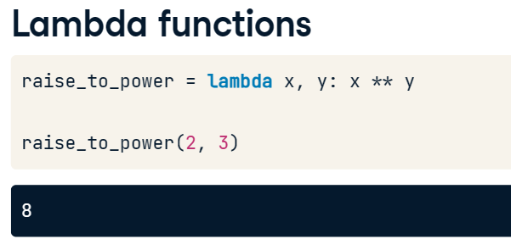

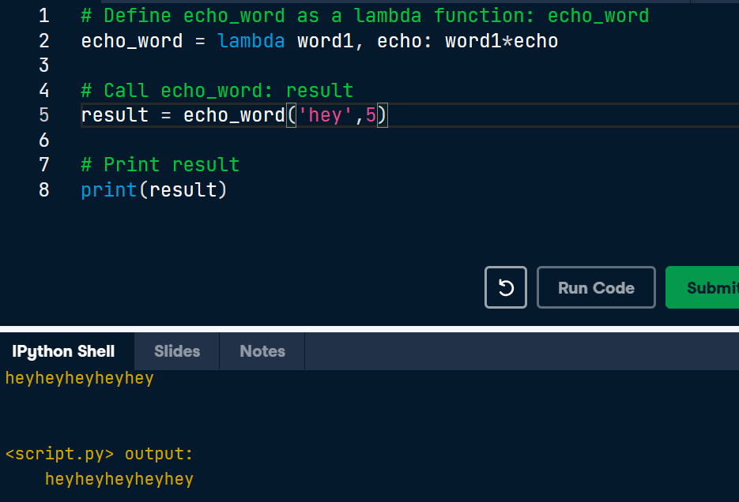

## Map() and lambda functions

* The best use case for lambda functions, however, are for when you want these simple functionalities to be anonymously embedded within larger expressions. What that means is that the functionality is not stored in the environment, unlike a function defined with def. To understand this idea better, you will use a lambda function in the context of the map() function.
* map() applies a function over an object, such as a list.
* Here, you can use lambda functions to define the function that map() will use to process the object.

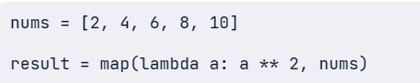

## Filter() and lambda functions

* The function filter() offers a way to filter out elements from a list that don't satisfy certain criteria.

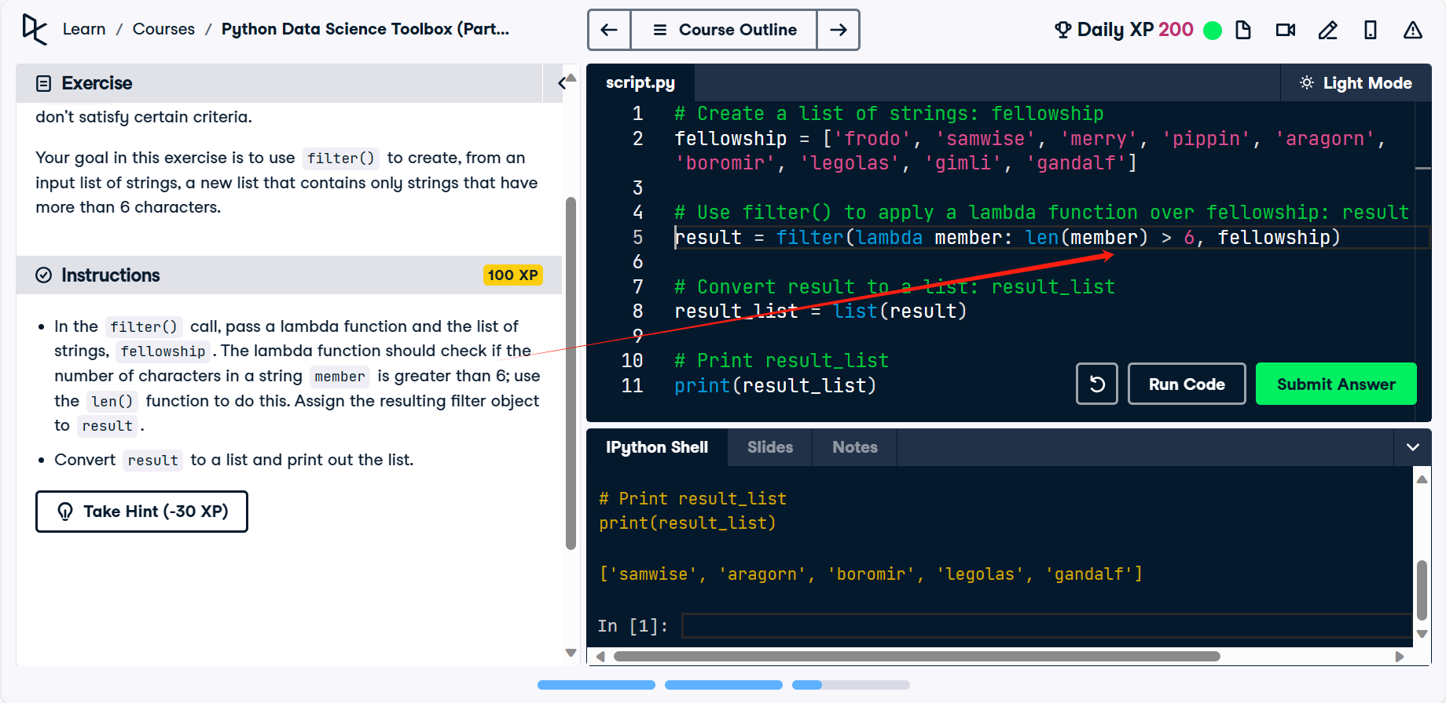

## Reduce() and lambda functions

* The reduce() function is useful for performing some computation on a list and, unlike map() and filter(), returns a single value as a result.
* To use reduce(), you must import it from the functools module.
* “concatenates “ 一般是指把两个放在一起: item 1 + item 2酱紫

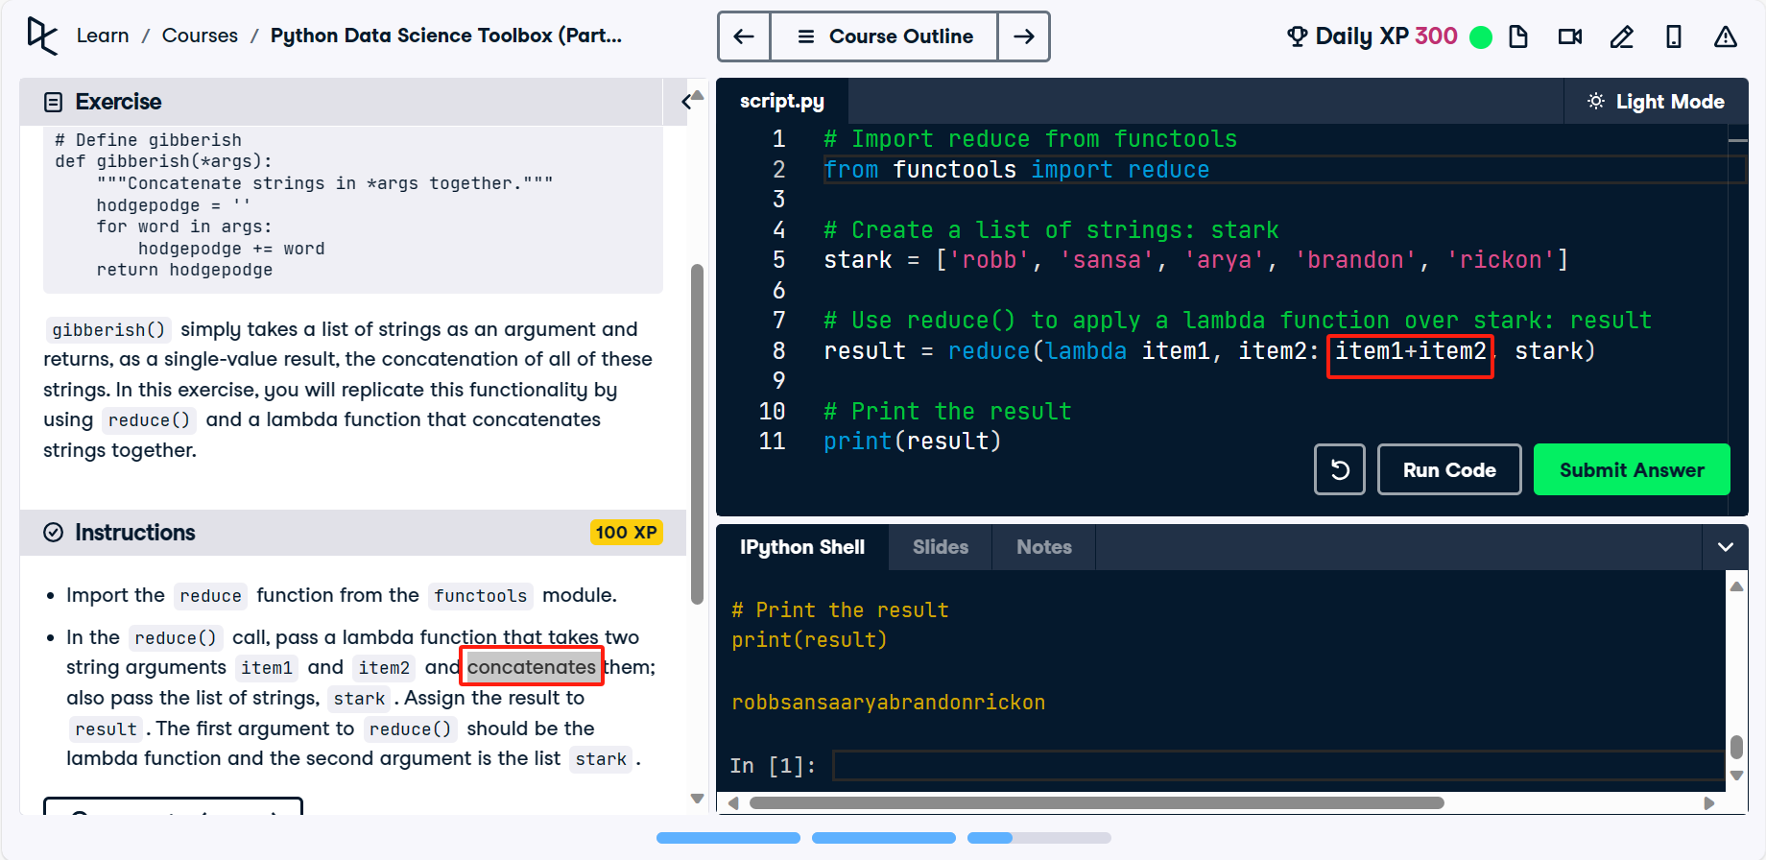

## Error handling: Try-Except, Raise

* Try-Except

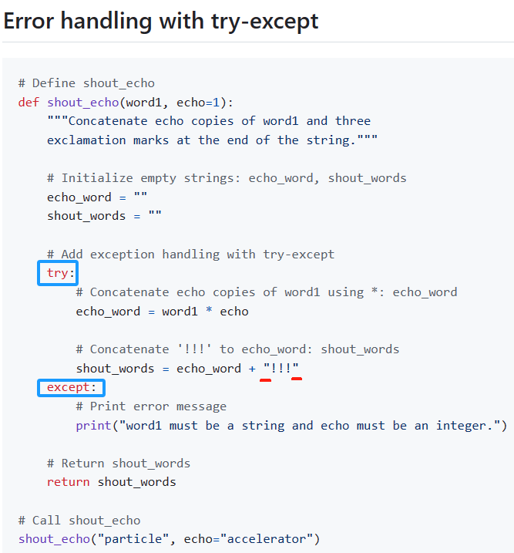

* add a raise statement to the shout\_echo() function you defined before to raise an error message when the value supplied by the user to the echo argument is less than 0.
* In the body of the if statement, add a raise statement that raises a ValueError with message 'echo must be greater than or equal to 0' when the value supplied by the user to echo is less than 0.

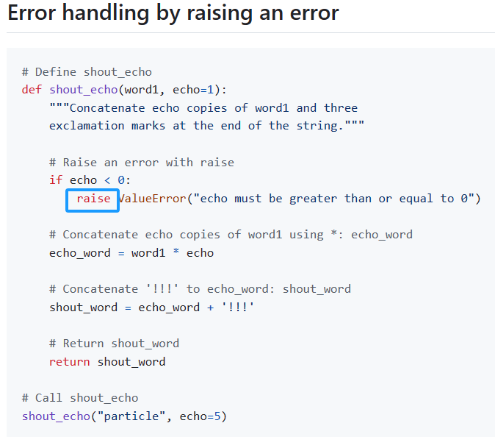

## Cases

* 注意用x[0:2]来找出text前两位
* 注意filter()里面后者放的是筛选的对象

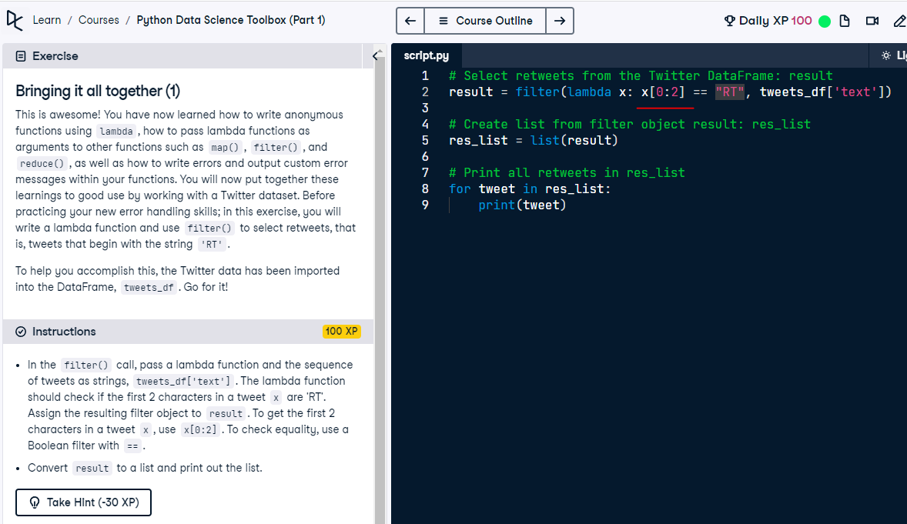

# 12/14/23 **【Python Data Science Toolbox (Part II)】**

## Iterators vs Iterables

* Iterators vs iterables

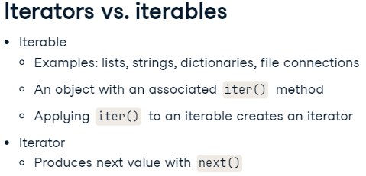

* 我们一般称Iterable为可迭代对象。Python 中任意的对象，只要它定义了可以返回一个迭代器的\_\_iter\_\_方法，或者定义了可以支持下标索引的\_\_getitem\_\_方法，那么它就是一个可迭代对象。我们常用到的集合数据类型都是 Iterable。例如列表（list）、元组（tuple）、字典（dict）、集合（set）、字符串（str）等。
* Iterator是迭代器的意思。任意对象，只要定义了next()（Python 2 版本）或者\_\_next\_\_()（Python 3 版本） 方法，那么它就是一个迭代器。迭代器中还有另一个函数\_\_iter\_\_()，它和 next() 方法形成迭代器协议。
  + iter() - 返回主要是返回迭代器对象本身，即return self。如果你自己定义个迭代器，实现该函数就能使用for ... in ...语句遍历了。
  + next() - 获取容器中的下一个元素，当没有可访问元素后，就抛出StopIteration异常。

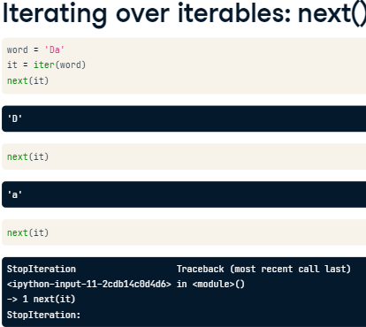

* + 一个 Iterator 只能遍历一次
  + Can also print all values of an iterator in one fell swoop using the star operator \*, referred to as the splat operator in some circles. This star operator unpacks all elements of an iterator or an iterable. Be warned, however, once you do so, you cannot do it again as there are no more values to iterate through! We would have to redefine our iterator to do so.

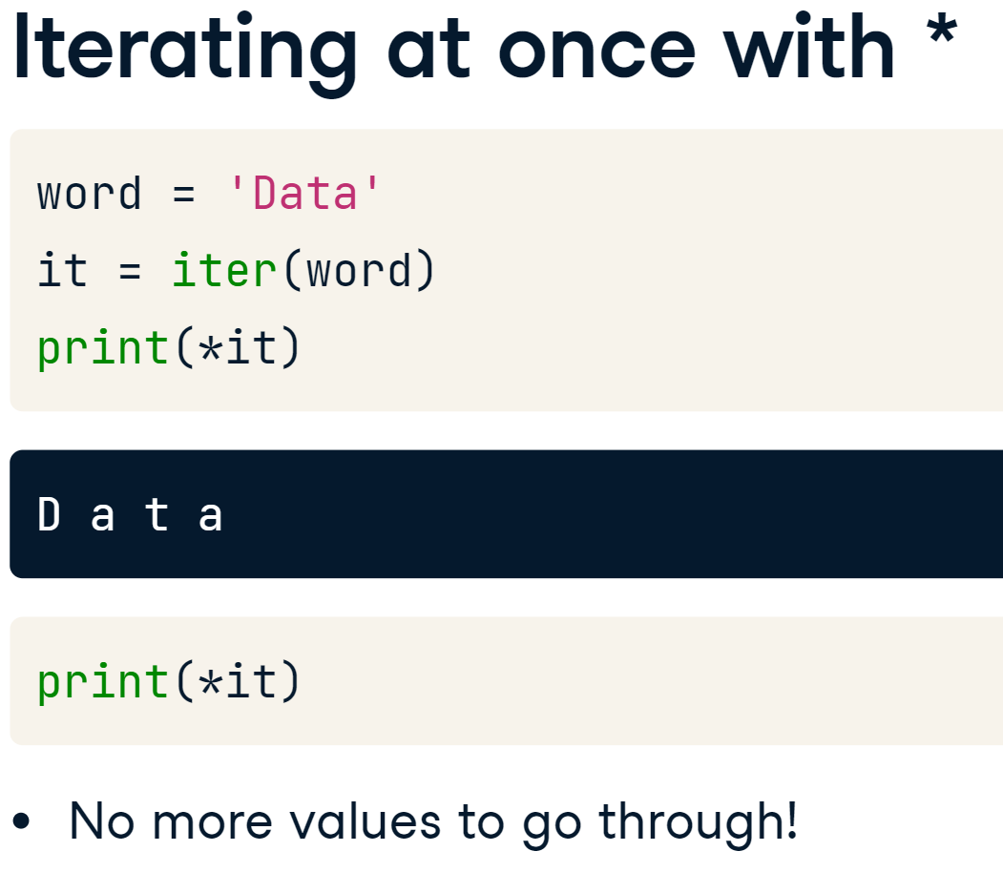

* *iterable* is an object that can return an *iterator*, while an *iterator* is an object that keeps state and produces the next value when you call next() on it.
* 例子

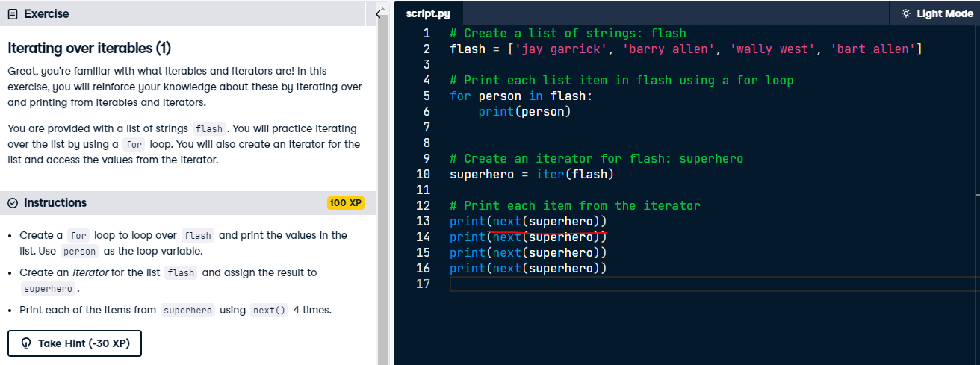

* range() doesn't actually create the list; instead, it creates a range object with an iterator that produces the values until it reaches the limit (in the example, until the value 4).
* Googol = 1.0 × 10100

## Enumerator() vs Zip()

* enumerate is a function that takes any iterable as argument, such as a list, and returns a special enumerate object, which consists of pairs containing the elements of the original iterable, along with their index within the iterable. We can use the function list to turn this enumerate object into a list of tuples and print it to see what it contains. The enumerate object itself

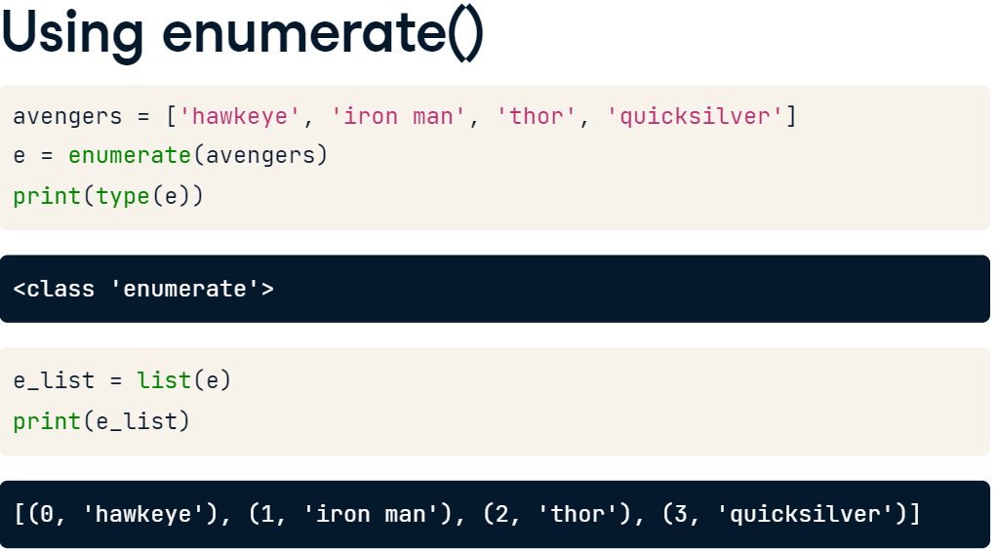

* enumerate函数，解决了我们又想直接迭代又需要知道元素下标的情形。
* 它的用法也很简单，我们把需要迭代的对象或者迭代器传入enumerate函数当中，它会为我们创建一个新的迭代器，同时返回下标以及迭代的内容。
* It is the default behavior of enumerate to begin indexing at 0. However, you can alter this with a second argument, start, which you can see here.

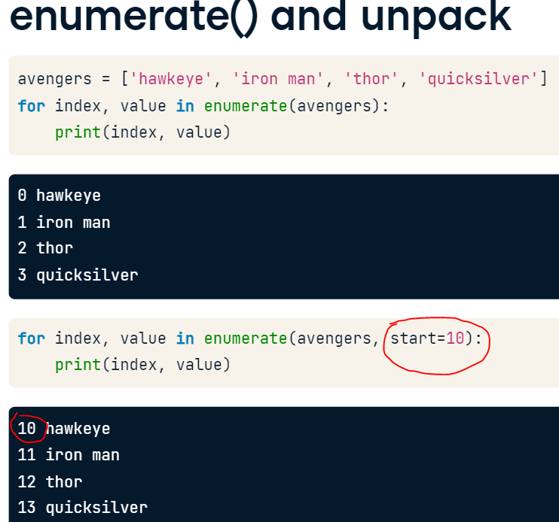

* Zip() accepts an arbitrary number of iterables and returns an iterator of tuples.
* 多对象迭代。
* 它的应用场景非常简单，就是我们想要同时迭代多份数据，比如用户的名字和用户的职业数据是分开的，我们希望同时遍历一个用户的职业和名字。如果不使用zip，我们可能只能放弃迭代器回到传统的下标遍历的模式了。这样当然是可以的，不过有两个小问题，第一个小问题当然是代码的可读性变差了，不够pythonic，第二个问题是我们需要维护两个容器长度不一样的情况，会增加额外的代码。而使用zip，可以同时解决以上两个问题。

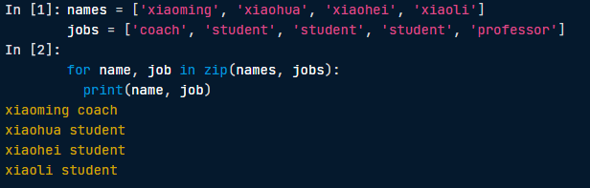

* If you wanted to print the values of a zip object, you can convert it into a list and then print it. Printing just a zip object will not return the values unless you unpack it first.

## Using Zip()

* Another interesting function that you've learned is zip(), which takes any number of iterables and returns a zip object that is an iterator of tuples.
* If you wanted to print the values of a zip object, you can convert it into a list and then print it.
* Printing just a zip object will not return the values unless you unpack it first.

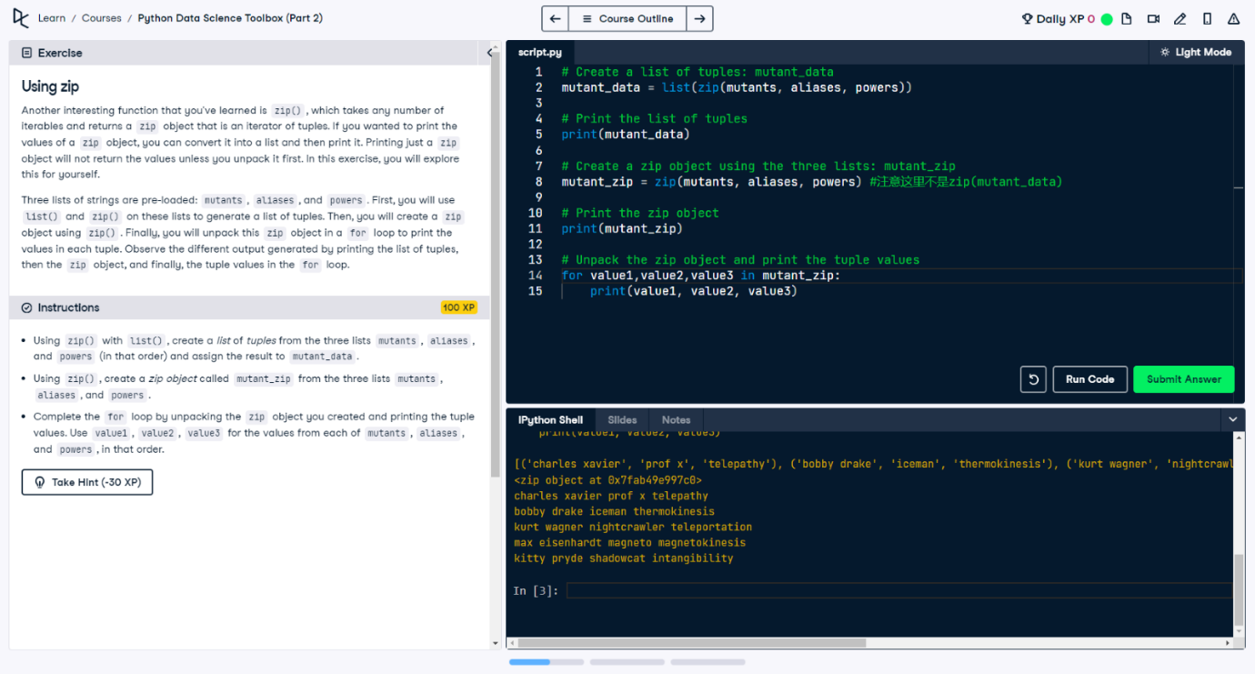

## Using \* and zip to 'unzip'

* There is no unzip function for doing the reverse of what zip() does.
* We can, however, reverse what has been zipped together by using zip() with a little help from \*
* unpacks an iterable such as a list or a tuple into positional arguments in a function call.

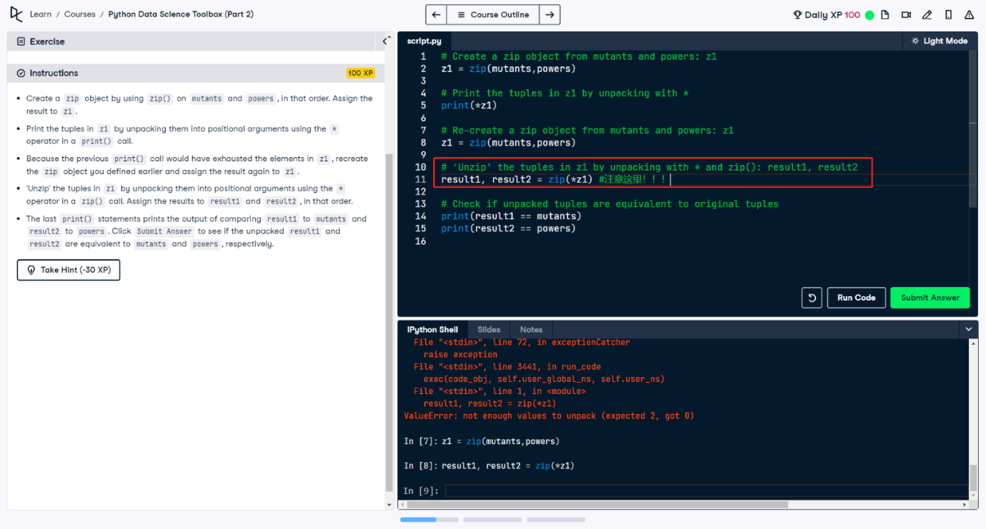

## Using iterators to load large files into memory

* Sometimes, the data we have to process reaches a size that is too much for a computer's memory to handle. This is a common problem faced by data scientists. A solution to this is to process an entire data source chunk by chunk, instead of a single go all at once.
* In this exercise, you will do just that. You will process a large csv file of Twitter data in the same way that you processed 'tweets.csv' in Bringing it all together exercises of the prequel course, but this time, working on it in chunks of 10 entries at a time.
* Initialize an empty dictionary counts\_dict for storing the results of processing the Twitter data.
* Iterate over the 'tweets.csv' file by using a for loop. Use the loop variable chunk and iterate over the call to pd.read\_csv() with a chunksize of 10.
* In the inner loop, iterate over the column 'lang' in chunk by using a for loop. Use the loop variable entry.

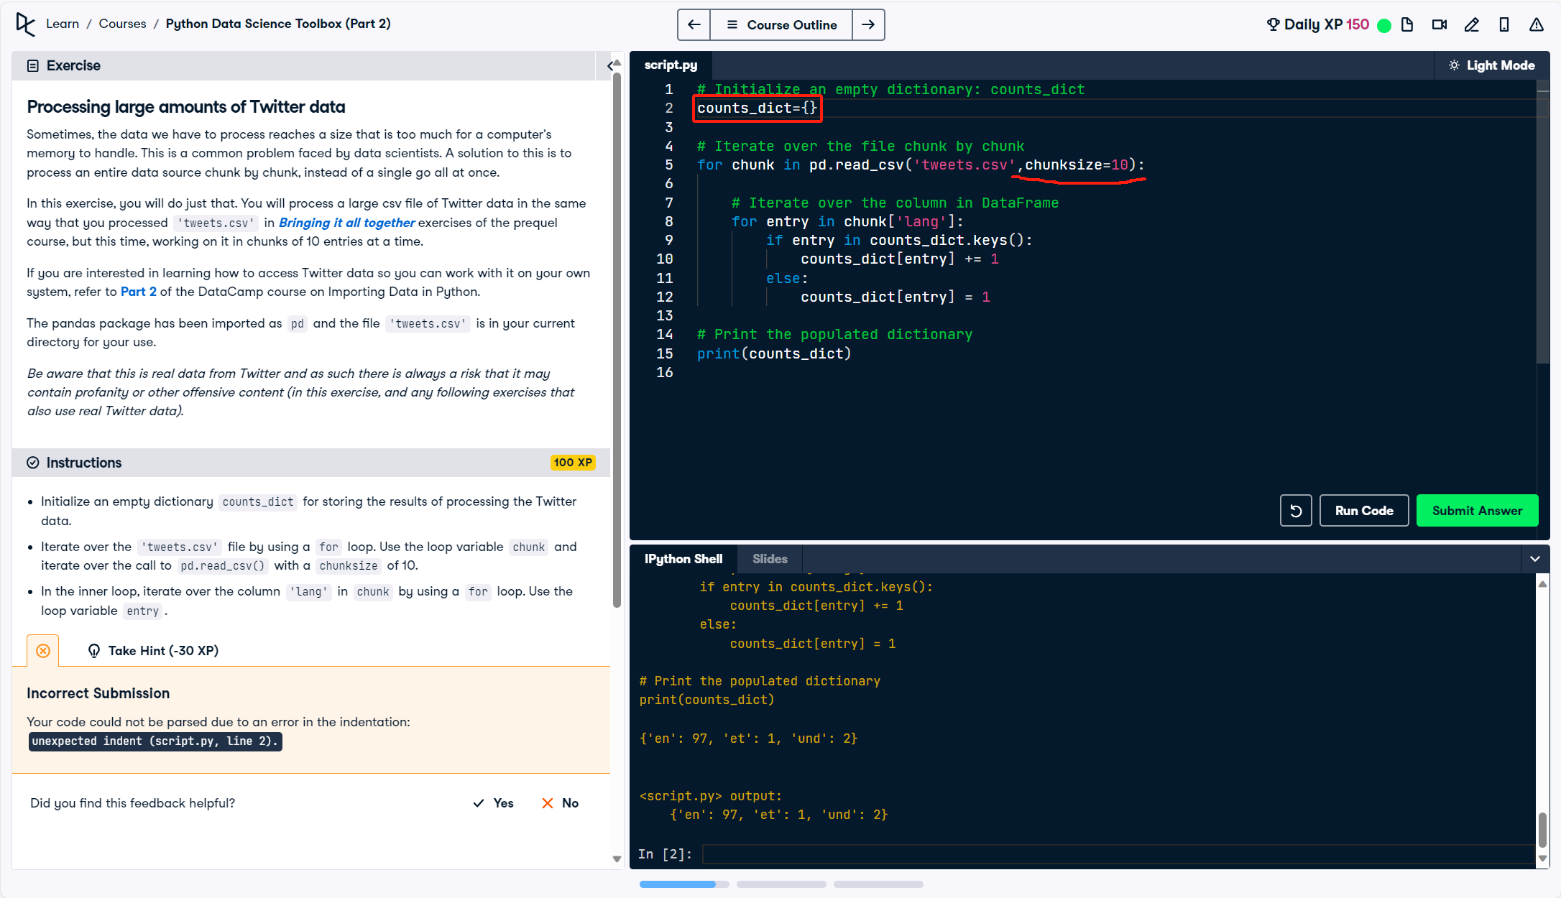

* 第二个例子：把上面的过程变成了一个function

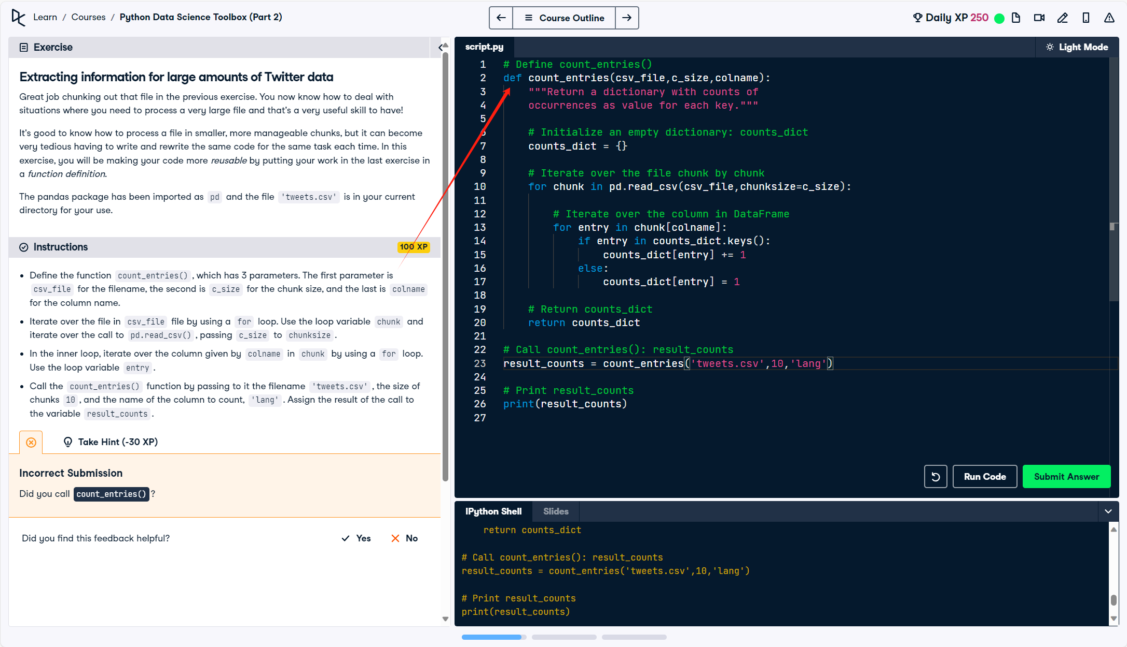

# 01/29/24 List comprehensions and generators

## List comprehensions

* + - 不可以针对integer object建立list comprehensions

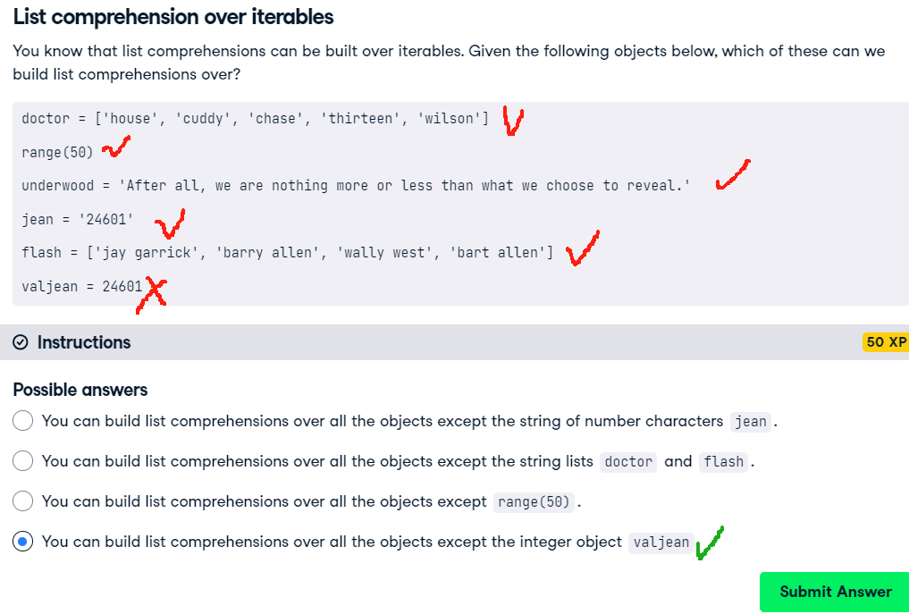

## Nested List comprehensions

* + - A list comprehension within another list comprehension, or nested list comprehensions.
    - To create the list of lists, you simply have to supply the list comprehension as the output expression of the overall list comprehension: **[[output expression] for iterator variable in iterable]**

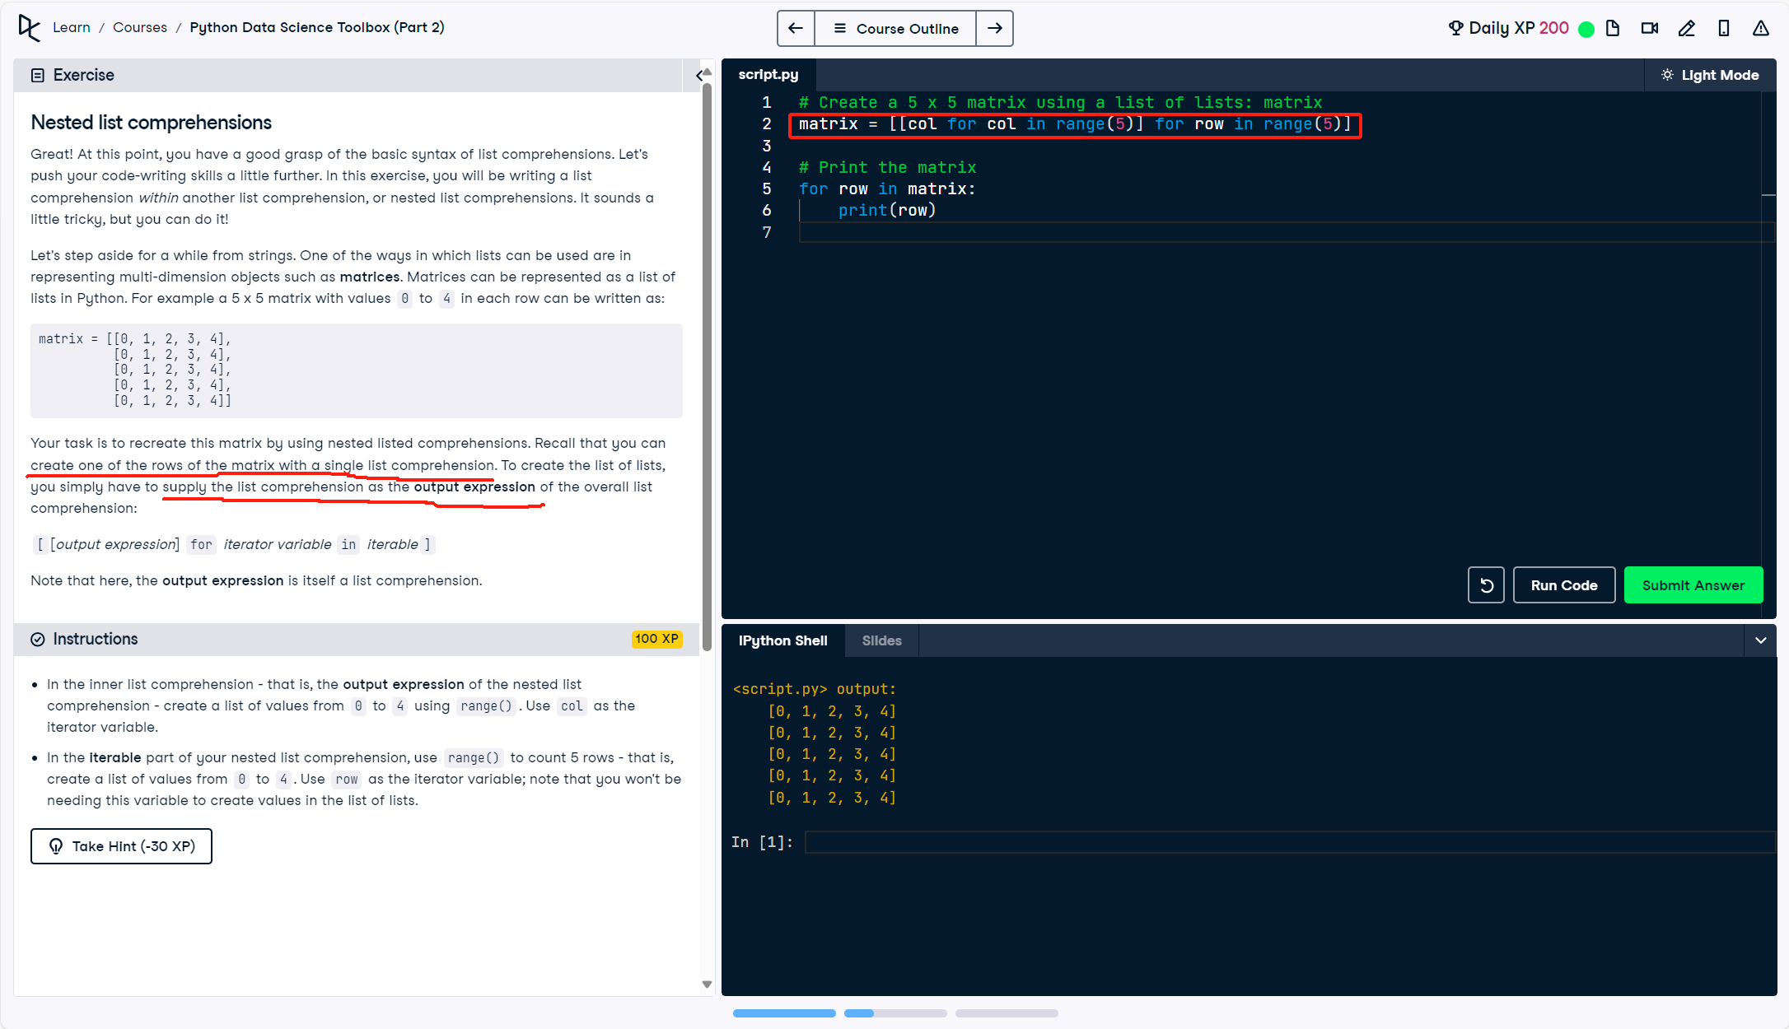

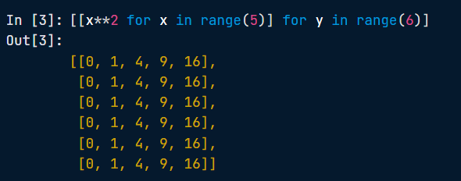

## Conditionals in comprehensions

* you can also create lists with values that meet only a certain condition. One way of doing this is by using conditionals on iterator variables
* **[output expression for iterator variable in iterable if predicate expression]**
* 也可以用if-else

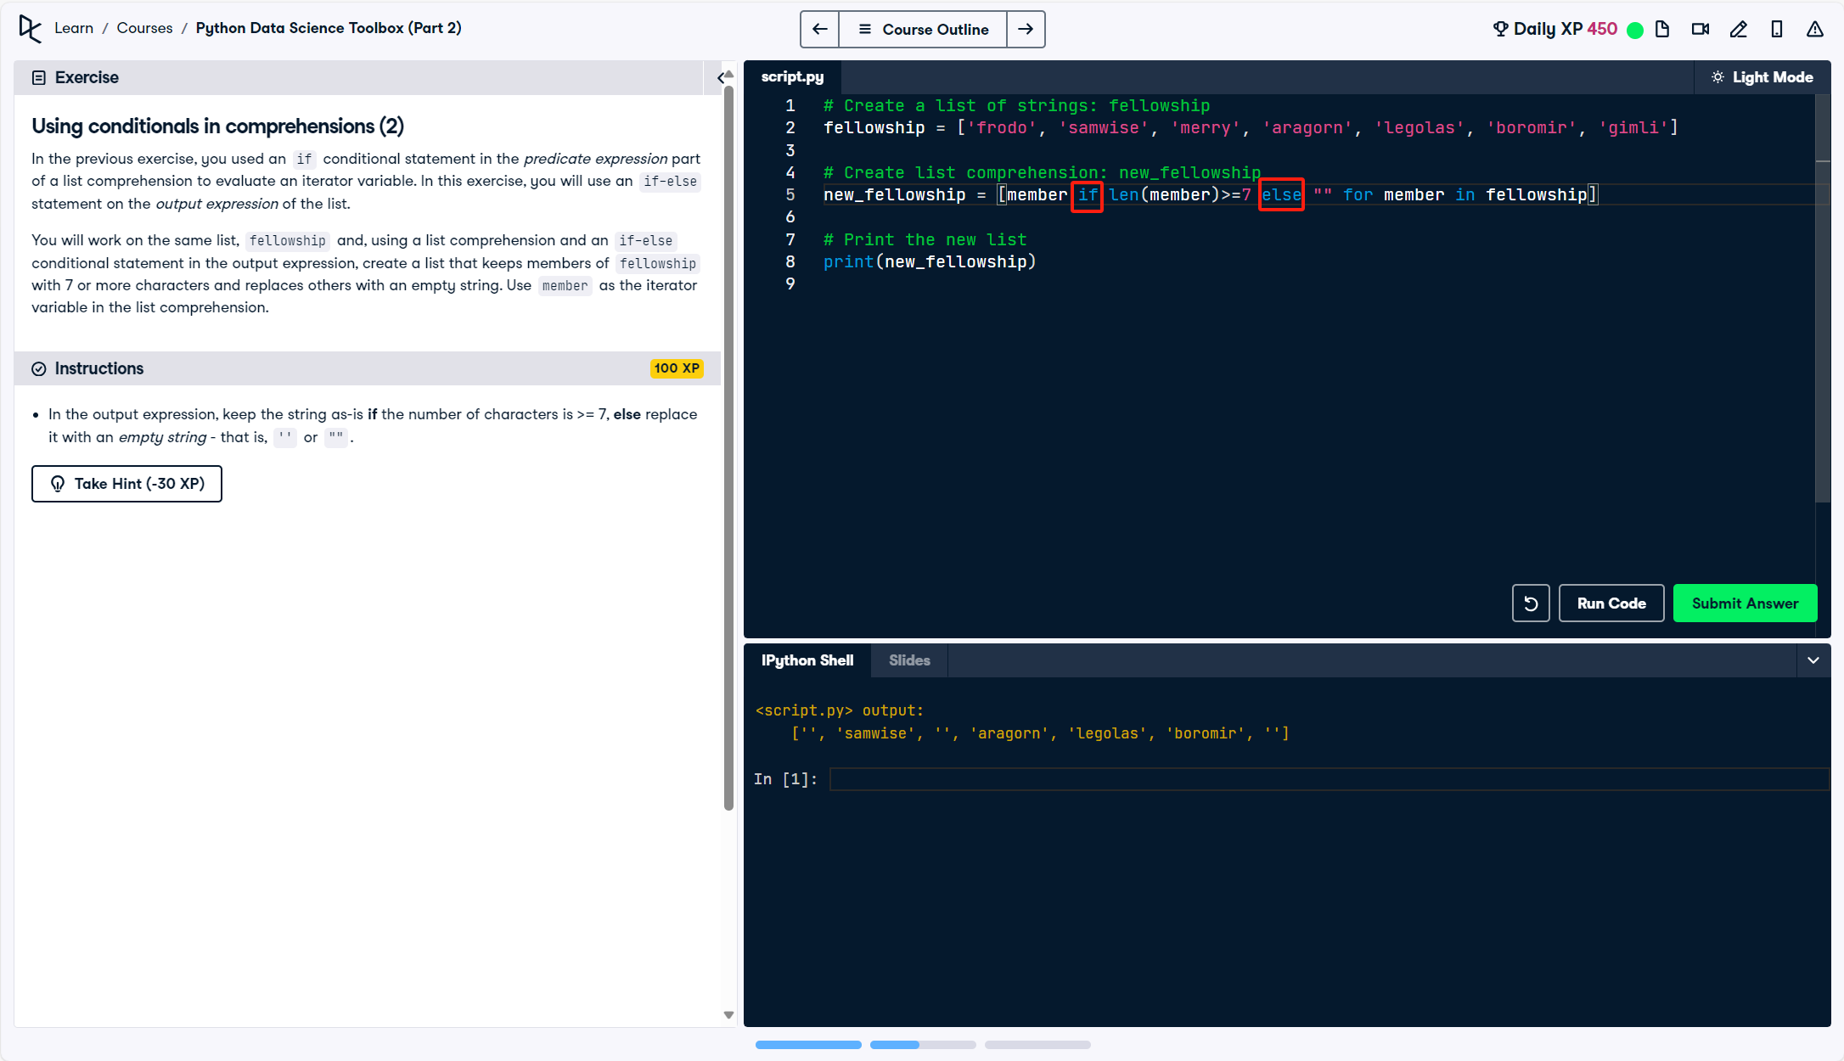

## Dict comprehensions

* Recall that the main difference between a list comprehension and a dict comprehension is the use of curly braces {} instead of []. Additionally, members of the dictionary are created using a colon :, as in <key> : <value>.

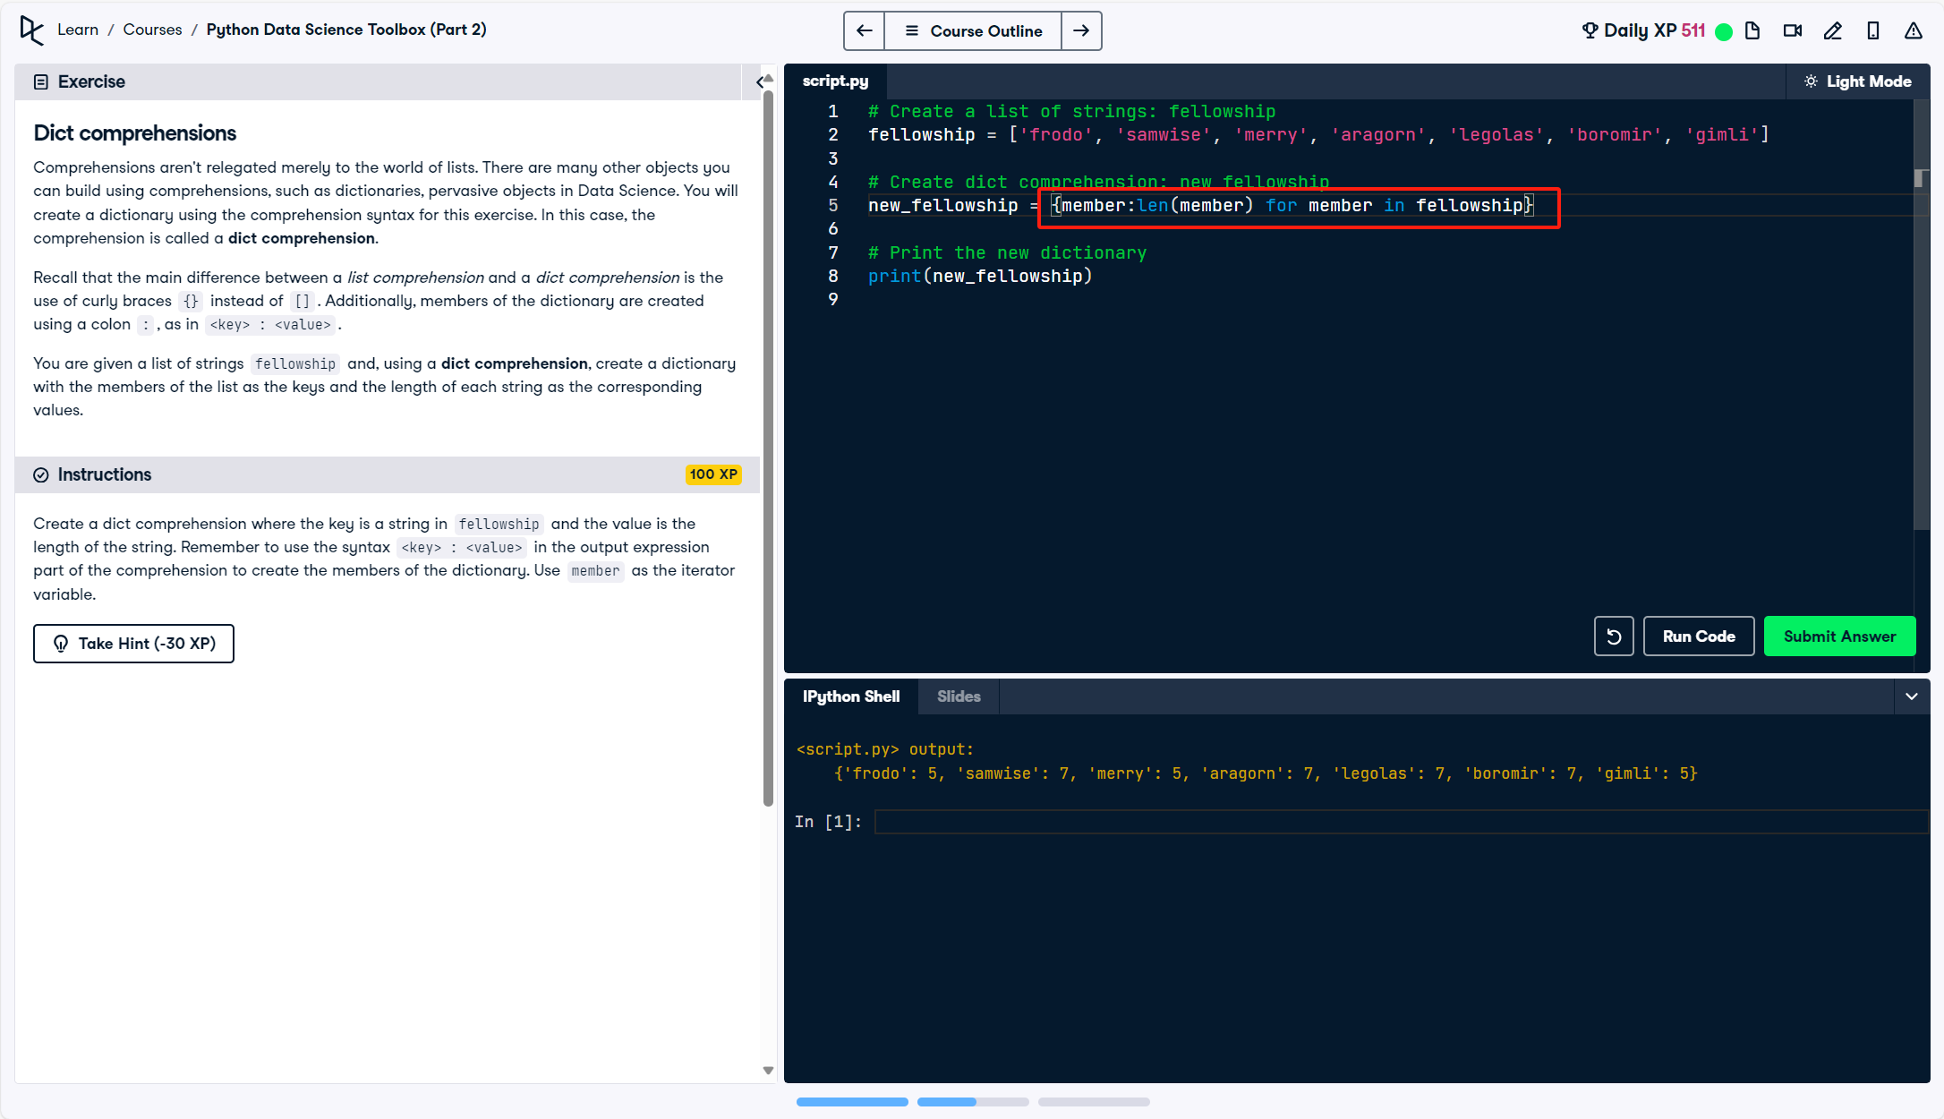

## Generator

* a generator is like a list comprehension except it does not store the list in memory: it does not construct the list, but is an object we can iterate over to produce elements of the list as required.
* use of parentheses () in generator expressions and brackets [] in list comprehensions.

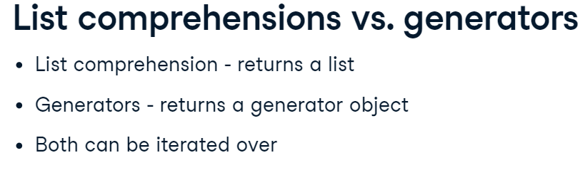

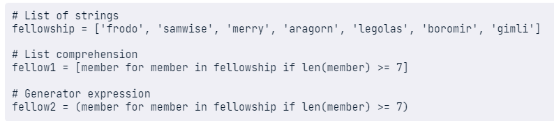

* Generator functions使用的是def和yield
* Generator functions are functions that, like generator expressions, yield a series of values, instead of returning a single value. A generator function is defined as you do a regular function, but whenever it generates a value, it uses the keyword yield instead of return.

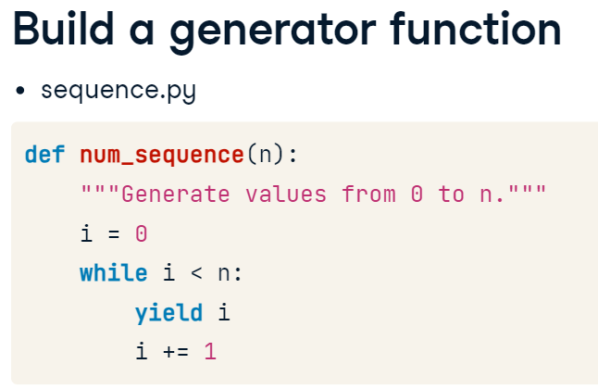

* 例子：创造一个generator function和这个表达类似

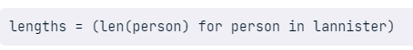

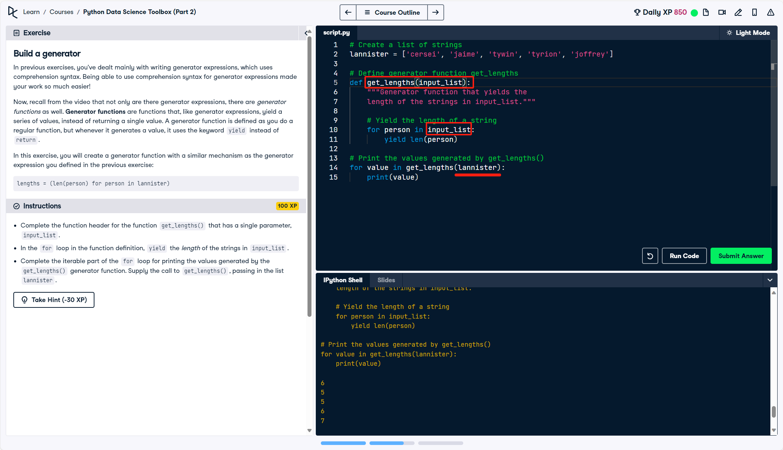

## List comprehensions for time-stamped data

* 先从df里面的拿出created\_at这一列，然后从里面的拿出第12th to 19th characters只是关于时间的组成tweet\_clock\_time

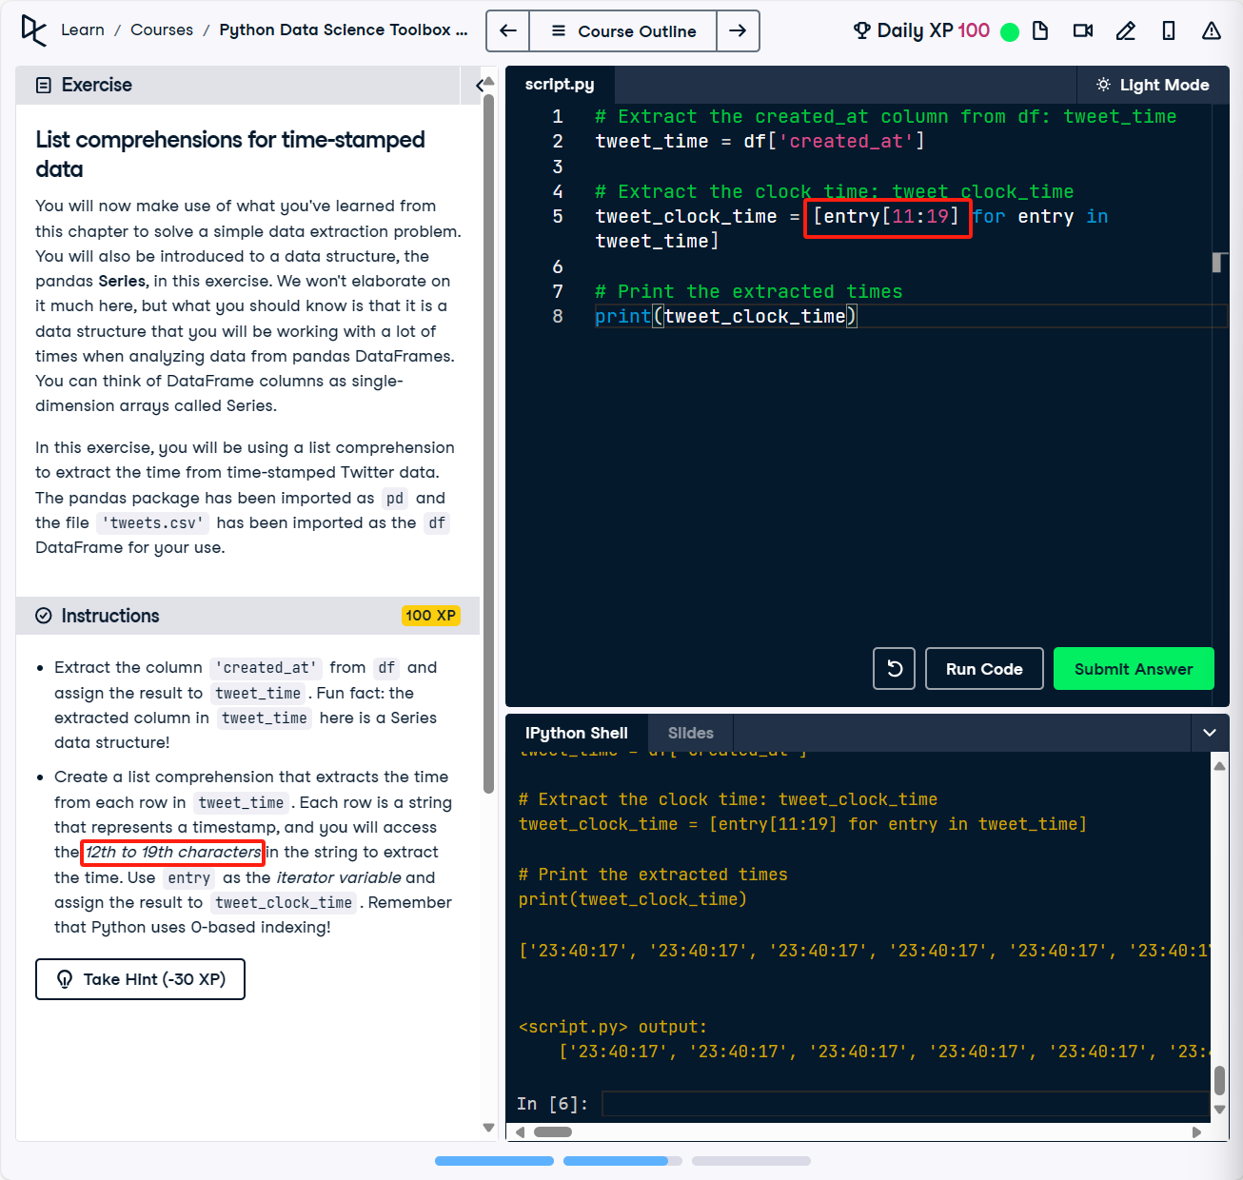

* Create a list comprehension that extracts the time from each row in tweet\_time. Each row is a string that represents a timestamp, and you will access the 12th to 19th characters in the string to extract the time. Use entry as the iterator variable and assign the result to tweet\_clock\_time. Additionally, add a conditional expression that checks whether entry[17:19] is equal to '19'.

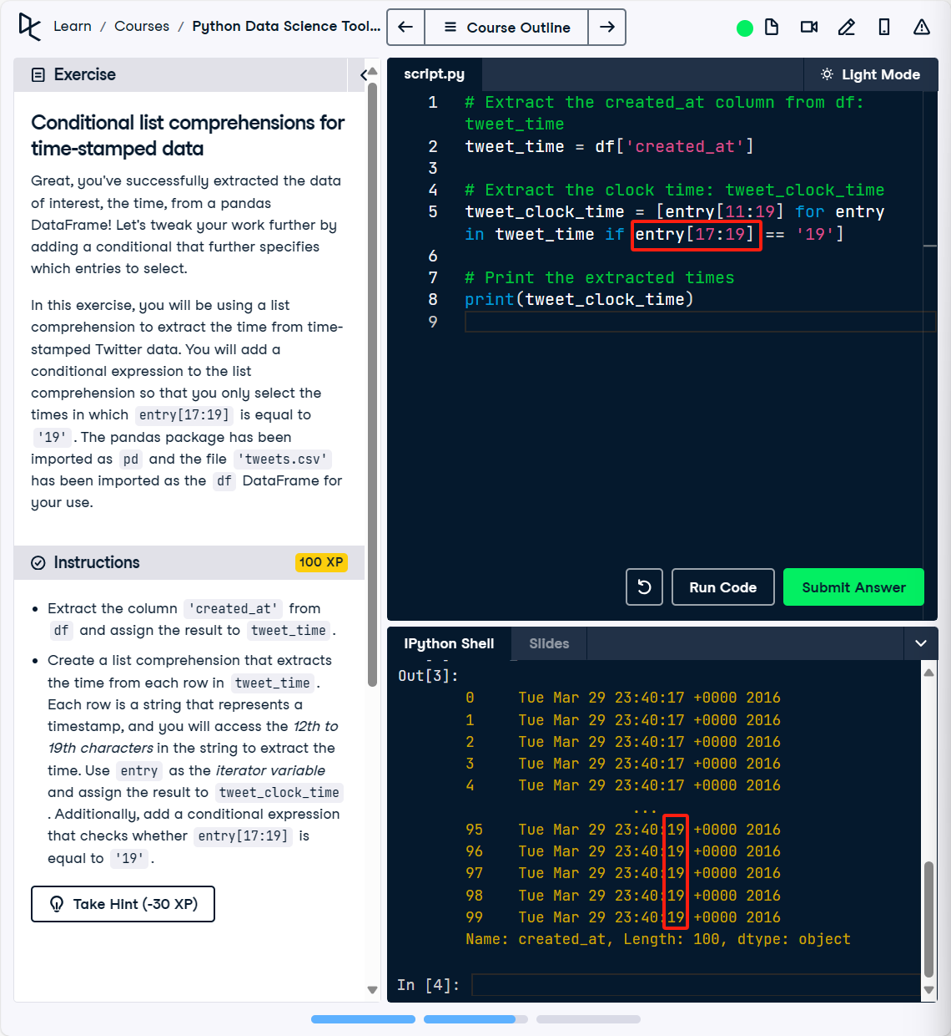

# 03/10/24 Bringing it all together!

* The csv file 'world\_dev\_ind.csv' is in your current directory for your use. To begin, you need to open a connection to this file using what is known as a context manager. For example, the command with open('datacamp.csv') as datacamp binds the csv file 'datacamp.csv' as datacamp in the context manager. Here, the with statement is the context manager, and its purpose is to ensure that resources are efficiently allocated when opening a connection to a file.

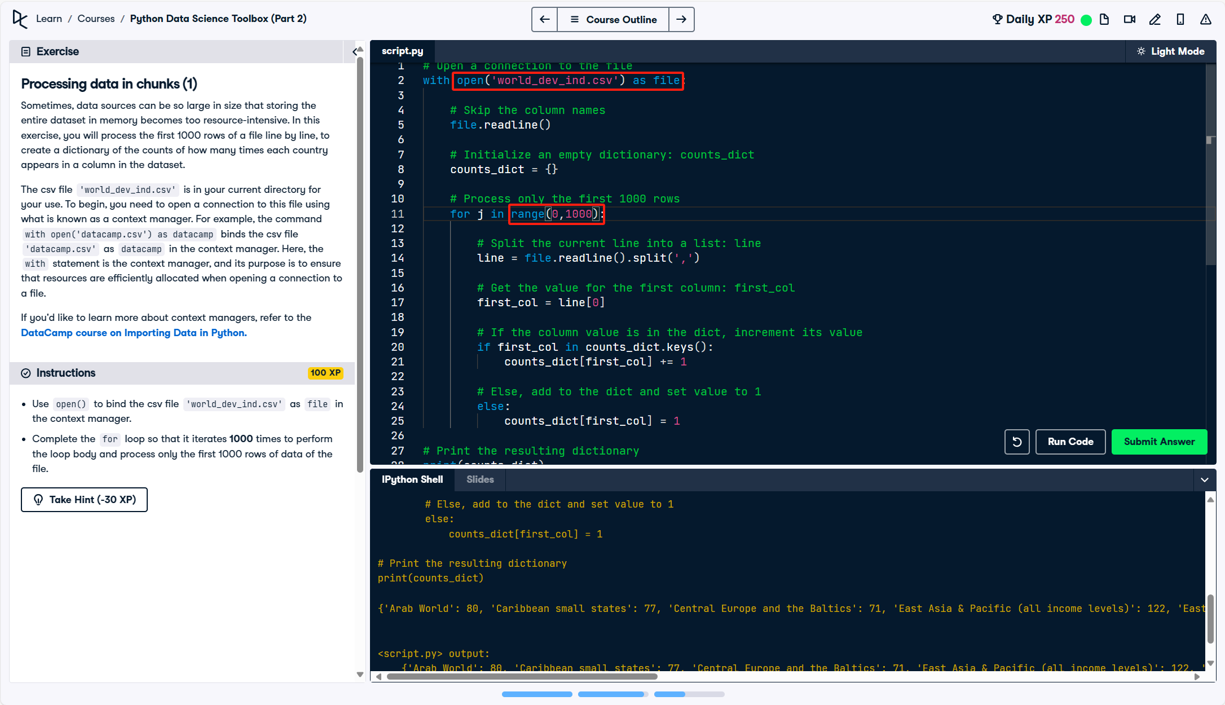

* Note that when you open a connection to a file, the resulting file object is already a generator! So out in the wild, you won't have to explicitly create generator objects in cases such as this. However, for pedagogical reasons, we are having you practice how to do this here with the read\_large\_file() function. Go for it!
* 可以使用for来遍历的，都是Iterable。可以使用next来遍历的，都是Iterator。
  + next(iterator[, default])
  + iterator – 可迭代对象；default – 可选，用于设置在没有下一个元素时返回该默认值，如果不设置，又没有下一个元素则会触发 StopIteration 异常。

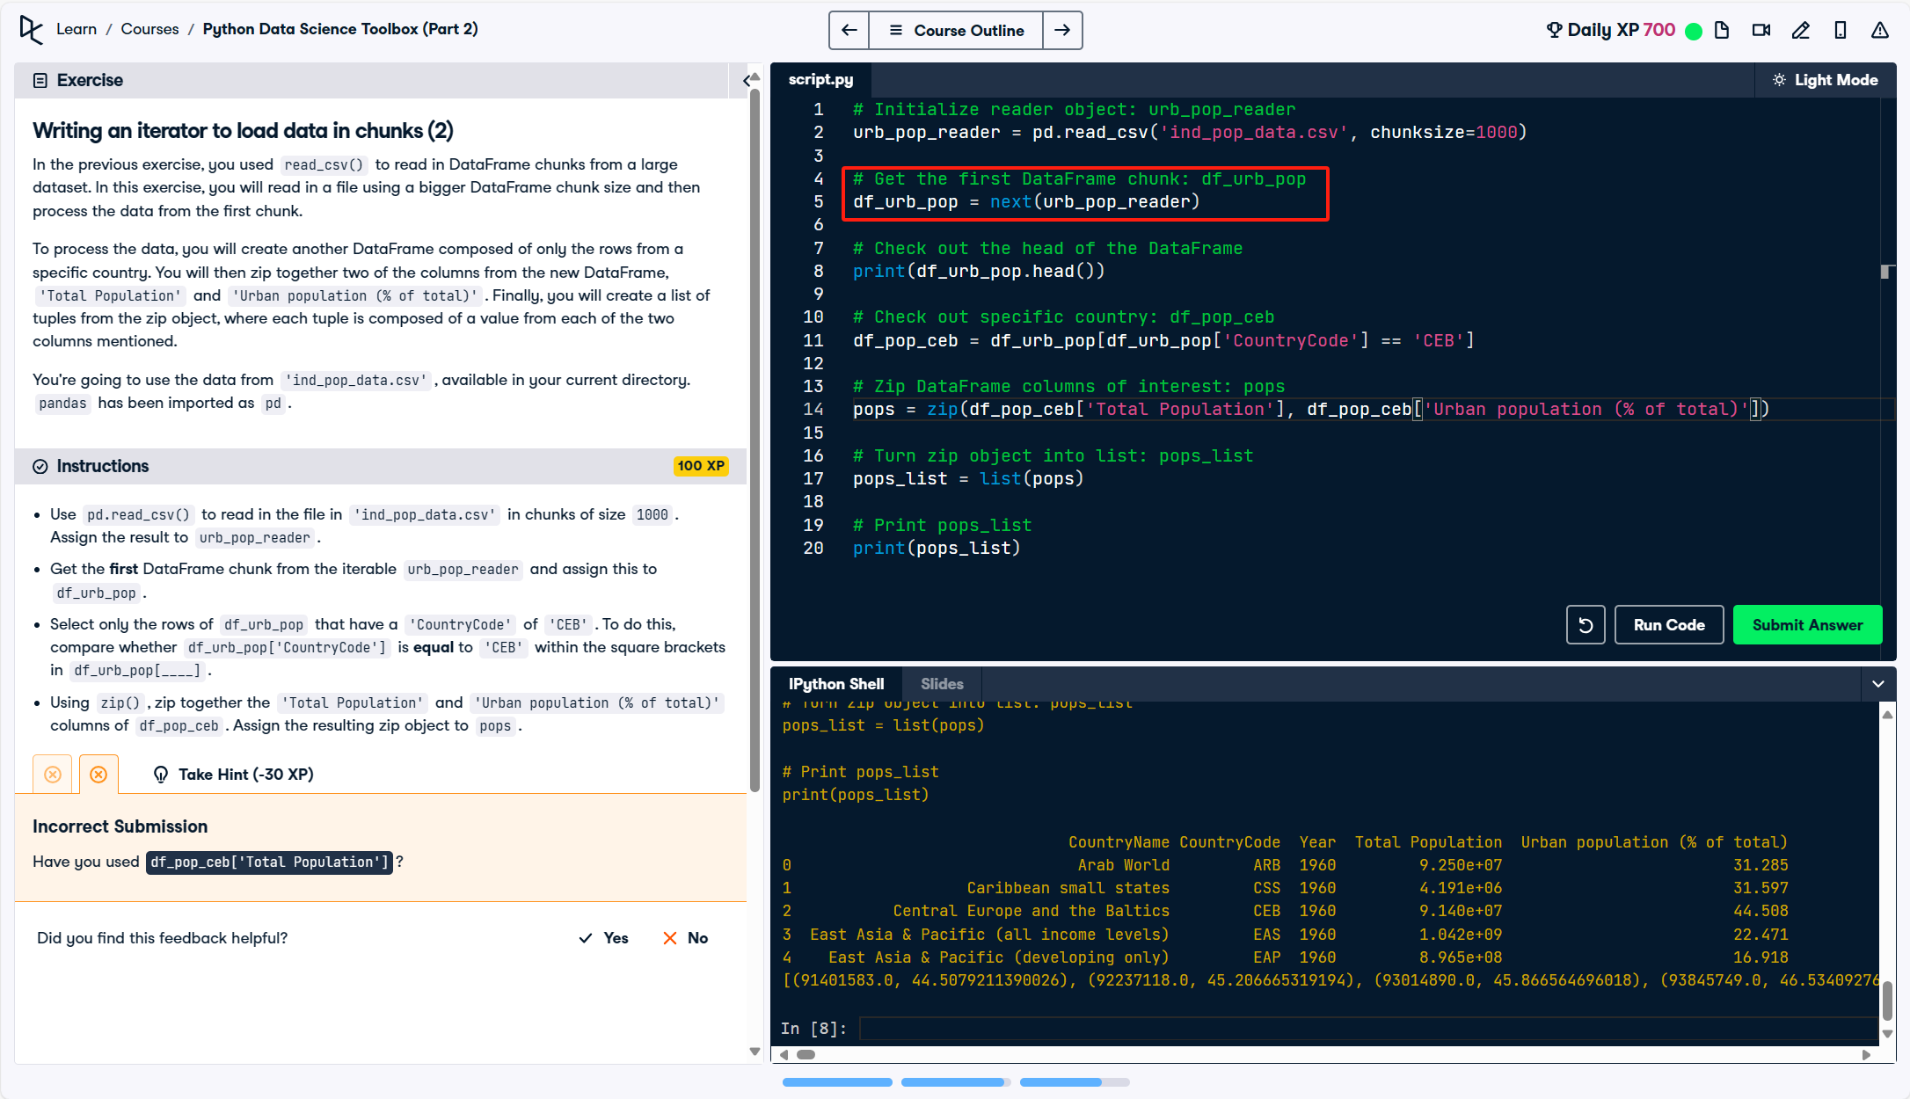

* 这个的重点是pd.concat()的用法
* 如果是append的话是用 data = data.append(df\_pop\_ceb)
* Append是dataframe的成员函数 – 一定是附属在某个对象下面。比如某个表格添加一行之类的
* Contact是个全局函数 global function
* Pd.concat()是一个功能。把原来的”data”这个dataframe和新的df\_pop\_ceb结合在一起

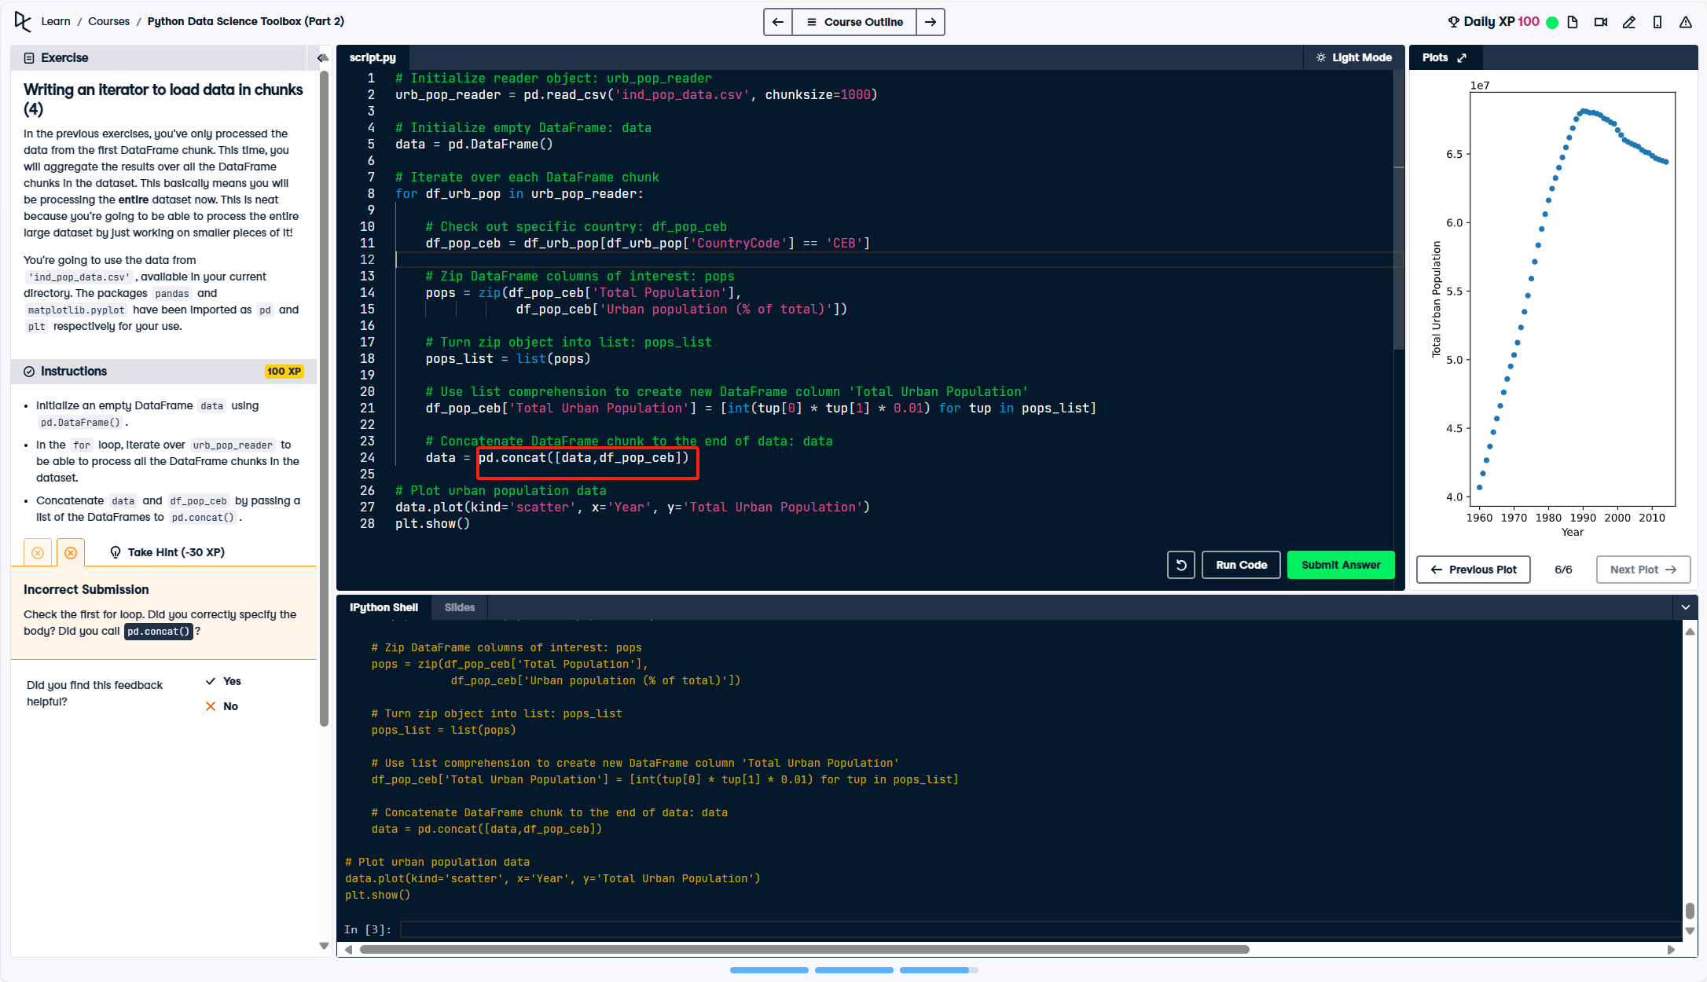

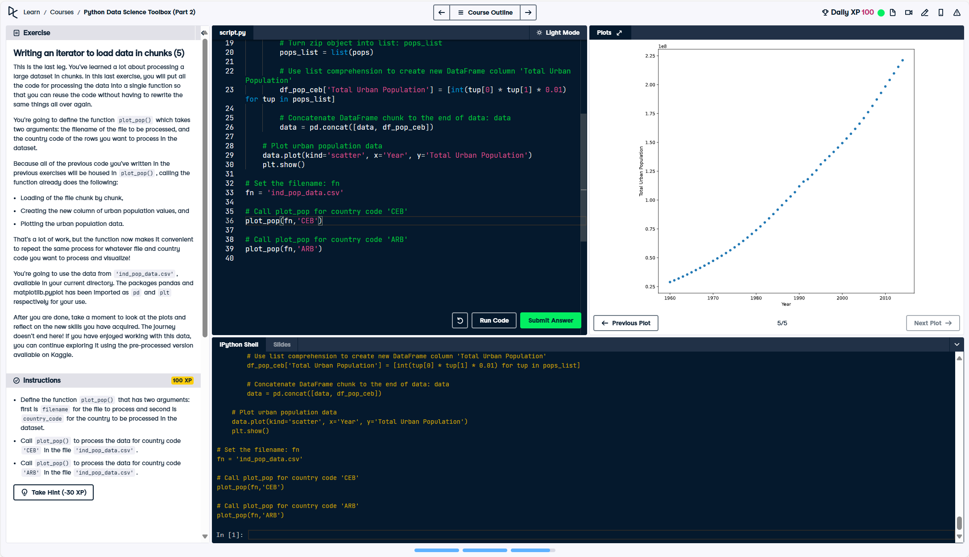

# 03/11/24 **【Investigating Netflix Movies】**Project

* + - netflix\_subset = netflix\_df[netflix\_df['type'] == 'Movie'] 针对某个dataframe某一列做筛选然后储存成一个新的subset
    - netflix\_movies = netflix\_subset[["title", "country", "genre", "release\_year", "duration"]] 挑选出某个dataframe里面某几列重新储存为新的dataframe
    - Using a for loop and if/elif statements, iterate through the rows of netflix\_movies and assign colors of your choice to four genre groups ("Children", "Documentaries", "Stand-Up", and "Other" for everything else). Save the results in a colors list.

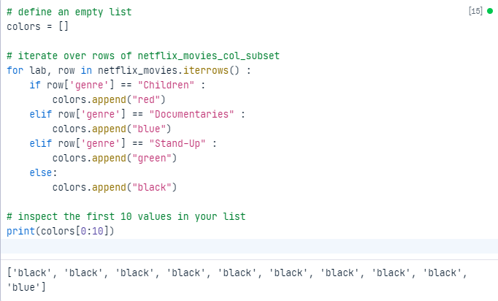

------------------------------------------------------------

# define an empty list

colors = []

# iterate over rows of netflix\_movies\_col\_subset

for lab, row in netflix\_movies\_col\_subset.iterrows() :

if row['genre'] == "children" :

colors.append("red")

elif row['genre'] == "documentaries" :

colors.append("blue")

elif row['genre'] == "stand-up" :

colors.append("green")

else:

colors.append("black")

# inspect the first 10 values in your list

print(colors[0:10])

------------------------------------------------------------

* + - Initialize a matplotlib figure object called fig and create a scatter plot for movie duration by release year using the colors list to color the points and using the labels "Release year" for the x-axis, "Duration (min)" for the y-axis, and the title "Movie Duration by Year of Release".
    - 用之前定义的color list来画散点图

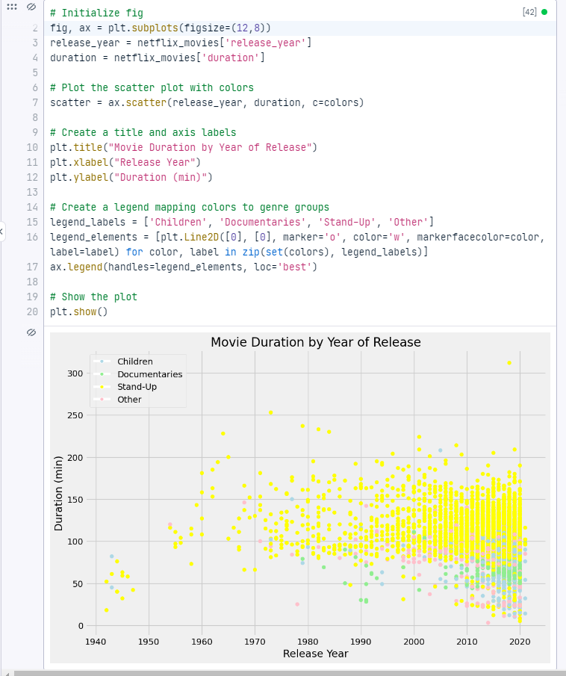

------------------------------------------------------------

# Initialize fig

fig, ax = plt.subplots(figsize=(12,8))

release\_year = netflix\_movies['release\_year']

duration = netflix\_movies['duration']

# Plot the scatter plot with colors

scatter = ax.scatter(release\_year, duration, c=colors)

# Create a title and axis labels

plt.title("Movie Duration by Year of Release")

plt.xlabel("Release Year")

plt.ylabel("Duration (min)")

# Create a legend mapping colors to genre groups

legend\_labels = ['Children', 'Documentaries', 'Stand-Up', 'Other']

legend\_elements = [plt.Line2D([0], [0], marker='o', color='w', markerfacecolor=color, label=label) for color, label in zip(set(colors), legend\_labels)]

ax.legend(handles=legend\_elements, loc='best')

# Show the plot

plt.show()

------------------------------------------------------------

* + - 两个numpy作比较

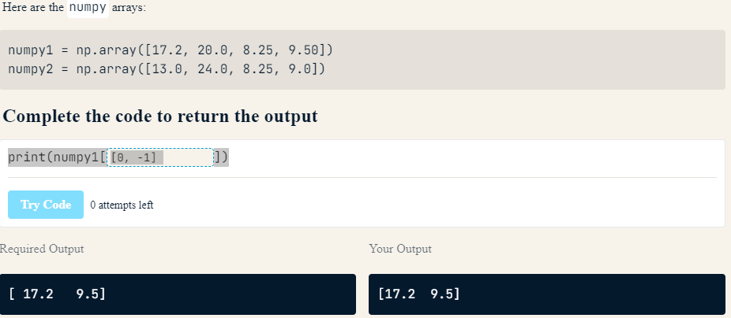

------------------------------------------------------------

print(numpy1[numpy1 > numpy2])

------------------------------------------------------------

* + - Np\_2d[:,0] >> first column of the 2D numpy array

# 03/13/24 【**Data Manipulation with pandas】-** Transforming DataFrames

* + - pandas is built on top of two essential Python packages, NumPy and Matplotlib.
    - Numpy provides multidimensional array objects for easy data manipulation that pandas uses to store data, and Matplotlib has powerful data visualization capabilities that pandas takes advantage of.
    - Rectangular data又称作tabular data
    - 每一个observation又称为row
    - 每个variable指的是column
    - A DataFrame's shape attribute contains a tuple that holds the number of rows followed by the number of columns. Since this is an attribute instead of a method, you write it without parentheses.
    - 先是行数，然后列数df.shape(行数，列数)

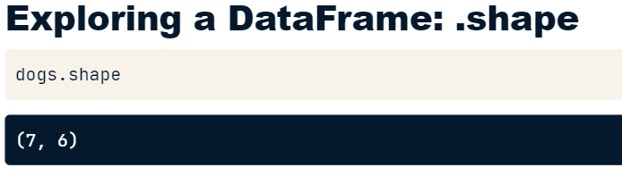

* + - The describe method computes some summary statistics for numerical columns, like mean and median. "count" is the number of non-missing values in each column. describe is good for a quick overview of numeric variables, but if you want more control, you'll see how to perform more specific calculations later in the course.

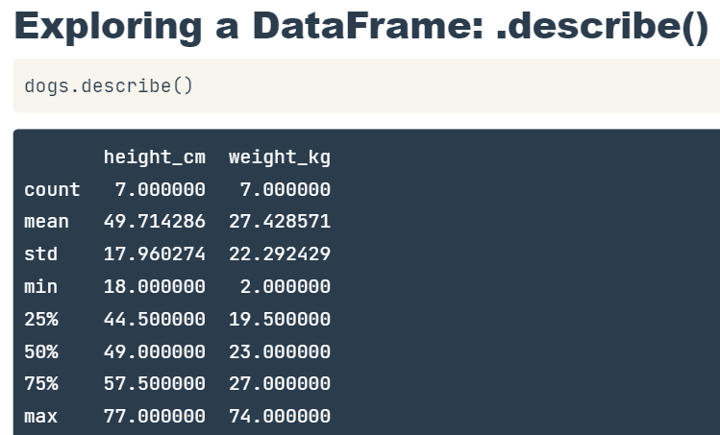

* + - Dataframe 有三个components/attributes: df.values; .index, .columns
* .values: A two-dimensional NumPy array of values.
* .columns: An index of columns: the column names.
* .index: An index for the rows: either row numbers or row names.
  + - Index其实储存的就是行的数据
    - 例子：
* print(homelessness.head())
* print(homelessness.info())
* print(homelessness.shape) >> 注意没有括号！
* print(homelessness.describe())
* print(homelessness.values)
* print(homelessness.columns)
* print(homelessness.index)
  + - If you want to filter on multiple values of a categorical variable, the easiest way is to use the isin method. This takes in a list of values to filter for. Here, we check if the color of a dog is black or brown, and use this condition to subset the data.

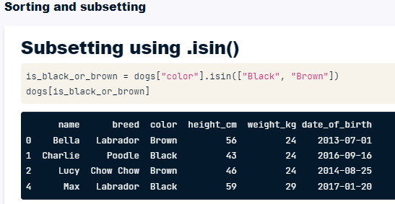

* + - You can sort the rows by passing a column name to .sort\_values(). df.sort\_values("breed")
    - In cases where rows have the same value (this is common if you sort on a categorical variable), you may wish to break the ties by sorting on another column. You can sort on multiple columns in this way by passing a list of column names.
* df.sort\_values(["breed", "weight\_kg"])
* homelessness\_fam = homelessness.sort\_values("family\_members",ascending=False)
* 注意这个是对两个栏目排序，并且一个是倒叙一个是顺序。ho {MSG /ID 65F25F6F000062EF306F0001} melessness\_reg\_fam = homelessness.sort\_values(['region','family\_members'],ascending = [True,False])
  + - 注意对df选择栏目的时候括号的数目和双引号！
* 选一个 df["col\_a"]
* 选两个state\_fam = homelessness[["family\_members","state"]]
* dogs[dogs["height\_cm"] > 60]
* 注意根据文本text进行筛选的时候用双引号和双等号mountain\_reg = homelessness[homelessness["region"]=="Mountain"]
* 注意有两个筛选条件的时候用圆括号括住每个条件，链接用& dogs[(dogs["height\_cm"] > 60) & (dogs["color"] == "tan")]
  + - Subsetting data based on a categorical variable often involves using the "or" operator (|) to select rows from multiple categories. This can get tedious when you want all states in one of three different regions, for example. Instead, use the .isin() method, which will allow you to tackle this problem by writing one condition instead of three separate ones.

------------------------------------------------------------

colors = ["brown", "black", "tan"]

condition = dogs["color"].isin(colors)

dogs[condition]

------------------------------------------------------------

------------------------------------------------------------

# The Mojave Desert states

State\_list = ["California", "Arizona", "Nevada", "Utah"]

# Filter for rows in the Mojave Desert states

mojave\_homelessness = homelessness[homelessness["state"].isin(canu)]

# See the result

print(mojave\_homelessness)

------------------------------------------------------------

* south\_mid\_atlantic = homelessness[(homelessness["region"] == "South Atlantic") | (homelessness["region"] == "Mid-Atlantic")]
* south\_mid\_atlantic = homelessness[homelessness["region"].isin(["South Atlantic","Mid-Atlantic"])]

# 03/14/24 Aggregating DataFrames

* + - 一些统计数据
* print(sales["weekly\_sales"].median())
* print(sales["weekly\_sales"].mean())
* print(sales.info())
* print(sales["date"].max())

## .agg() method

* + - The .agg() method allows you to apply your own custom functions to a DataFrame, as well as apply functions to more than one column of a DataFrame at once, making your aggregations super-efficient. df['column'].agg(function)
* In the custom function for this exercise, "IQR" is short for inter-quartile range, which is the 75th percentile minus the 25th percentile. It's an alternative to standard deviation that is helpful if your data contains outliers.
* 这个例子是先定义iqr function，然后运用在agg()里面

------------------------------------------------------------

# A custom IQR function

def iqr(column):

return column.quantile(0.75) - column.quantile(0.25)

# Print IQR of the temperature\_c column

print(sales["temperature\_c"].agg(iqr))

------------------------------------------------------------

* 这个例子是运用两个公式，iqr和np.median
* 并且运用到dataframe多个column上面！

------------------------------------------------------------

# Import NumPy and create custom IQR function

import numpy as np

def iqr(column):

return column.quantile(0.75) - column.quantile(0.25)

# Update to print IQR and median of temperature\_c, fuel\_price\_usd\_per\_l, & unemployment

print(sales[["temperature\_c", "fuel\_price\_usd\_per\_l", "unemployment"]].agg([iqr,np.median]))

------------------------------------------------------------

## Cumulative statistics一些公式

* 注意最后.cumsum(), .cummax()这些是有括号的！

------------------------------------------------------------

# Sort sales\_1\_1 by date

sales\_1\_1 = sales\_1\_1.sort\_values("date")

# Get the cumulative sum of weekly\_sales, add as cum\_weekly\_sales col

sales\_1\_1["cum\_weekly\_sales"] = sales\_1\_1["weekly\_sales"].cumsum()

# Get the cumulative max of weekly\_sales, add as cum\_max\_sales col

sales\_1\_1["cum\_max\_sales"] = sales\_1\_1["weekly\_sales"].cummax()

# See the columns you calculated

print(sales\_1\_1[["date", "weekly\_sales", "cum\_weekly\_sales", "cum\_max\_sales"]])

------------------------------------------------------------

## Counting – categorical data

* + - 统计categorical数据，使用counting
* 这个例子是drop duplicate pairs of store and type，是根据配对来drop的 store\_types = sales.drop\_duplicates(["store","type"])
* 对某个df里面根据某个列统计 store\_counts = store\_types["type"].value\_counts()
* 也是统计但是返回的是比例 store\_props = store\_types["type"].value\_counts(normalize=True)
* 不仅仅是统计，还得排序dept\_counts\_sorted = store\_depts["department"].value\_counts(sort=True)
* 这个是计算比例并且排序dept\_props\_sorted = store\_depts["department"].value\_counts(sort=True, normalize=True)
  + - 对sales这个dataframe里面的所有满足type =A条件的对象它们的weekly\_sales 数据进行加总 >> sales\_A = sales[sales["type"] == "A"]["weekly\_sales"].sum()

## .groupby()

* 先根据type这一列分组然后计算每组的weekly\_sales和sales\_by\_type = sales.groupby("type")["weekly\_sales"].sum()
* 根据两个列来排序然后再计算weekly\_sales 的总和sales\_by\_type\_is\_holiday = sales.groupby(["type","is\_holiday"])["weekly\_sales"].sum()
* 这里groupby和agg()以及numpy里面的统计功能结合，现根据type来进行分组，然后统计每个组别的weekly\_sales的统计值>> sales\_stats = sales.groupby("type")["weekly\_sales"].agg([np.min,np.max,np.mean,np.median])
* 这里在上面的基础上统计两个不同对象的unemp\_fuel\_stats = sales.groupby("type")["unemployment","fuel\_price\_usd\_per\_l"].agg([np.min,np.max,np.mean,np.median])

## Pivot Table

* + - the .pivot\_table() method is an alternative to .groupby().
    - The "values" argument is the column that you want to summarize, and the index column is the column that you want to group by.
    - By default, pivot\_table takes the mean value for each group.
    - mean\_sales\_by\_type = sales.pivot\_table(values="weekly\_sales",index="type")
    - To get multiple summary statistics at a time, we can pass a list of functions to the aggfunc argument.
* 根据type分类，计算weekly\_sales的均值和中值。注意的是用的是aggfunc是pivot\_table里面的一个argument，不是外面的 mean\_med\_sales\_by\_type = sales.pivot\_table(values="weekly\_sales",index="type",aggfunc=[np.mean,np.median])
  + - 也可以创建一个类似矩阵的东西groupby 2 variables。用的是index和columns
* mean\_sales\_by\_type\_holiday = sales.pivot\_table(values="weekly\_sales",index="type",columns="is\_holiday")
* 可以看到每行是根据index="type"分类的
* 每列是根据columns="is\_holiday"

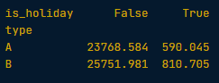

* + - The .pivot\_table() method has several useful arguments, including fill\_value and margins.
    - fill\_value replaces missing values with a real value (known as imputation). What to replace missing values with is a topic big enough to have its own course (Dealing with Missing Data in Python), but the simplest thing to do is to substitute a dummy value.
    - margins is a shortcut for when you pivoted by two variables, but also wanted to pivot by each of those variables separately: it gives the row and column totals of the pivot table contents.
* 这个例子是把缺失的数据用0填充。并且统计每行每列的总和
* print(sales.pivot\_table(index="department", columns="type", values="weekly\_sales",fill\_value = 0, margins = True))

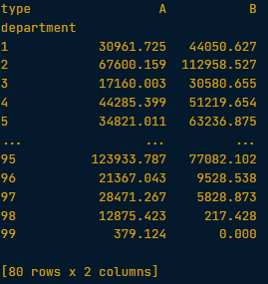对比margin = true: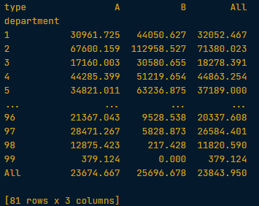

* The column 'All' returns an overall mean for each department, not (A+B)/2. (A+B)/2 would be a mean of means, rather than an overall mean per department!
  + - 使用两个列作为index的例子 temp\_by\_country\_city\_vs\_year = temperatures.pivot\_table(values="avg\_temp\_c",index=["country","city"],columns="year")

# 03/14/24 Slicing and Indexing DataFrames

## .set\_index(), .reset\_index(), .reset\_index(drop=True))

* + - .set\_index(“”)把某一列设置为index >> temperatures\_ind = temperatures.set\_index("city")

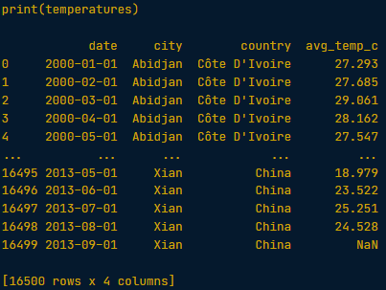 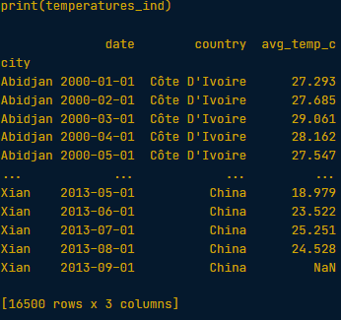

* + - .reset\_index()重新设置回去index >> print(temperatures\_ind.reset\_index())

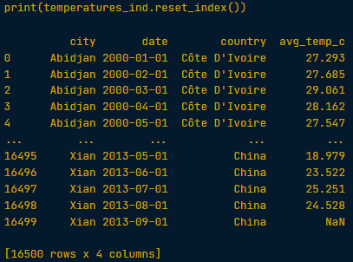

* + - .reset\_index(drop=True)) 把index内容去掉>> print(temperatures\_ind.reset\_index(drop=True))

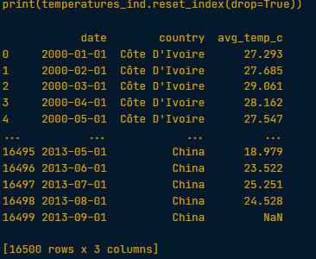

* + - 还可以设置两列作为index >> temperatures\_ind = temperatures.set\_index(["country","city"])

## .loc[]

* + - .loc[]: a subsetting method that accepts index values. When you pass it a single argument, it will take a subset of rows.
    - The code for subsetting using .loc[] can be easier to read than standard square bracket subsetting, which can make your code less burdensome to maintain.
    - 直接使用放括号和.loc[]的区别

------------------------------------------------------------

# Make a list of cities to subset on

cities = ["Moscow", "Saint Petersburg"]

# Subset temperatures using square brackets

print(temperatures[temperatures["city"].isin(cities)])

# Subset temperatures\_ind using .loc[]

print(temperatures\_ind.loc[cities])

------------------------------------------------------------

* print(temperatures[temperatures["city"].isin(cities)])

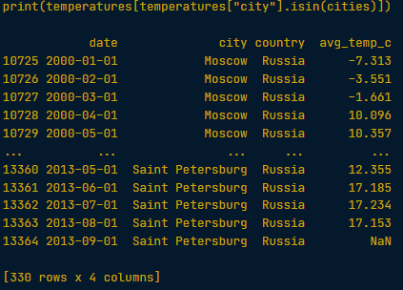

* print(temperatures\_ind.loc[cities])

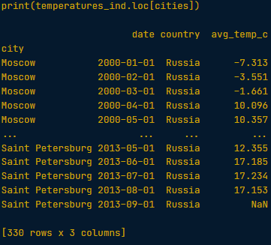

* + - 这里是保留满足两个配对的所有行。注意每个配对使用圆括号()！
    - .loc[]注意用的是方括号！

------------------------------------------------------------

# Index temperatures by country & city

temperatures\_ind = temperatures.set\_index(["country","city"])

# List of tuples: Brazil, Rio De Janeiro & Pakistan, Lahore

rows\_to\_keep = [("Brazil","Rio De Janeiro"),("Pakistan","Lahore")]

# Subset for rows to keep

print(temperatures\_ind.loc[rows\_to\_keep])

------------------------------------------------------------

## .sort\_index()

* + - to be able to sort by elements in the index.
    - print(temperatures\_ind.sort\_index())
    - 根据其中的某一列来sort用的是level来定义！ >> print(temperatures\_ind.sort\_index(level = "city"))
    - 对两列分别来sort且顺序不一样 >> print(temperatures\_ind.sort\_index(level = ["country","city"],ascending = [True,False]))
    - 先设定dates作为index然后再sort >> temperatures\_ind = temperatures.set\_index("date").sort\_values("date")

## 使用.loc[]来slice index values

* + - You can only slice an index if the index is sorted (using .sort\_index()).
    - To slice at the outer level, first and last can be strings.
    - To slice at inner levels, first and last should be tuples.
    - If you pass a single slice to .loc[], it will slice the rows.
    - 例子：

# Sort the index of temperatures\_ind

temperatures\_srt = temperatures\_ind.sort\_index()

# Subset rows from Pakistan to Russia

print(temperatures\_srt.loc["Pakistan":"Russia"])

# Try to subset rows from Lahore to Moscow

print(temperatures\_srt.loc["Lahore":"Moscow"])

# Subset rows from Pakistan, Lahore to Russia, Moscow

print(temperatures\_srt.loc[("Pakistan","Lahore"):("Russia","Moscow")])

* + - 注意这个例子是包含所有行用引号：然后列数那边不需要括号！

print(temperatures\_srt.loc[:,"date":"avg\_temp\_c"])

* + - The important thing to remember is to keep your dates in ISO 8601 format, that is, "yyyy-mm-dd" for year-month-day, "yyyy-mm" for year-month, and "yyyy" for year.
    - 竟然可以直接用年份或者说数字和英文结合来sort…

# Use Boolean conditions to subset temperatures for rows in 2010 and 2011

temperatures\_bool = temperatures[(temperatures["date"] >= "2010-01-01") & (temperatures["date"] <= "2011-12-31")]

print(temperatures\_bool)

# Set date as the index and sort the index

temperatures\_ind = temperatures.set\_index("date").sort\_values("date")

# Use .loc[] to subset temperatures\_ind for rows in 2010 and 2011

print(temperatures\_ind.loc["2010":"2011"])

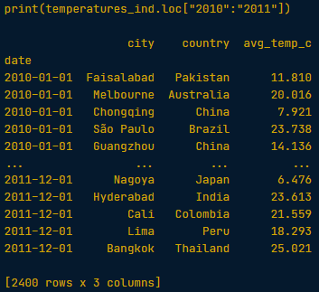

# Use .loc[] to subset temperatures\_ind for rows from Aug 2010 to Feb 2011

print(temperatures\_ind.loc["Aug 2010":"Feb 2011"])

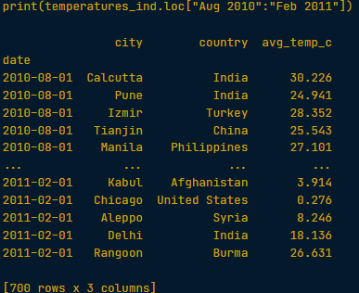

## .iloc[]

* + - The most common ways to subset rows are the ways we've previously discussed: using a Boolean condition or by index labels.
    - However, it is also occasionally useful to pass row numbers.
    - This is done using .iloc[], and like .loc[], it can take two arguments to let you subset by rows and columns.
    - 注意这里得到前三行还可以直接 print(temperatures.iloc[:5])

# Get 23rd row, 2nd column (index 22, 1)

print(temperatures.iloc[22,1])

# Use slicing to get the first 5 rows

print(temperatures.iloc[0:5,:])

# Use slicing to get columns 3 to 4

print(temperatures.iloc[:,2:4])

# Use slicing in both directions at once

print(temperatures.iloc[0:5,2:4])

* + - 取date这列里面的年或者月或者日单独做一列
    - You can access the components of a date (year, month and day) using code of the form dataframe["column"].dt.component. For example, the month component is dataframe["column"].dt.month, and the year component is dataframe["column"].dt.year.

# Add a year column to temperatures

temperatures["year"] = temperatures["date"].dt.year

## the .loc[] + slicing combination is often helpful

* + - 这个例子主要是注意country和city配对组合就是满足这样pair的筛选这种是用()圆括号
    - 然后注意根据年份选择列的时候要引号！

# Subset for Egypt to India

temp\_by\_country\_city\_vs\_year.loc["Egypt":"India"]

# Subset for Egypt, Cairo to India, Delhi

temp\_by\_country\_city\_vs\_year.loc[("Egypt","Cairo"):("India","Delhi")]

# Subset for Egypt, Cairo to India, Delhi, and 2005 to 2010

temp\_by\_country\_city\_vs\_year.loc[("Egypt","Cairo"):("India","Delhi"),"2005":"2010"]

* + - 非常困惑的一个例子，参考

# Get the worldwide mean temp by year

mean\_temp\_by\_year = temp\_by\_country\_city\_vs\_year.mean()

# Filter for the year that had the highest mean temp

print(mean\_temp\_by\_year[mean\_temp\_by\_year == mean\_temp\_by\_year.max()])

# Get the mean temp by city

mean\_temp\_by\_city = temp\_by\_country\_city\_vs\_year.mean(axis="columns")

# Filter for the city that had the lowest mean temp

print(mean\_temp\_by\_city[mean\_temp\_by\_city == mean\_temp\_by\_city.min()])

# 03/15/24 Creating and Visualizing DataFrames

## matplotlib.pyplot

* + - matplotlib.pyplot has been imported as plt
    - Bar chart
    - 第一注意这里先groupby然后再根据某一列数据去和
    - 对想要画图的对象直接.plot(kind="bar")

# Import matplotlib.pyplot with alias plt

import matplotlib.pyplot as plt

# Look at the first few rows of data

print(avocados.head())

# Get the total number of avocados sold of each size

nb\_sold\_by\_size = avocados.groupby("size")["nb\_sold"].sum()

# Create a bar plot of the number of avocados sold by size

nb\_sold\_by\_size.plot(kind="bar")

# Show the plot

plt.show()

* + - Line chart

# Import matplotlib.pyplot with alias plt

import matplotlib.pyplot as plt

# Get the total number of avocados sold on each date

nb\_sold\_by\_date = avocados.groupby("date")["nb\_sold"].sum()

# Create a line plot of the number of avocados sold by date

nb\_sold\_by\_date.plot(kind="line")

# Show the plot

plt.show()

* + - Scatter Plot

# Scatter plot of avg\_price vs. nb\_sold with title

avocados.plot(kind="scatter",x="avg\_price",y="nb\_sold",title="Number of avocados sold vs. average price")

# Show the plot

plt.show()

* + - Histogram
    - 注意除了用].plot(kind="hist")还可以直接.hist()
    - avocados[avocados["type"] == "organic"]["avg\_price"].hist()

# Histogram of conventional avg\_price

avocados[avocados["type"]=="conventional"]["avg\_price"].plot(kind="hist")

# Histogram of organic avg\_price

avocados[avocados["type"]=="organic"]["avg\_price"].plot(kind="hist")

# Add a legend

plt.legend(["conventional","organic"])

# Show the plot

plt.show()

* + - 可以对多列同时画直方图
    - You can plot histograms for multiple variables at a time as follows: dogs[["height\_cm", "weight\_kg"]].hist()

# List the columns with missing values

cols\_with\_missing = ["small\_sold", "large\_sold", "xl\_sold"]

# Create histograms showing the distributions cols\_with\_missing

avocados\_2016[cols\_with\_missing].hist()

# Show the plot

plt.show()

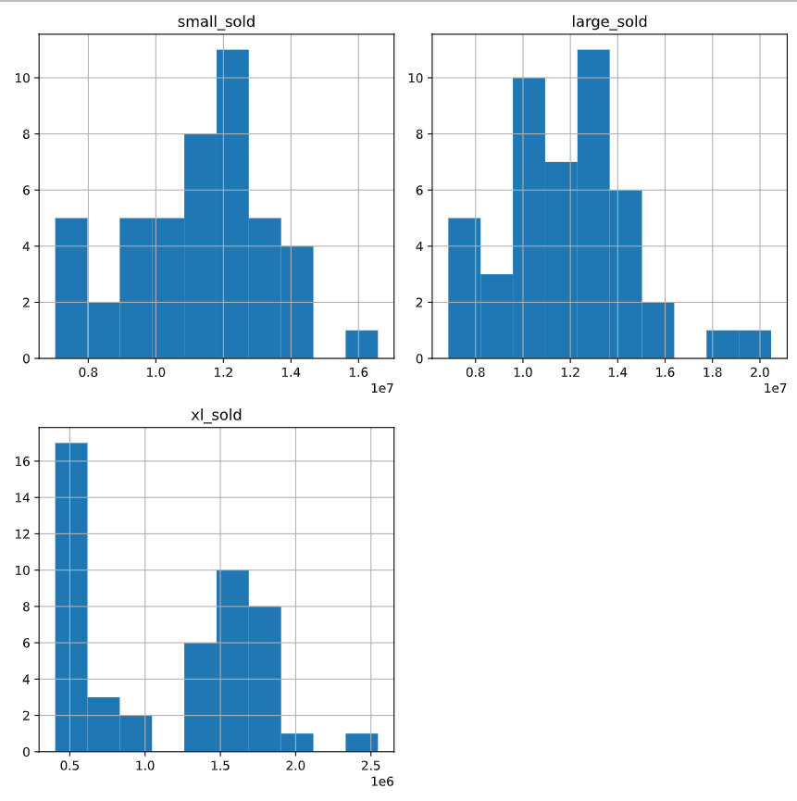

* + - 修改透明度用alpha! >> .hist(alpha=0.5)

# Modify histogram transparency to 0.5

avocados[avocados["type"] == "conventional"]["avg\_price"].hist(alpha=0.5)

# Modify histogram transparency to 0.5

avocados[avocados["type"] == "organic"]["avg\_price"].hist(alpha=0.5)

# Add a legend

plt.legend(["conventional", "organic"])

# Show the plot

plt.show()

* + - 修改bins

# Modify bins to 20

avocados[avocados["type"] == "conventional"]["avg\_price"].hist(alpha=0.5,bins=20)

# Modify bins to 20

avocados[avocados["type"] == "organic"]["avg\_price"].hist(alpha=0.5,bins=20)

# Add a legend

plt.legend(["conventional", "organic"])

# Show the plot

plt.show()

## Missing Values

* + - NaN = not a number
    - 使用.isna()方法将返回一个 DataFrame，其中包含与原始 DataFrame 大小相同的布尔值。所有为NA值的单元格，例如None或numpy.NaN将是True。和其他单元格会False。
    - 返回相同大小的大型 DataFrame 并不是一个好主意。我们可以在方法any()之后添加函数isna()来了解列是否包含NA值：
    - 顺便说一下，isnull()函数是Pandas中isna()函数的别名，它们的工作方式相同。

# Import matplotlib.pyplot with alias plt

import matplotlib.pyplot as plt

# Check individual values for missing values

print(avocados\_2016.isna())

# Check each column for missing values

print(avocados\_2016.isna().any())

# Bar plot of missing values by variable

avocados\_2016.isna().sum().plot(kind="bar")

# Show plot

plt.show()

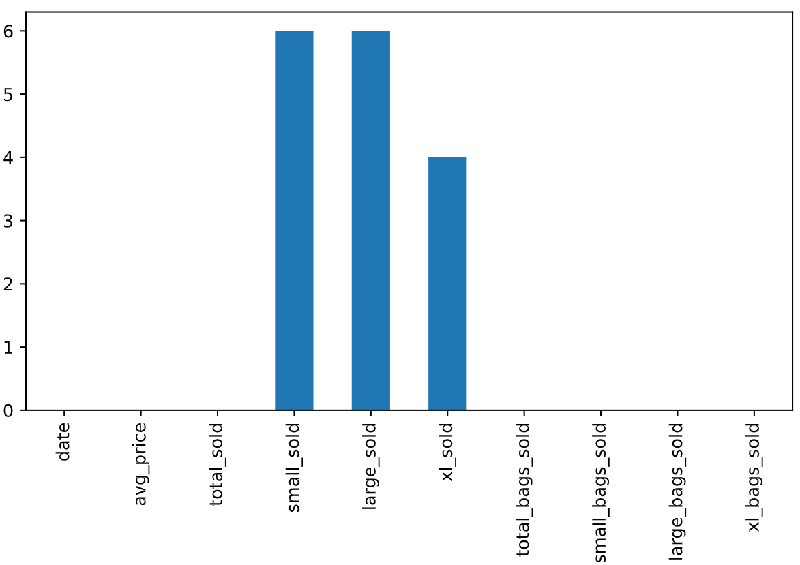

* + - 用dropna()去掉有缺失值的行

# Remove rows with missing values

avocados\_complete = avocados\_2016.dropna()

# Check if any columns contain missing values

print(avocados\_complete.isna().any())

* + - 使用fillna()把缺失值的部分用0填充

# From previous step

cols\_with\_missing = ["small\_sold", "large\_sold", "xl\_sold"]

avocados\_2016[cols\_with\_missing].hist()

plt.show()

# Fill in missing values with 0

avocados\_filled = avocados\_2016.fillna(0)

# Create histograms of the filled columns

avocados\_filled[cols\_with\_missing].hist()

# Show the plot

plt.show()

## List of dictionaries

* + - 注意这个例子里面把listbian’che变成dataframe时候使用pd.DataFrame() 两个大写！
    - 创建list的时候用引号不能直接date

# Create a list of dictionaries with new data

avocados\_list = [

    {"date": "2019-11-03", "small\_sold": 10376832, "large\_sold": 7835071},

    {"date": "2019-11-10", "small\_sold": 10717154, "large\_sold": 8561348},

]

# Convert list into DataFrame

avocados\_2019 = pd.DataFrame(avocados\_list)

# Print the new DataFrame

print(avocados\_2019)

## Dictionary of lists

* + - 例子
    - The list-of-dictionaries method creates DataFrames column-by-column.

# Create a dictionary of lists with new data

avocados\_dict = {

  "date": ["2019-11-17","2019-12-01"],

  "small\_sold": [10859987,9291631],

  "large\_sold": [7674135,6238096]

}

# Convert dictionary into DataFrame

avocados\_2019 = pd.DataFrame(avocados\_dict)

# Print the new DataFrame

print(avocados\_2019)

## csv - comma-separated values

* + - 读取pd.read\_csv(“xxxxxx”)

# Read CSV as DataFrame called airline\_bumping

airline\_bumping = pd.read\_csv("airline\_bumping.csv")

# Take a look at the DataFrame

print(airline\_bumping)

* + - 储存成csv文件用xxxx.to\_csv(“xxxxxxx”)

# Create airline\_totals\_sorted

airline\_totals\_sorted = airline\_totals.sort\_values("bumps\_per\_10k",ascending=False)

# Print airline\_totals\_sorted

print(airline\_totals\_sorted)

# Save as airline\_totals\_sorted.csv

airline\_totals\_sorted.to\_csv("airline\_totals\_sorted.csv")

# 03/17/24 **【Exploring NYC Public School Test Result Scores】**Project

* + - 注意要得到其中几列要两个方括号
    - 用agg()的方法去计算多个统计指标

# Re-run this cell

import pandas as pd

# Read in the data

schools = pd.read\_csv("schools.csv")

# Preview the data

schools.head()

# The best math results are at least 80% of the \*maximum possible score of 800\* for math.

# Save your results in a pandas DataFrame called best\_math\_schools, including "school\_name" and "average\_math" columns, sorted by "average\_math" in descending order.

best\_math\_schools = schools[schools["average\_math"]>0.8\*800][["school\_name","average\_math"]].sort\_values("average\_math",ascending=False)

best\_math\_schools.head()

# What are the top 10 performing schools based on the combined SAT scores?

# Save your results as a pandas DataFrame called top\_10\_schools containing the "school\_name" and a new column named "total\_SAT", with results ordered by "total\_SAT" in descending order.

schools["total\_SAT"] = schools["average\_math"] + schools["average\_reading"] + schools["average\_writing"]

top\_10\_schools = schools.sort\_values("total\_SAT",ascending=False).head(10)[["school\_name","total\_SAT"]]

top\_10\_schools

# Which single borough has the largest standard deviation in the combined SAT score?

# Save your results as a pandas DataFrame called largest\_std\_dev.

# The DataFrame should contain one row, with:

* "borough" - the name of the NYC borough with the largest standard deviation of "total\_SAT".
* "num\_schools" - the number of schools in the borough.
* "average\_SAT" - the mean of "total\_SAT".
* "std\_SAT" - the standard deviation of "total\_SAT".

Round all numeric values to two decimal places.

schools\_stat = schools.groupby('borough')['total\_SAT'].agg(['count', 'mean', 'std']).round(2).sort\_values('std', ascending=False)

schools\_stat

largest\_SD = schools\_stat["std"].max()

largest\_SD

largest\_std\_dev = schools\_stat\_largest\_SD.rename(columns={"count":"num\_schools", "mean":"average\_SAT", "std":"std\_SAT"})

largest\_std\_dev

# 03/19/24【**Joining Data with pandas**】Data Merging Basics

## Merge()

* + - merge的'inner'的类型称为内连接，它在拼接的过程中会取两张表的键（key）的交集进行拼接。什么意思呢？下面以图解的方式来一步一步拆解。
    - 这个例子是将“taxi\_owners ”和“taxi\_veh ”合并，合并的列是"vid"。保存成一个新的dataframe“taxi\_own\_veh”>>是taxi\_own\_veh = taxi\_owners.merge(taxi\_veh,on="vid")
    - suffixes 给重复列加后缀taxi\_own\_veh = taxi\_owners.merge(taxi\_veh, on='vid', suffixes=("\_own", "\_veh"))

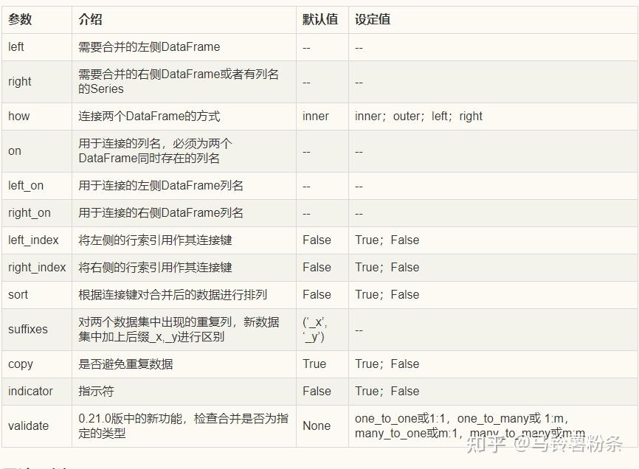

* + - 例子

# Merge the taxi\_owners and taxi\_veh tables setting a suffix

taxi\_own\_veh = taxi\_owners.merge(taxi\_veh, on='vid', suffixes=('\_own','\_veh'))

# Print the value\_counts to find the most popular fuel\_type

print(taxi\_own\_veh['fuel\_type'].value\_counts())

* + - It is necessary to understand that inner joins only return the rows with matching values in both tables.

## One to many relationships

* + - In a one-to-many relationship, every row in the left table is related to one or more rows in the right table.
    - 例子：
* Group licenses\_owners by title and count the number of accounts for each title. Save the result as counted\_df 注意这里用的是.agg({'account':'count'})
* Sort counted\_df by the number of accounts in descending order, and save this as a variable named sorted\_df. 注意这里直接在sort\_values后面用”account”了不需要再xxxxx\_df[“xxx”]
* ascending=False 不用引号哇！

# Merge the licenses and biz\_owners table on account

licenses\_owners = licenses.merge(biz\_owners,on="account")

# Group the results by title then count the number of accounts

counted\_df = licenses\_owners.groupby("title").agg({'account':'count'})

# Sort the counted\_df in desending order

sorted\_df = counted\_df.sort\_values("account",ascending=False)

# Use .head() method to print the first few rows of sorted\_df

print(sorted\_df.head())

* + - \ 这玩意叫做blackslash line，是一种continuation method用来add the second merge on the next line so python will read this as just one line of the code

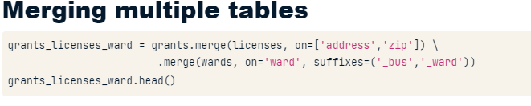

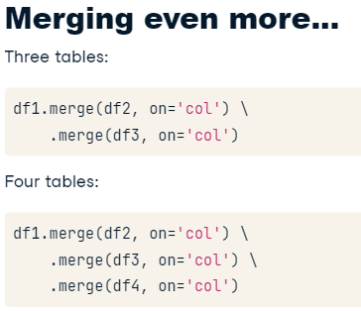

* + - 用多个共同列的合并on=["year","month","day"])

# Merge the ridership and cal tables

ridership\_cal = ridership.merge(cal,on=["year","month","day"])

* + - 多表合并。以下是他们的关系

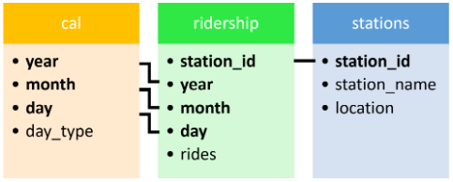

# Merge the ridership, cal, and stations tables

ridership\_cal\_stations = ridership.merge(cal, on=['year','month','day']) \

                            .merge(stations,on="station\_id")

* + - 这个例子可以学的是如何把筛选条件变成一个变量。筛选的时候用的是.loc

# Create a filter to filter ridership\_cal\_stations

filter\_criteria = ((ridership\_cal\_stations['month'] == 7)

                   & (ridership\_cal\_stations['day\_type'] == "Weekday")

                   & (ridership\_cal\_stations['station\_name'] == "Wilson"))

# Use .loc and the filter to select for rides

print(ridership\_cal\_stations.loc[filter\_criteria, 'rides'].sum())

* + - 这是另一个例子，也是三表合并
    - 记得换行的时候是Ctrl+Enter就可以自动缩进了
    - 然后这里计算的是 income这一列的中值

# Merge licenses and zip\_demo, on zip; and merge the wards on ward

licenses\_zip\_ward = licenses.merge(zip\_demo,on="zip") \

                        .merge(wards,on="ward")

# Print the results by alderman and show median income

print(licenses\_zip\_ward.groupby("alderman").agg({'income':'median'}))

* + - 包含了suffixes后缀的例子

# Merge land\_use and census and merge result with licenses including suffixes

land\_cen\_lic = land\_use.merge(census,on="ward") \

        .merge(licenses,on="ward",suffixes=("\_cen","\_lic"))

* + - 根据三列来groupby的例子
    - Group land\_cen\_lic by ward, pop\_2010 (the population in 2010), and vacant, then count the number of accounts. Save the results to pop\_vac\_lic.
    - 这个例子要注意的是as\_index这个变量 as\_index=False
    - When as\_index=True the key(s) you use in groupby() will become an index in the new dataframe.

# Group by ward, pop\_2010, and vacant, then count the # of accounts

pop\_vac\_lic = land\_cen\_lic.groupby(["ward","pop\_2010","vacant"],

                                   as\_index=False).agg({'account':'count'})

* + - 这个例子注意的是对多列进行groupby的同时排列顺序也不一样

# Sort pop\_vac\_lic and print the results

sorted\_pop\_vac\_lic = pop\_vac\_lic.sort\_values(["vacant","account","pop\_2010"],

                                             ascending=[False,True,True])

# 03/21/24 Merging Tables With Different Join Types

## Inner Join & Left join

* + - By default, the merge method performs an inner join, returning only the rows of data with matching values in the key columns of both tables.
    - A left join returns all rows of data from the left table and only those rows from the right table where key columns match.
    - 使用的是how这个argument

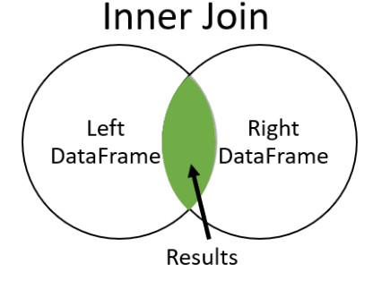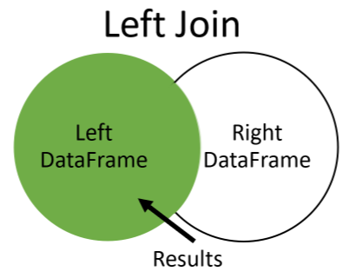

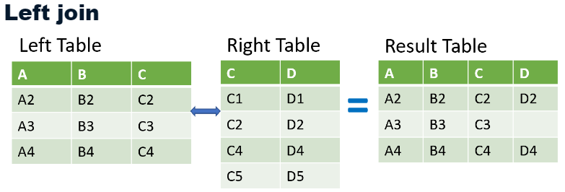

* + - 例子

# Merge movies and financials with a left join

movies\_financials = movies.merge(financials,on="id",how="left")

* + - 例子 – 计算出某一列里面NaN的个数

# Count the number of rows in the budget column that are missing

number\_of\_missing\_fin = movies\_financials['budget'].isnull().sum()

* + - 这个例子学习的是左边和右边的表格名字不一样的inner join

# Merge the movies and scifi\_only tables with an inner join

movies\_and\_scifi\_only = movies.merge(scifi\_only,left\_on="id",right\_on="movie\_id",how="inner")

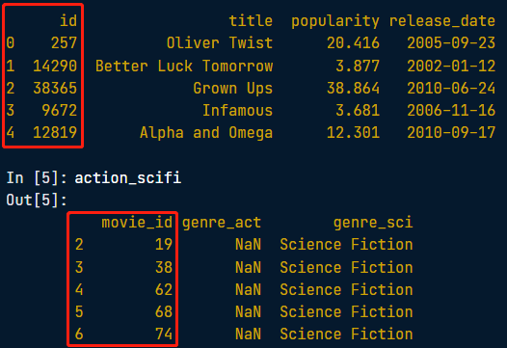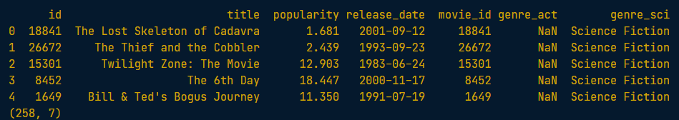

## Right join

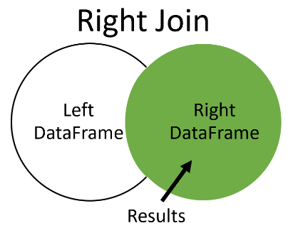

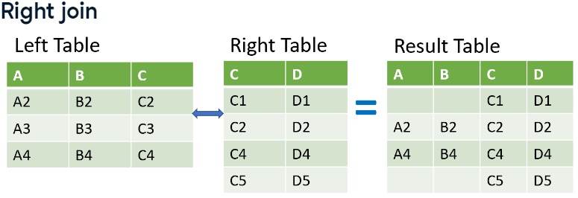

* + - It will return all of the rows from the right table and includes only those rows from the left table that have matching values.
    - Where there isn't a match, the columns from the left table will be missing in the result table, like rows one and four.
    - 例子

# Merge action\_movies to scifi\_movies with right join

action\_scifi = action\_movies.merge(scifi\_movies, on='movie\_id', how='right',suffixes=('\_act','\_sci'))

# Print the first few rows of action\_scifi to see the structure

print(action\_scifi.head())

* + - 这个例子想展示的是如何挑选出结果是NaN的那个 >> 用.isnull()！

# From action\_scifi, select only the rows where the genre\_act column is null

scifi\_only = action\_scifi[action\_scifi["genre\_act"].isnull()]

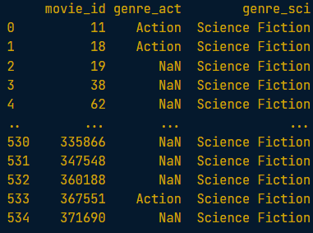

* + - 例子

# Use right join to merge the movie\_to\_genres and pop\_movies tables

genres\_movies = movie\_to\_genres.merge(pop\_movies, how='right',

                                      left\_on="movie\_id",

                                      right\_on="id")

# Count the number of genres

genre\_count = genres\_movies.groupby('genre').agg({'id':'count'})

# Plot a bar chart of the genre\_count

genre\_count.plot(kind='bar')

plt.show()

## Outer join

* + - An outer join will return all of the rows from both tables regardless if there is a match between the tables.
    - One cool aspect of using an outer join is that, because it returns all rows from both merged tables and null where they do not match, you can use it to find rows that do not have a match in the other table.

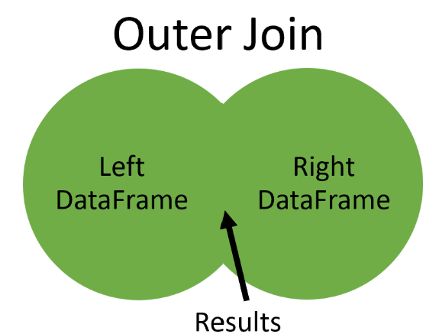

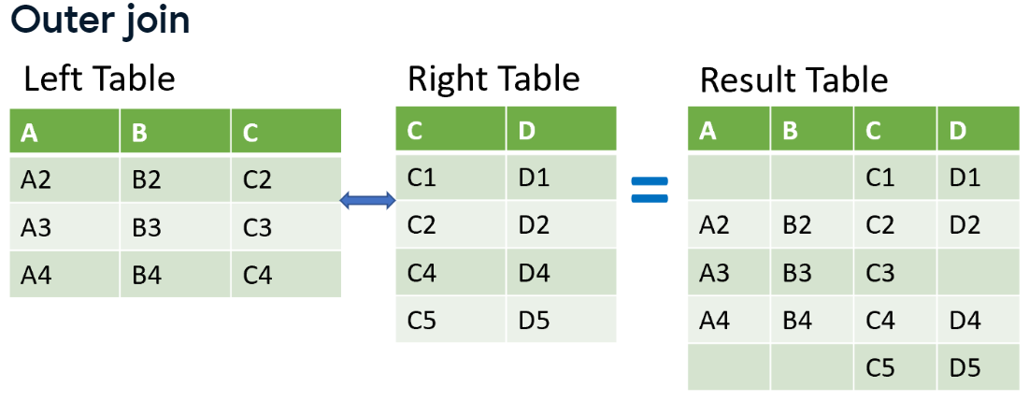

* + - 挑选出绿色的部分

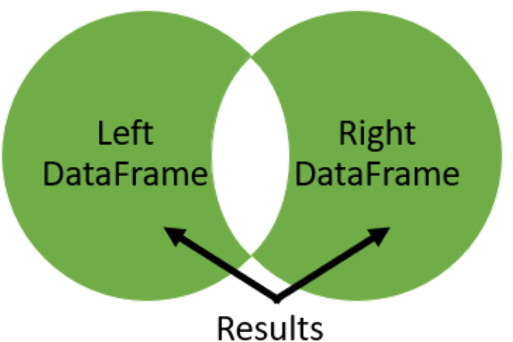

# Merge iron\_1\_actors to iron\_2\_actors on id with outer join using suffixes

iron\_1\_and\_2 = iron\_1\_actors.merge(iron\_2\_actors,

                                     on="id",

                                     how="outer",

                                     suffixes=('\_1','\_2'))

# Create an index that returns true if name\_1 or name\_2 are null

m = ((iron\_1\_and\_2['name\_1'].isnull()) |

     (iron\_1\_and\_2['name\_2'].isnull()))

# Print the first few rows of iron\_1\_and\_2

print(iron\_1\_and\_2[m].head())

## Self join – 可以是inner, outer, right, left

* + - You might need to merge a table to itself when working with tables that have a hierarchical relationship, like employee and manager.
    - You might use this on sequential relationships such as logistic movements.
    - Graph data, such as networks of friends, might also require this technique.
    - Merging a table to itself can be useful when you want to compare values in a column to other values in the same column.
    - 这个例子是把一个表通过id进行self join然后筛选出job\_dir里面Director并且job\_crew不是Director的。简单说就是hierarchical排序

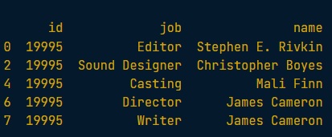

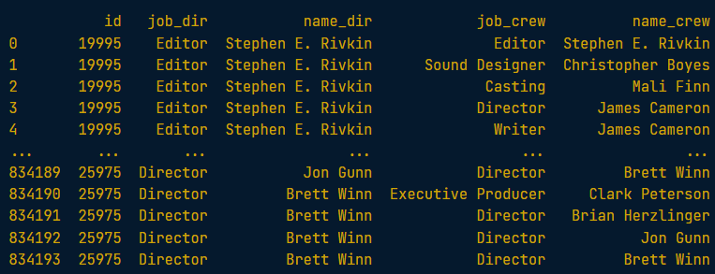

# Merge the crews table to itself

crews\_self\_merged = crews.merge(crews, on='id', how='inner',

                                suffixes=('\_dir','\_crew'))

# Create a boolean index to select the appropriate rows

boolean\_filter = ((crews\_self\_merged['job\_dir'] == 'Director') &

                  (crews\_self\_merged['job\_crew'] != 'Director'))

direct\_crews = crews\_self\_merged[boolean\_filter]

# Print the first few rows of direct\_crews

print(direct\_crews.head())

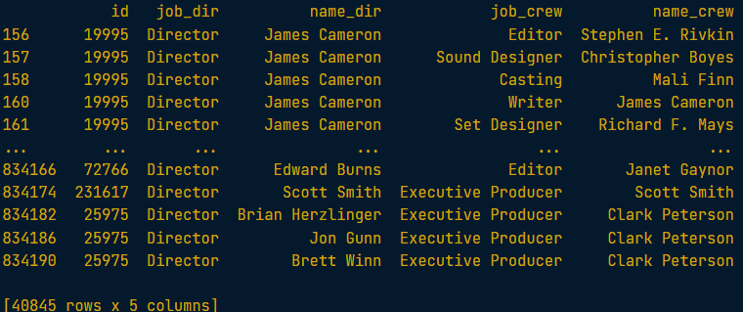

## Merge in indices

* + - Whenever we are using the left\_on or right\_on arguments with an index, we need to set the respective left\_index and right\_index arguments to True. The left\_index and right\_index tell the merge method to use the separate indexes.
    - Merging on indexes is just like merging on columns, so if you need to merge based on indexes, there's no need to turn the indexes into columns first.
    - 这个例子注意的是self join那部分。可以看到right\_on用的是id这一列所以对应的要有一个right\_index=true

# Merge sequels and financials on index id

sequels\_fin = sequels.merge(financials, on='id', how='left')

# Self merge with suffixes as inner join with left on sequel and right on id

orig\_seq = sequels\_fin.merge(sequels\_fin, how='inner', left\_on='sequel',

                             right\_on='id', right\_index=True,

                             suffixes=('\_org','\_seq'))

# Add calculation to subtract revenue\_org from revenue\_seq

orig\_seq['diff'] = orig\_seq['revenue\_seq'] - orig\_seq['revenue\_org']

# Select the title\_org, title\_seq, and diff

titles\_diff = orig\_seq[['title\_org','title\_seq','diff']]

# Print the first rows of the sorted titles\_diff

print(titles\_diff.sort\_values("diff",ascending=False).head())

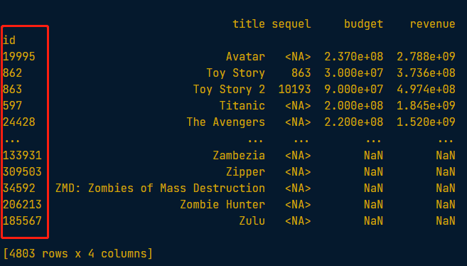

# 03/24/24 Advanced Merging and Concatenating

## Filtering Join

* So far, we have only worked with mutating joins 变形链接, which combines data from two tables.
* However, filtering joins filter observations from one table based on whether or not they match an observation in another table.

## Semi Join

* A semi join filters the left table down to those observations that have a match in the right table.
* It is similar to an inner join where only the intersection between the tables is returned, but unlike an inner join, only the columns from the left table are shown.
* Finally, no duplicate rows from the left table are returned, even if there is a one-to-many relationship.
* 整个过程大概如下：It first merges the tables, then searches it for which rows belong in the final result creating a filter and subsets the left table with that filter.

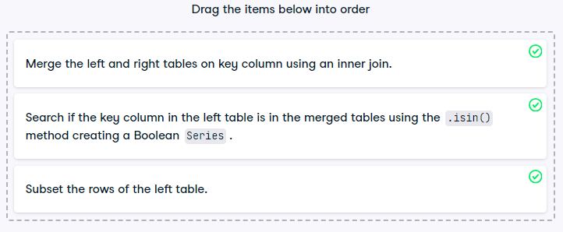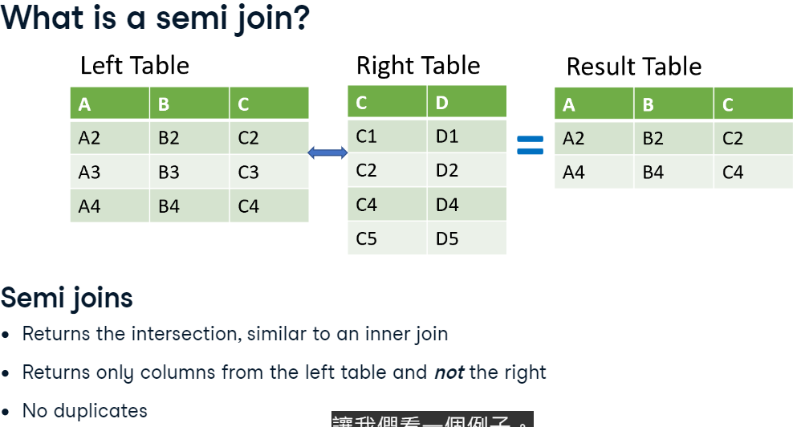

## Anti Join

* An anti join returns the observations in the left table that do not have a matching observation in the right table.
* It also only returns the columns from the left table.
* 例子：You performed an anti join by first merging the tables with a left join, selecting the ID of those employees who did not support a top customer, and then subsetting the original employee's table. From that, we can see that there are five employees not supporting top customers. Anti joins are a powerful tool to filter a main table (i.e. employees) by another (i.e. customers).

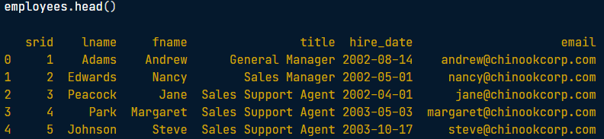

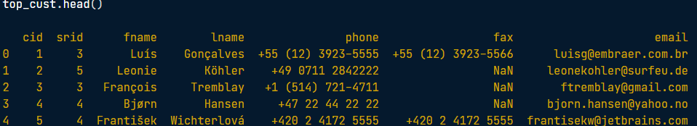

# Merge employees and top\_cust

empl\_cust = employees.merge(top\_cust, on='srid',

                                 how='left', indicator=True)

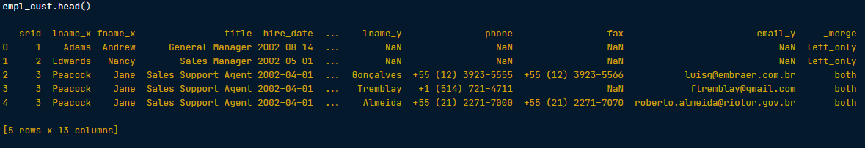

# Select the srid column where \_merge is left\_only

srid\_list = empl\_cust.loc[empl\_cust['\_merge'] == 'left\_only', 'srid']

# Get employees not working with top customers

print(employees[employees["srid"].isin(srid\_list)])

* 这个例子注意的是在计算count的那部分要有引号！

# Group the top\_tracks by gid and count the tid rows

cnt\_by\_gid = top\_tracks.groupby(['gid'], as\_index=False).agg({'tid':'count'})

## Concatenation >> grow vertically

* 用的是pandas的.concat()
* 可以vertical可以horizontal
* Axis=0 就是vertical
* 例子：要concat的对象用[]方括号

# Concatenate the tracks

tracks\_from\_albums = pd.concat([tracks\_master,tracks\_ride,tracks\_st],sort=True)

print(tracks\_from\_albums)

* 这个例子学习的是ignore\_index。设置为True的时候就会根据index从0开始排序了

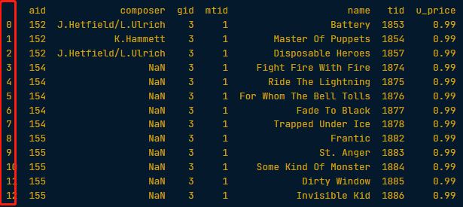

# Concatenate the tracks so the index goes from 0 to n-1

tracks\_from\_albums = pd.concat([tracks\_master,tracks\_ride,tracks\_st],sort=True,ignore\_index=True)

print(tracks\_from\_albums)

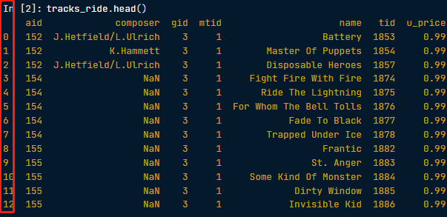

* Concat的其他参数

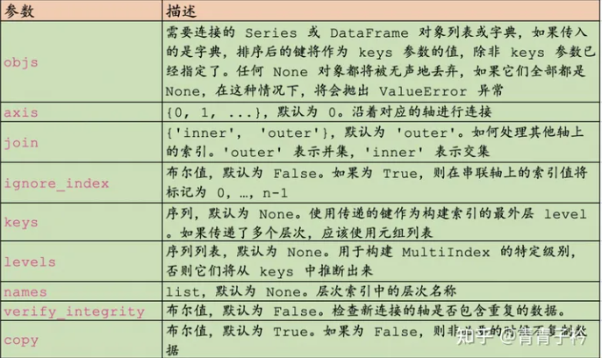

* 这个例子学习的是join。设置为inner的时候呢只有在所有表格里面都存在的列才会返回

# Concatenate the tracks, show only columns names that are in all tables

tracks\_from\_albums = pd.concat([tracks\_master,tracks\_ride,tracks\_st], join="inner",sort=True)

print(tracks\_from\_albums)

* 这个例子注意keys定义的时候要有引号和括号！
* 注意agg里面要求均值用的是”mean”！
* 注意这里用了groupby(level=0)来根据index keys来排序

# Concatenate the tables and add keys

inv\_jul\_thr\_sep = pd.concat([inv\_jul,inv\_aug,inv\_sep], keys=['7Jul', '8Aug', '9Sep'])

# Group the invoices by the index keys and find avg of the total column

avg\_inv\_by\_month = inv\_jul\_thr\_sep.groupby(level=0).agg({"total":"mean"})

# Bar plot of avg\_inv\_by\_month

avg\_inv\_by\_month.plot(kind="bar")

plt.show()

## verifying integrity >>. merge(validate=”???”) 和.concat(verify\_integrity=True/False)

* 可以有的一些选项.merge(validate= 'many\_to\_many'/ 'one\_to\_many'/ 'many\_to\_one')

# 03/24/24 Merging Ordered and Time-Series Data

## Merge\_ordered()

* his method can merge time-series and other ordered data.
* 和merge方法的对比

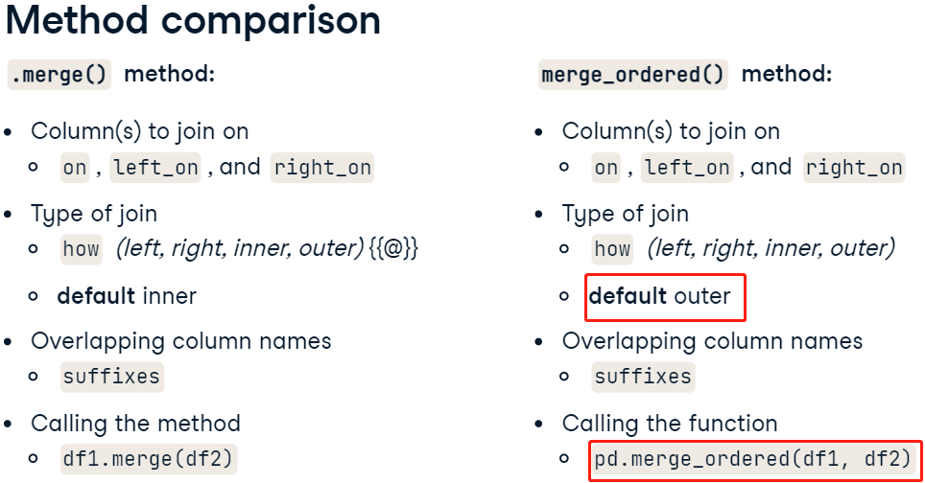

* 在 Pandas 中，merge\_ordered 是一种用于合并有序数据的函数。它类似于 merge 函数，但适用于处理时间序列数据或其他有序数据。merge\_ordered 在合并时会保留原始数据的顺序，并且支持对缺失值进行处理。
* We can fill in this missing data using a technique called forward filling. It will interpolate missing data by filling the missing values with the previous value. In the table shown here, the second and fourth rows of column B are filled with the values of B in the rows proceeding them. Fill\_method

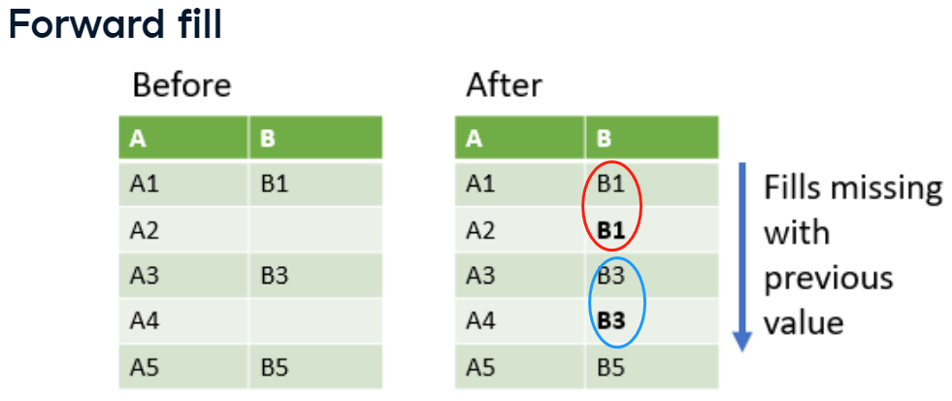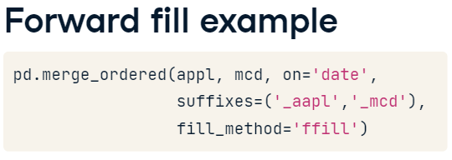

* 这个例子要注意的是两个表格的列名不一样的时候可以用left\_on和right\_on分别定义要组合的列

# Use merge\_ordered() to merge gdp and sp500 on year and date

gdp\_sp500 = pd.merge\_ordered(gdp,sp500, left\_on="year", right\_on="date", how="left" ,fill\_method='ffill')

# Print gdp\_sp500

print(gdp\_sp500)

* 这个例子是在两列上合并on有两个变量

# Merge gdp and pop on date and country with fill and notice rows 2 and 3

ctry\_date = pd.merge\_ordered(gdp,pop,on=["date","country"],fill\_method='ffill')

# Print ctry\_date

print(ctry\_date)

## Merge\_asof() – 只能left join

* The merge\_asof() method is similar to an ordered left join. It has similar features as merge\_ordered().
* The merge\_asof() function will always perform a left join.
* However, unlike an ordered left join, merge\_asof() will match on the nearest value columns rather than equal values. This brings up an important point - whatever columns you merge on must be sorted.
* First, you might think of this method when you are working with data sampled from a process and the dates or times may not exactly align. It could also be used when you are working on a time-series training set, where you do not want any events from the future to be visible before that point in time.
* 下面这种是使用默认的direction为backward的例子。可以选择forward啊nearest其他direction

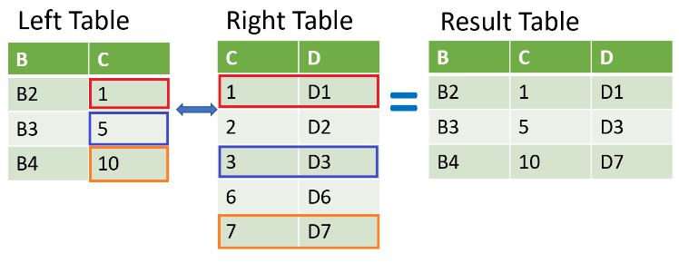

* 注意是pd.merge\_asof()！在pandas里面的
* 这个例子注意的是三个表格的合并，然后计算差异，最后画图。注意plot那边直接用方括号选择对应的列名即可。

# Use merge\_asof() to merge jpm and wells

jpm\_wells = pd.merge\_asof(jpm,wells,on="date\_time",direction="nearest",suffixes=('', '\_wells'))

# Use merge\_asof() to merge jpm\_wells and bac

jpm\_wells\_bac = pd.merge\_asof(jpm\_wells,bac,on="date\_time",suffixes=('\_jpm', '\_bac'),diection='nearest')

# Compute price diff

price\_diffs = jpm\_wells\_bac.diff()

# Plot the price diff of the close of jpm, wells and bac only

price\_diffs.plot(y=[“close\_jpm”, “close\_wells”, “close\_bac”])

plt.show()

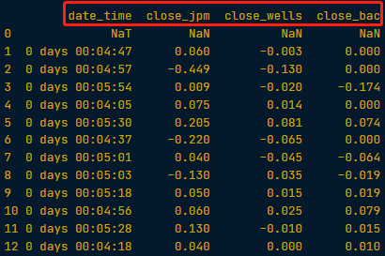

* 这个例子学习的是它怎么定义if条件那部分的conditional expression
* Create a list using a list comprehension and a conditional expression, named is\_recession, where for each row if the gdp\_recession['econ\_status'] value is equal to 'recession' then enter 'r' else 'g'.
* 更牛逼的是竟然可以把条件当作颜色.. 注意这里的r和g是red 和 green。代表颜色的code。相当于把颜色的一堆codes输入到color那里…

# Merge gdp and recession on date using merge\_asof()

gdp\_recession = pd.merge\_asof(gdp,recession,on="date")

# Create a list based on the row value of gdp\_recession['econ\_status']

is\_recession = ['r' if s=='recession' else 'g' for s in gdp\_recession['econ\_status']]

# Plot a bar chart of gdp\_recession

gdp\_recession.plot(kind="bar", y="gdp", x="date", color=is\_recession, rot=90)

plt.show()

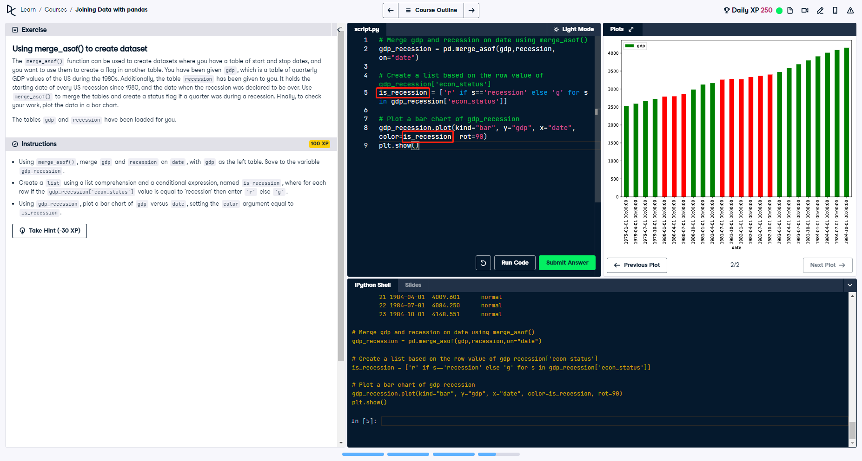

## .query()

# //24 【**Introduction to Statistics in Python**】

## Xxxxxx

* + - Xxxxxx
    - Sss
    - ssss

# //24 【Introduction to Data Visualization with Matplotlib】

## Xxxxxx

* + - Xxxxxx
    - Sss
    - ssss

# //24 【xxxxxx】

## Xxxxxx

* + - Xxxxxx
    - Sss
    - ssss